Network client software
Operation Manual

Date of
2012-06-16

Directory
1 Application environment and software installation
1.1 camera factory default values
1.2 operating environment requirements
1.3 Software Installation and use of summary
1.4 client software camera data table
2 Key functions of the operating instructions
2.1 software starts
2.2 The module features a brief description of
2.3 how to add the camera and play
2.4 how to carry out the plan video
2.5 Motion detection settings
2.6 client alarm settings
2.7 video playback
2.8 context menu (stream switching round of the Tour, landing equipment, the FTP, the digital zoom)
2.9 System Settings
2.10 device settings
2.11 capture
2.12 The local video
2.13 electronic map
2.14 ESF format to AVI
2.15 local records query
2.16 alarm file upload management
2.17 masking block set
2.18 lock screen
3 additional features of the client software
3.1 Control keyboard settings
4 Use Notes
5 Frequently Asked Questions
5.1 client software how to achieve two-way voice intercom
5.2 A total of which video type
5.3 screen color ribbon
5.4 DVR space calculation
5.5 How do I exit full-screen viewing mode
5.6 how to set up to boot automatically connect image, automatic video
5.7 Above the client software users and user of the camera above What is the difference
5.8 when the access of multiple camera monitoring software often get stuck or interface does not respond to how to do
5.9 client software which enabled dual-stream viewing
5.10 video playback when bad
6 Annex
6.1 Network Knowledge Introduction
6.2 motion detection alarm and send a message
6.3 motion detection alarm uploaded to the FTP
6.4 SD card using the File Description
6.5 search software for use
6.6 Network ball machine in the client software to set the auto-cruise
6.7 Remote Access
6.8 How to use the Plug and Play (IPnP)

Explain

1, network cameras, like a computer belonging to the high-tech products, testing and use of the process, not to frequent power outages, or internal procedures will be problems, the camera is normal to start to be 2-3 minutes from power to power-off interval of at least more than three minutes.

2, due to the complexity of the network camera, if you first use network camera, we strongly recommend that you read this document 6.1 “network basic knowledge introduced”. Some knowledge of the network because the network camera will be used.

3, this manual will be updated frequently, if necessary, please contact the business or technical personnel to obtain the latest manual.

1.An application environment and software installation
1.1 camera factory default values
Default IP: 192.168.1.128
Subnet Mask: 255.255.255.0
Default Gateway: 192.168.1.1
PTZ protocol: PELCO-D
Baud Rate: 2400
Address code: 1
User Name: admin
Password: admin

1.2 Operating environment requirements
The computer hardware requirements are as follows：
System Description | Recommended configuration
CPU | Intel i3/5 CPU
Motherboard | MSI
Memory | Kingston 2G +
Hard disk | Seagate 2 TB or more
Graphics | ATI 1GB (Note: The graphics have a variety of ATI graphics card to watch HD video better. NVIDIA graphics card to play the game bette）
VGA interface | One used to access a computer monitor (or connect a large screen liquid crystal display)
NIC | the the realtek 100M or 100/1000M adaptive
* Solemnly declare that：

With computers, in strict accordance with the above recommended to go with to ensure that the hardware and software compatibility and stability. The above configuration must use the regular factory, and Lu-master hardware testing, so as not assigned to shoddy products.

Software: Supports 32-bit Windows XP Professional Edition, WIN7 Ultimate Edition, Windows 2003 Enterprise Edition. 64 operating system is not supported.

1.3 Software installation and use of summary

1.3.1 Software Installation
Double-click the file setup.exe, the installation program which the software installation process is relatively simple, as shown：
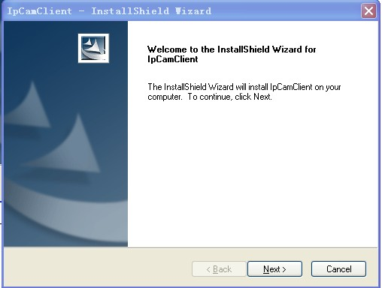
Click Next to complete the installation.
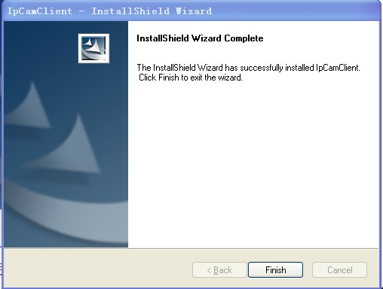

Description:

In the process of installing the software, firewalls and antivirus software should be temporarily closed to allow the software to achieve the full installation. Software installation to the default path is C: \ Program Files \ IPCAM installation path is best not to change.

1.3.2 Use summary

After the software installation is complete, the following will be on your desktop shortcuts:

IpCamClient.exe: Our client software is the main program, the default login user name and password are admin.

DeviceSearch.exe: network camera search tool to search LAN camera.

FilePlayer.exe: dedicated player for video files, used to play the video file.

Uninstall: Uninstall network cameras client software.

1.4 Client software camera data table
Client software on a different PC configuration platform, the differences in various aspects of management camera, the number of management, the number of key operating platform configuration CPU (decoding computing power), according to the configuration of the test machine, to assess a The data can be used as the lowest users to run software to configure and manage the camera:
- 客户端管理摄像机数据

Operating environment | CPU Intel i3, 1G memory
Serial number | 摄像机个数（台） |  |  | CPU market share（%）
Serial number | Video | Broadcast | Total | CPU market share（%）
1 | 0 | 10(Million resolution) | 10 | 85-99
2 | 10 | 10 | 10 | 89-99

Description:

Serial number: video = 0 means no video, only the number of playback screen

Note: It is recommended that a computer to manage up to 9-10 (in millions at the same time play) network camera

CPU occupancy rate is preferably not more than 70%

2 Key functions of the operating instructions

2.1 Software startup
The software installation is complete, will the desktop to generate a “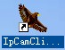” Shortcut key by double-clicking on the desktop “” Shortcut key to run the main program。
The first time you run this software
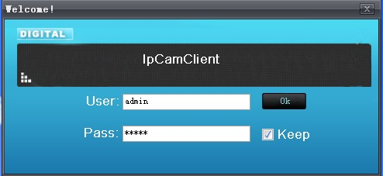
Enter your user name and password into the main interface of the client (the default user name and password are admin)
The login interface is as follows: (the "Preview" interface)
When you click on the lower left corner ，Will bring up the PTZ control interface, as follows: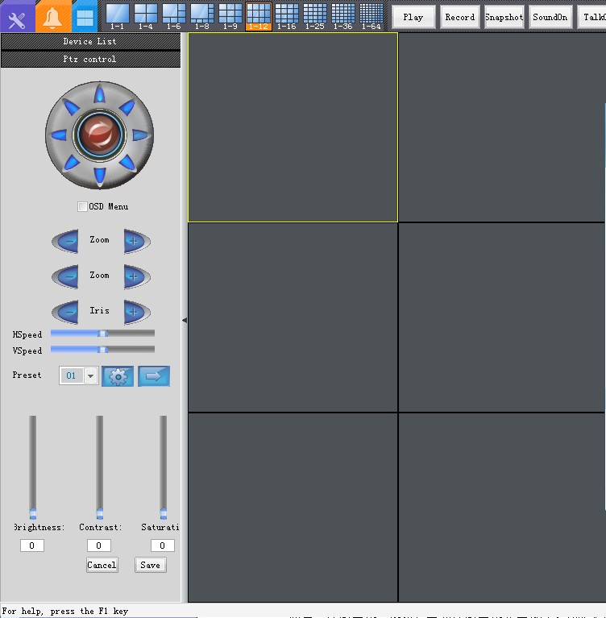
Click on the upper left corner  After the emergence of the interface;
Click "Control Panel" button, Control Panel interface appears as follows: (you can choose the options to be operating)
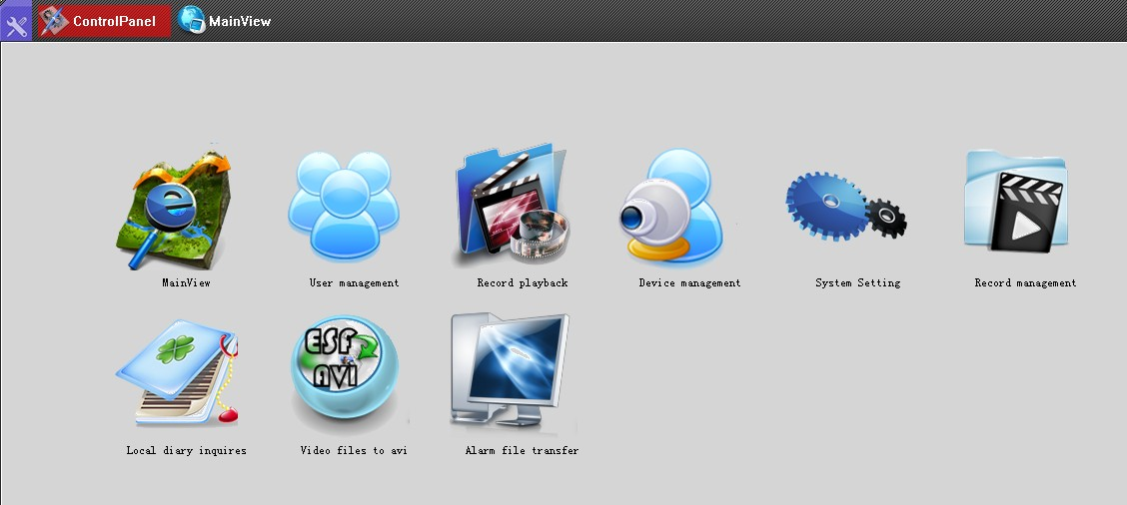
The language switch, click Control Panel → System Settings → Basic→，Click Save, and then restart the client software language to switch to select the language you want to switch.
2.2 A brief description of each module functions
2.2.1 Control Panel
1 Preview: real-time viewing of camera equipment. And through the operation of its toolbar.
2, the system settings: with dual-stream playback, alarm settings for the client, the client user management, control keyboard settings, specific functional details, please view this document 2.9 system settings.

3．Device Manager: containing the search online equipment, equipment for various operations (add / delete / modify equipment, etc.), remote configuration of the equipment (basic settings, network, alarm, mobile wireless networks, video and audio, user management, subtitles, time settings, the preceding video, PTZ), the specific features detailed See this document 2.10 device settings.

4, user management: Administrators can add users or delete users, and to add the user the appropriate permissions. The specific feature details please see this document 2.9 System Settings -> client user management.
5, the recording management: including the local plan video (2.4 how to plan video), capture / video file save path, local video file to package length.
6, video playback: the history of video playback. The specific feature details please see this document 2.7 video playback.
7, the local log query: the main function is to modify the boot record of inquiries, photo cameras, and view historical alarm log information and details please see this document 2.15 local log query.
8, esf turn avi: the esf format of video files converted to avi format. Details of introduction See this document 2.14 esf turn avi.
9.Alarm file transfer management: motion detection alarm / external alarm to upload to FTP or E-mail, you can check file is being uploaded to an FTP or E-mail. For more introduction, please see 2.16 of this document alarm file upload management.
2.2.2 The main preview -> Toolbars
1.A split screen: the visual style, you can control the camera large ones channel to watch into 1,4,6,8,9,12,16,25,36,64 screen.
2, Play / Stop buttons: control the camera image connect / disconnect.
3, the "Video" button: local video. Details please see the 2.12 local recording of this document.
4, the "capture" button: The camera real-time screen snapshots. Specific function details please see 2.11 of this document capture
5, "Open Sound" button: open sound, you can voice intercom and alarm issued when the alarm sounds.
6, voice intercom button: board and client can be a voice intercom.
7.Device Settings button: to set the device. The specific function details please see the 2.10 set the device of this document.
8, the "full screen" button: the picture full screen display. Details please see this document 2.8.3 in the current playback screen right-click.
9, the "lock screen" button: lock the screen. Details See this document 2.18 lock screen
2.3 how to add the camera and play
(A) to add the camera:
Method one: click on the "Device Manager" select "control panel" interface to enter the Device Manager settings interface:
Click on the button, pop-up window as shown below, we can add a camera you want to add by checking the equipment
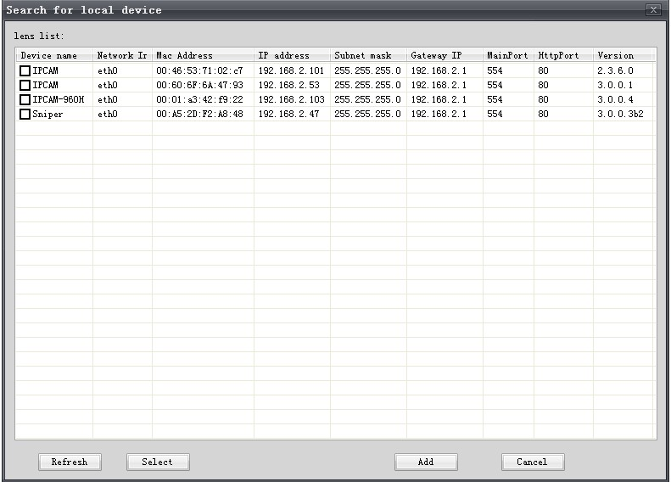
Then we can see the camera added to it in the main preview interface.
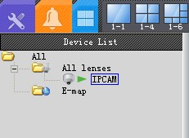
Method two:
Right function: (in the main preview interface)
- Right-click the "lens", click the sub menu, the search appliance.
- right-click "electronic map", click the sub-menu "Search for.
* Note:
1． search camera, put the computer firewall is turned off, in order to search for the camera IP address. Click Start → Control Panel → Windows Firewall, open or close the windows firewall features page, close off the windows firewall can.
2． monitoring software which search tools, search tool and install the software generated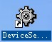 A search tool, use the search tool here, should be outside of this search tool to turn off.
(B) camera playback
Drag the camera to the channel, or double-click can make it play in the channel.
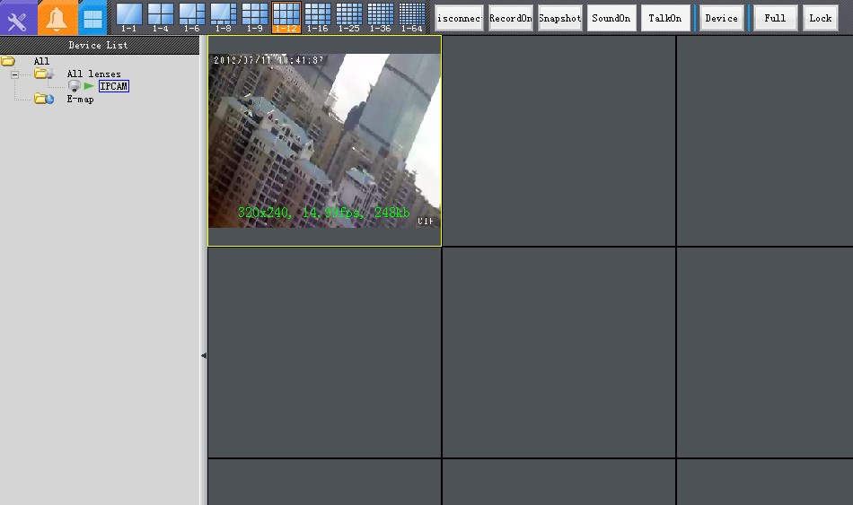
Status lights:
Offline: stream 1 and stream 2 are disconnected.
Playback status: a playback of the stream or stream playback.
Video Status: Manual recording, scheduled recording when the display state.
Connection Status: stream 1 and stream 2, a connection status of a disconnected state.
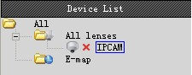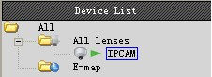
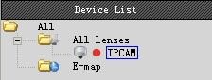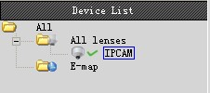
2.4 how to carry out the plan video
"Video Management" select "control panel" interface, pop-up video settings window:
Select the corresponding camera, click the "New Plan, it can be the camera for video-making. Video of the new plan is to select the "lens" of all the cameras of the lens following. Opcode stream options bar, you can choose to use stream 1 or stream 2 video, where video is recorded in the monitor the computer above the video to save the path and the duration of each video can be set in the page (note: After setting the length of each path you want to restart the client software to be effective). The image above grab fear of concurrent e-mail settings, please refer to 6.2 of this document "motion detection alarm to send an e-mail.

Description:
Set video program recorded on top of the D: drive, you can see the video below the path to D: \ record \ PC \ Record file, video file name to S-video time named.
2.5 Motion detection settings
Step 1: Turn on the camera board-side motion detection alarm function:
"Preview" interface to select the desired channel camera, click the "Device Settings" in the toolbar to bring up the Device Settings window, select the "alarm" the board-side motion detection alarm settings. Check the "open the alarm function.
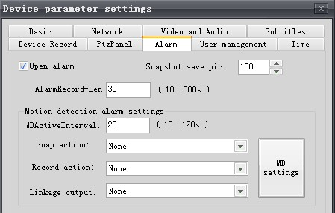
Step 2: Open the software's motion detection feature, and set up motion detection area:
Click on the image above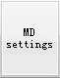
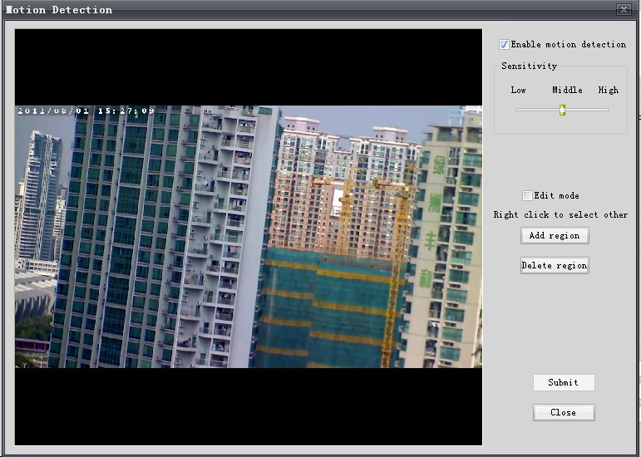
Check the "Allow motion detection, simply click the" add a new area, draw the image you want to detect the location of the monitoring box, the first frame is 0, if you want to add the test box, continue to click to add a new area the second box 1, you want to add so you can add a maximum of 5 motion detection area. Delete the current area, set before the monitoring box one by one to delete. Delete the current detection box, you must stop the current video camera, have set and click "Submit".
Step 3: Set the action of motion detection, such as video and capture
In the "control panel" interface to select "System Settings" -> "Client alarm set"
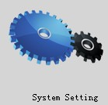

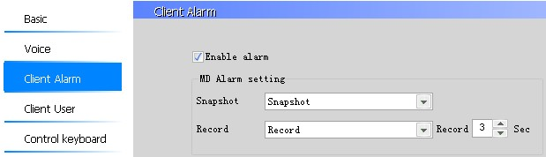
Check the "Open the alarm function, select the motion detection occurs after the action, and to select the length of recording time. Video and capture client-based, video and pictures are stored in the monitor computer above.
Step 4: motion detection video file
Monitor screen there will be a rectangle set up motion detection, flash, video path and the duration of each video is set in the "Control Panel" -> "Video Management". If recorded in the top of the D: drive, can see the path below in D: \ record \ PC \ Record video files, video files named A recording time.
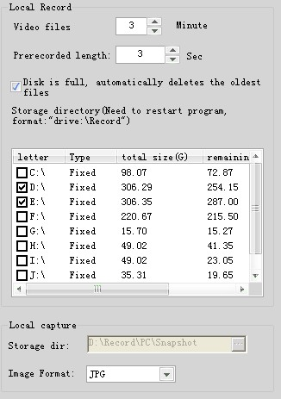
Description:
A camera when the channel is not being played or did not choose the channel, "Motion Detection" option is not optional.
Sensitivity: to raise or lower the sensitivity of the detection box image change. The higher the sensitivity, when subtle screen changes detection box will generate an alarm. Conversely, the lower, you need the big picture changes.
2.6 client alarm settings
Our monitoring software, in addition to the support of the motion detection alarm, also supports an external alarm device to trigger the alarm, such as infrared alarm transmitters, when the external alarm device is triggered alarm monitoring software can capture video.
The setup steps are as follows:
Step 1: Turn on the camera board-side motion detection alarm function:
, Select the camera to be set in the main preview interface, click the "Device Settings" in the toolbar to bring up the Device Settings window, select the "alarm" the board-side motion detection alarm settings. Check the "open the alarm function.
Step 2: Turn the alarm function of the client software
In the "control panel" interface to select "System Settings" -> "Client alarm set"

Check the "Open the alarm function, select the motion detection occurs after the action, and to select the length of recording time.
Capture the action:
Refers to when an external alarm device is triggered alarm monitoring software to capture the action taken, there are four options
None: refers to an external alarm device triggers an alarm, do not take any action.
Capture: refers to the external alarm device triggers an alarm, picture capture to monitor the computer above the local capture image save path set in the "Control Panel" -> "Video Management".
Capture and sent-mail: Reference 6.2 of this document, the motion detection alarm uploaded to the mailbox.
Capture and sent to the FTP server: Reference in this document 6.3 "motion detection alarm uploaded to either an FTP.
Video action:
Refers to an external alarm device when an alarm is triggered, the monitoring software to take video action, there are three options
None: When an external alarm device to trigger the alarm, do not take any action.
Video: refers to trigger an alarm when an external alarm device. The video will be saved to monitor the computer above, set the video to save the path in the "Control Panel" -> "Video Management".
The video concurrency sent to the FTP server: Reference in this document 6.3 "motion detection alarm uploaded to either an FTP.
* Note: video capture are client-based, video and pictures are stored in the monitor computer above.
2.7 video playback
"Control panel" interface to select "video playback", the pop-up video playback player:


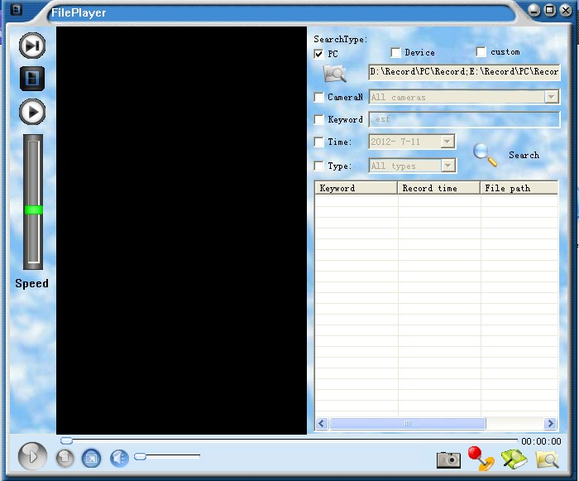
Open video files: open the specified video file for playback.
Search for files: video file search.
Can customize the search, such as by time search, search by channel, each channel corresponding to the IP address of a video camera
Capture: capture the video file screen.
 Playback controls: Control playback speed, and frame by frame playback, key-frame playback.
 Frame by frame playback.
Only play a key frame.
 Normal playback.
 Video playback speed control. Up drag for quick playback of up to X16 times the speed down to the slowest 1/8 of playback speed. Fast playback, video files, or a playback on the player over.
2.8 right-click menu
2.8.1 select the camera list IPCAM, right-click the camera to do the following
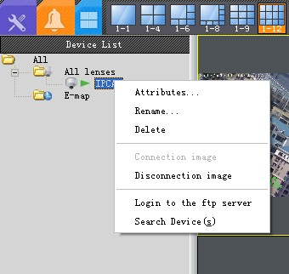
1 Properties
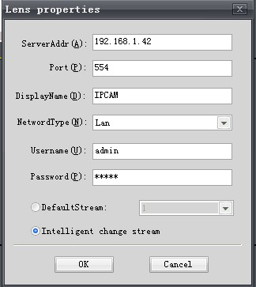
This option can be added to the camera's IP address and port number.
Network Type: If it is within the network, choose the LAN, if the Internet, we chose the Internet.
The default stream: select the default stream can choose to watch the stream 1 or stream 2.
Intelligent stream best player: (SD HD auto switching):
Select the function can be achieved SD HD automatically switch to explain in detail as follows (Note: a large stream refers to the stream a small stream that stream 2):
(1) when only stream 1, stream 2 Disconnect the viewing stream, the background video is stream.
Monitoring software, the default stream is open, the stream must be two open you can use the dual-stream. Way open stream: "Device Settings" -> "audio" page, the current stream to select stream 2, and check to enable the stream, as shown below:
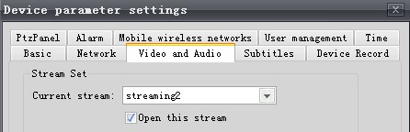
(2) enable dual-stream, regardless of what stream to watch the background all the stream video.
An example (if it is one million high-definition camera):
The current screen is 36 screen, CIF resolution of the small stream to watch, to watch the way the screen, then double-click on this picture will be full-screen display, and 1 million or 2 million of the stream resolution display. Here you can automatically switch of the SD to HD.
Advantages:
Save computer CPU resources, when viewing a computer can watch more cameras, background video, still high-definition effect.
Description: The default is to choose the intelligent selection of the stream for optimal playback, camera settings here only for the current set is valid. Other cameras need to be set.
Rename: modify the camera display name, such as floors, floor two.
Delete: delete the camera from the channel.
4, connect the image: to play the camcorder, playback status is unavailable.
Disconnected images: disconnect the player disconnected unavailable.
6, log on to the FTP equipment: log on to the camera FTP and camera SD card to operate, such as view, download videos and pictures of the SD card, SD card path, there are two folders, a record store the local video file a snapshot, for the store to capture the image file.

2.8.2 select the "lens", right click the device tree:
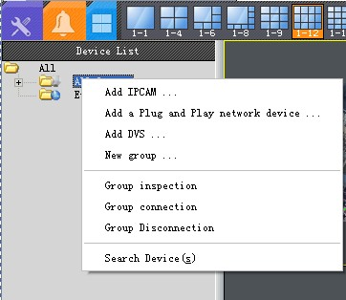
Add IPCAM: manually add a camera.
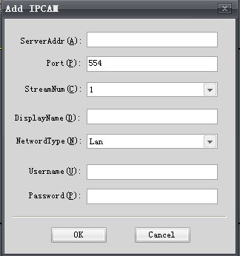
2, add the plug-and-play network device: directly by adding a plug and play machine, enter the user name and password of your application to the top of the plug-and-play Web site, the Plug and Play user the following cameras will be added to it all.
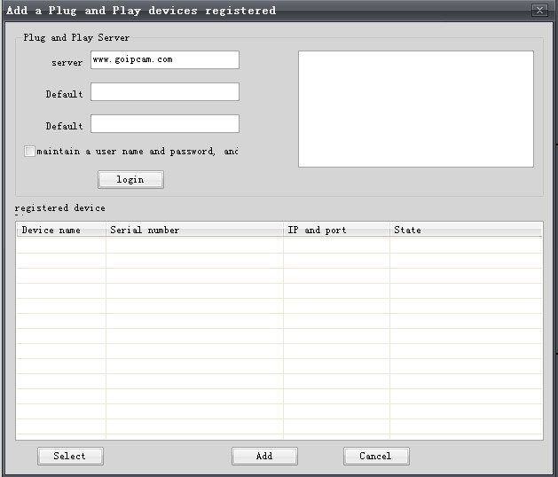
3, add the DVS. (The current version is not yet support the addition of DVS).
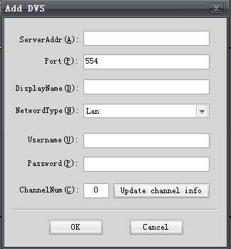
4.The four new groups: the camera by group. The camera can drag it to the new grouping.
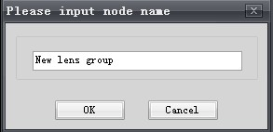
5, group visits: select your camera grouping, click on visits, group visits time, "Control Panel" -> "System Settings" -> "basic" -> "patrol switch length.
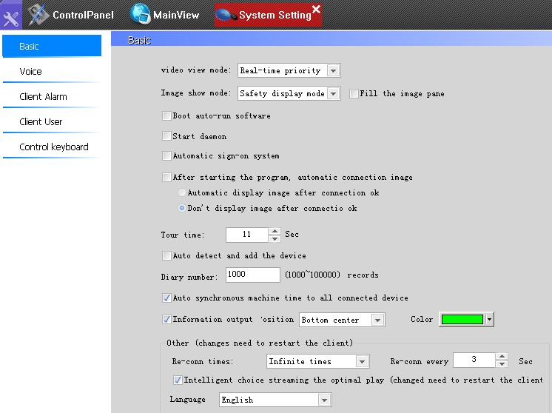
* Note: The patrol inspections are carried out in accordance with the current display large ones. If the number of cameras in the list of current camera is less than or equal to the current display large ones, you do not see the patrol effect. For example: the current display 4 screen viewing, the number of cameras in the camera list is less than or equal to 4, you can not see the patrol effect, able to see more than 4.

2.8.3 In the current playback screen right-click:
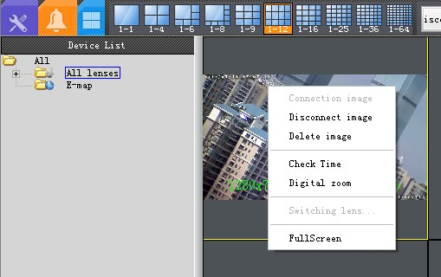
1, the digital zoom:
Right-point play in the current screen, select the "digital zoom", you can open the digital zoom function, scroll your mouse wheel to zoom.
Click the right mouse button again, select the "digital zoom", you can cancel the digital zoom function. Video playback, digital amplification.
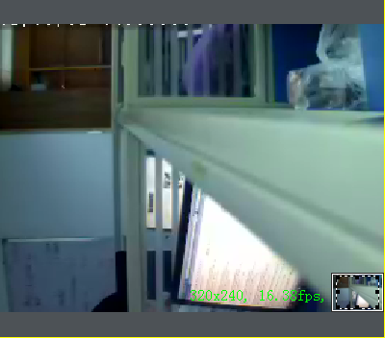
2, full-screen display:
The first method: Right click at any point in the playback screen, select "full screen", the picture full screen display. Right-click again, select "Exit Full Screen", then exit the full screen.
The second method: click on the toolbar, full-screen display, full screen display of the screen. Any point in the playback screen, click the right mouse button, select "Exit Full Screen", then exit the full screen.
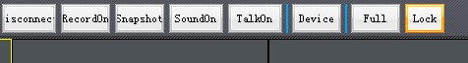
2.9 System Settings

In the "control panel" interface to select "System Settings" pop-up system settings interface, system settings can be carried out.
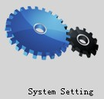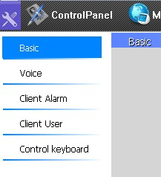
Basic
A video browsing mode:
Priority smooth --- increase the video buffer time, to ensure smooth video, but there will be some delay.
Priority real-time --- to reduce the video buffer time, guarantee real-time video, but the card screen.
2, the image display mode:
Safe display mode --- no independent display card case.
Accelerated priority mode --- independent display card case.
The images fill the pane: ignore the image of the original resolution, full screen video channel.
3, break automatically reconnect times, reconnect interval.
4, you can set the computer is turned on, automatically run and automatically log monitoring software.
5, the program starts automatically connect to the image:
This feature is usually with the four functions use
6, inspect the switch length: Set the grouping patrol time interval length
7, add automatic detection equipment:
Check this new equipment will be automatically added to it, but to double-click the new equipment or dragging equipment to the broadcast channel in order to play. Not designed as an add on the playback camera because, automatically added into the device when the camera a lot, to play, it is likely to cause computer crashes, this is according to customers' needs before they play.
8, all connected devices automatically synchronize this downtime:
When the camera to display an incorrect time, check this feature, the time of the camera and monitor computer time synchronization.
9, the information output: the output displayed in real-time image resolution, bit rate, frame rate.
10, the language switch: to select the language you want to switch, click Save, and then restart the client software language to switch.

Sound
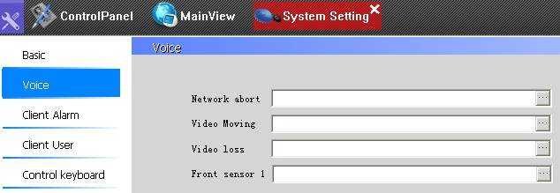
Click Custom alarm sound at the time of the occurrence of the various states.
client alarm settings
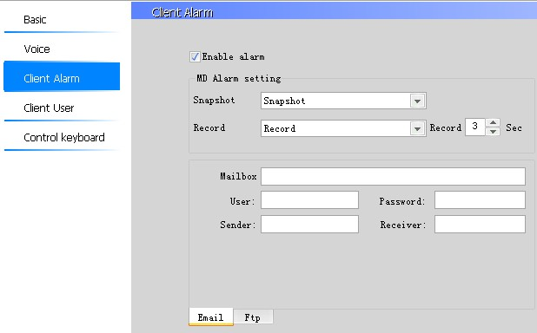
1, open the alarm function: you want the client to execute a mobile alarm action, this option must be checked.
2, snap action: trigger motion detection, capture-related actions:
Capture: when motion detection is triggered to capture images to the computer above its capture path is set in the recording / playback
Capture and sent-mail: trigger motion detection, capture images to the mailbox. See this document 6.2 "motion detection alarm to send an e-mail.
Capture and upload to the FTP server: trigger motion detection to capture pictures to an FTP server. See 6.3 of this document, motion detection alarm is sent to the FTP ".
Video action: trigger motion detection, video-related actions:
Video: motion detection trigger video to the computer above the video path set in the "Video Management, client-side motion detection recording the maximum time is 300 seconds.
Video and upload to the FTP server: when the motion detection is triggered, the video uploaded to the FTP server. See 6.3 of this document, motion detection alarm is sent to the FTP ".
Description:
As the video there are many types of motion detection recording, external alarm recording, scheduled recording, manual recording, client recording, front camera video and so on, in order not behind the confusion, please refer to 5.2 of the manual record type

■ client user management
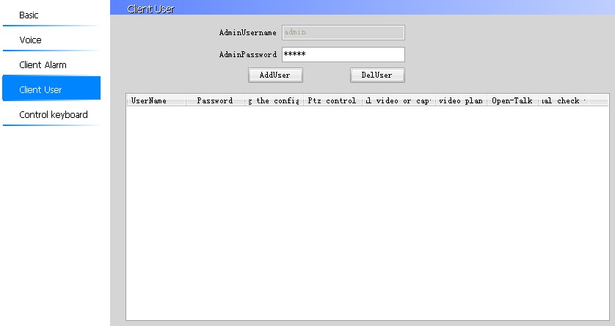
Click on the "Add User"
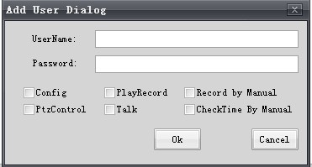
Where the user permissions for the client software, open the client software the user the appropriate permissions to the client, such as whether to allow the user to all cameras, video playback or voice intercom function, given the relevant permissions After all the cameras to take effect.

■ control the keyboard settings
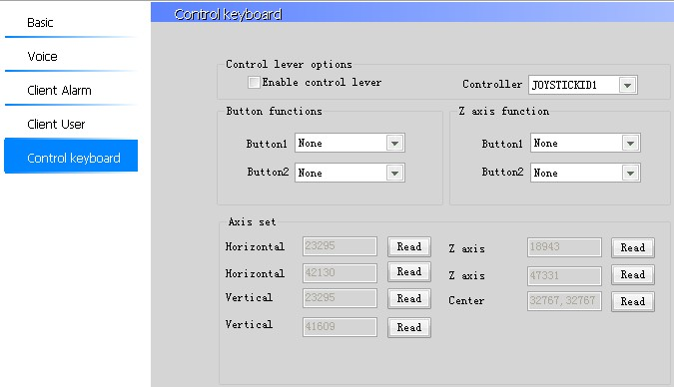
Support the function of the expansion of the use of USB controller keyboard to operate the ball machine.

2.10 device settings
The following settings are based on the front of the camera, and set the camera role in IE, to do so is a user-friendly operation. Select the camera you need to set up a video camera set up: "Preview" and then select the "Device Settings" of the tool bar to bring up the Device Settings window.
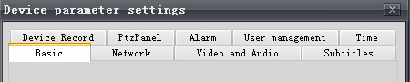
Basic
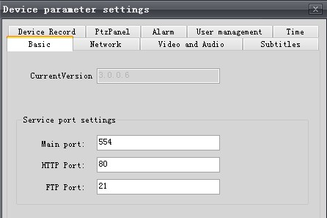
1, the main server port: camera data transfer port, default is 554, use the search tool to search for the primary port is the port.
HTTP port: port number of the camera IE is using IE to access the camera using the port number, use the search tool to search, display the HTTP port is the port.
FTP port: default 21

■ Network
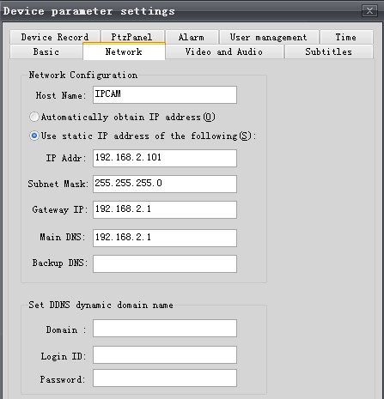
1 Host Name: the camera's display name

2, to obtain an IP address automatically:
This feature is not recommended, obtain an IP address, many customers can not find which cameras, it is recommended to use a static IP address.
3, use the following static IP address:
And computer IP address in the same network segment, if you want to modify the camera's IP address, it is recommended that in the search tool. IP address changed successfully, have the message in the search tool. See 6.5 of the document search software instructions. If you are not familiar to the network, then please see this document 6.1 network basic knowledge introduced ".
4 Dynamic DNS DDNS settings:
RMON, which is equivalent to set the camera's DDNS, see 6.7 of this document "Remote Access" in IE.

■ as the audio
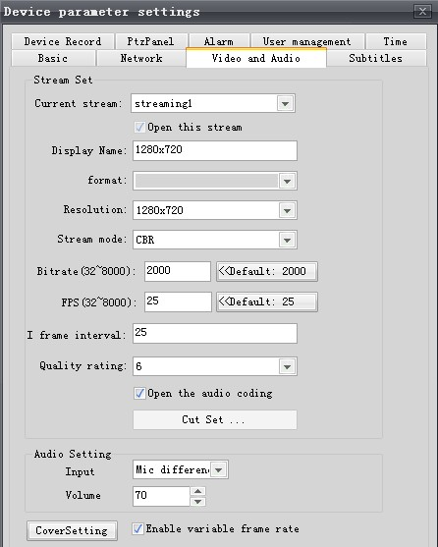
1, the current stream: Here is the set stream 1, stream 2, is not a stream switching, the user should pay attention to the settings here. Stream switch: Double-click the currently playing screen.
2 Display Name: temporarily useless.
3, standard: adjustable camera format CCD camera points PAL and NTSC, CMOS millions of cameras, only the PAL system.
4, Resolution: change the current resolution of the camera.
CCD resolution of QCIF and CIF, 2CIF, 4CIF;
Resolution of CMOS million CIF, 4CIF, 1.0MEGA, 2.0MEGA; (1.0MEGA refers to a million, 2 million 2.0MEGA refers)
Description:
If your camera plate side of the version number of 2.3.0.0 below, the resolution here to tune not a solution: fine in IE, go directly to the inside of the client software, you can.
5, the stream mode: sub-variable stream and a constant stream
Change stream: When the camera screen, moving objects came from, the stream will automatically lower down the screen, moving objects for a long time, the stream will automatically rise, and the result is basically the same, it is recommended to use a variable stream, you can save network bandwidth external network monitoring.
: Regardless of the screen, moving objects, the number of stream constant, a constant stream.
Rate: that limit the camera stream.
4CIF, and, 1.0MEGA when 2.0MEGA, maximum support 8000 (and some camera version is 4000), the greater the bit rate, the effect is more clear, but the video only with the hard disk space, the greater the Judgment based on our experience, when the camera is 4CIF can tune into 1500 when the camcorder is 1.0MEGA 3000 to the 2.0MEGA, tune into. When the largest stream of the camera is transferred to the 1500 mode to change stream, the stream will not exceed 1500 kbps
7, the frame rate:
For the CCD camera, PAL system for all resolutions up to 25, NTSC Resolution 30; the CMOS millions of cameras, PAL system, up to 2 million 15 1 million and 4CIF, CIF highest are 25
8, I frame interval: keyframe interval, the shorter the time, the shorter the time interval between key frames, image Delay smaller, code rheology. Instead, the key frame interval the longer image delay larger yards rheological small (relatively).
Quality Level: 6 clearest, the most obscure one
10, open the audio coding: open, two-way voice intercom.
11, lens switch settings: This feature is no use
12, the audio settings: input type (Linein: linear input, commonly used in the active voice for front-end input; MIC: microphone input, headset, microphone input), the volume gain (you can set the output volume, range 0-100);

■ subtitles
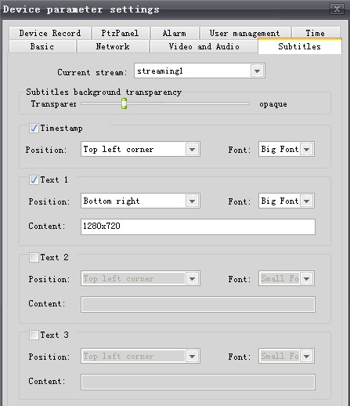
On the channel definition file and the time display, the OSD character overlay function.

■ head
Camera pan and tilt settings for the ball machine
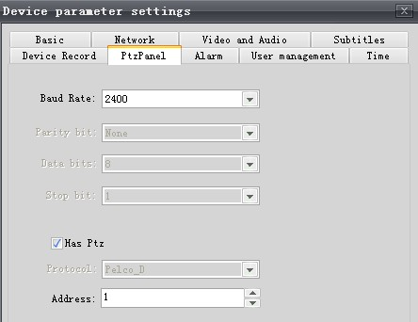
Our camera default values ​​are as follows:
PTZ protocol: PELCO-D, Baud Rate: 2400, address code: 1. The baud rate can be adjusted, and ball machine control panel can be agreed before.

■ front-end video
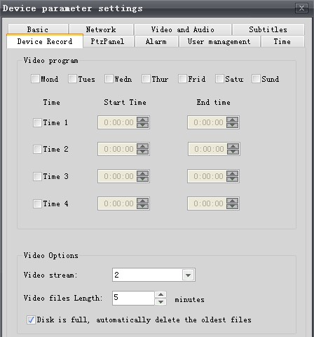
When the camera SD card, you can set the planned recording, such as by week, day video. Stream 1 or 2 video stream, such as when I watched the stream (SD) video-stream 1 (HD). Front-end video are recorded on the SD card above is not recorded in the computer above, due to the limited space of the SD card, recorded in the SD card above information will be constantly on the ground reached the monitoring center computer. Video type, see this manual What are the 5.2 video type.

■ Alarm
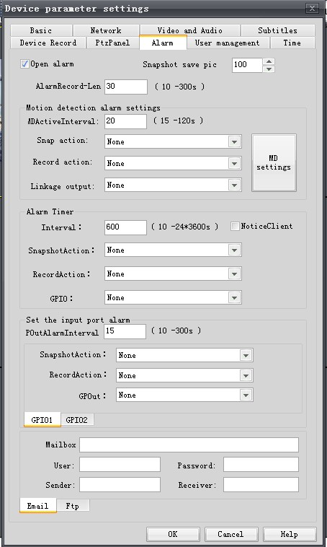
When the camera SD card, camera alarm action settings. Video are recorded on the SD card above, is not recorded in the computer above, due to the limited space of the SD card, recorded in the SD card above information will be constantly on the ground reached the monitoring center computer. See this document 6.4 SD card using the File Description ".

■ User Management
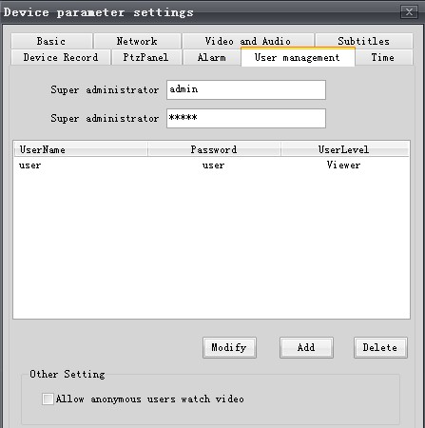
Set the login to the user name and authority of the camera, not landing the user name of the client software. Please distinguish.
Supports three user rights management, the super administrator has the highest authority, can perform all operations of the camera; the operator can watch the video, and can also modify the configuration of the inside, such as resolution, etc., but two can not, one can not add / delete users, but can modify their own password, and second, the camera can not restore the factory settings; observers can only watch, in addition to any right
Allow anonymous users to watch video:
Check the function, the user can make use of the "QuickTime" player to watch videos anonymously.

■ time setting
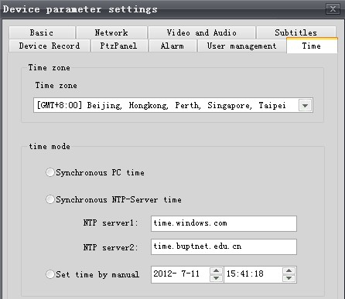
1, the time zone settings: you can set to display the currently selected time zone current time.
2, the synchronization of computer time: check the function, the camera displays the time and computer time synchronization.
Synchronized NTP server time: check the function, the camera displays the time with the NTP server time synchronization.
4, manually set the time: check the function, you can custom set the camera to display the time.
* Note: The effect Click "Save".
2.11 capture
The capture of the toolbar, click the "Preview" interface will be able to achieve capture.
Real-time capture, path settings and save the format under "Control Panel" → video:
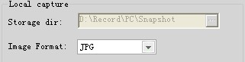

2.12 The local video
Selected in the "Preview" interface to the video channel, click on the toolbar to start recording, the recording function of the channel can be achieved.
In the inside of the "Control Panel" → video, you can set the recording path, recording the length of time:
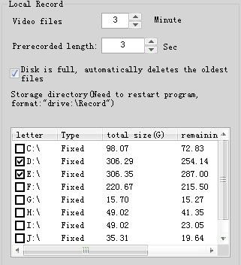
Note: After setting the file length packaged, video pre-recorded length to restart the client software to take effect.

2.13 electronic map

"Electronic map" of the left side of the device tree node click the right mouse button pop-up menu, select New Map prompted to add the BMP format map file is complete, double-click the new map node, the new map will be displayed in the bottom right corner of the screen, as shown :
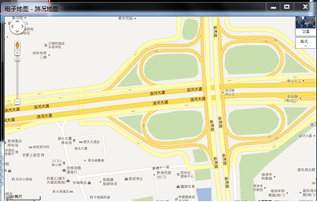
Right click on the new map, the pop-up menu, select Edit Map "on the map, then drag and drop the camera in the device tree node, release the mouse to see a camera icon. Such as: Mouse to put the camera icon on its associated camera information, Such as: 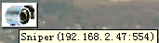 Right to see its properties, as shown below:
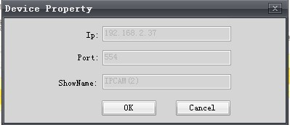
Double-click the icon to open the camera images to watch when the camera when the alarm icon will flash on the map, as shown in Figure:
Note: double-click the map will add full-screen display.

2.14 esf format transfer avi

In the "Control Panel" -> the esf turn avi ":


You can convert video file format. Can only be converted into avi format.
Here are the steps: Add "-> -> Click" Output directory "->" Convert "need to convert video format files.

2.15 local records query

"Control Panel" -> "local records query", the interface as shown below:


Modify the boot record of inquiries, photo cameras, historical and alarm recording, motion detection or external alarm devices to trigger the alarm, video or capture. View alarm video capture pictures.

Column in the video file path, double-click the alarm recording path you want to view live video can be played when the alarm.
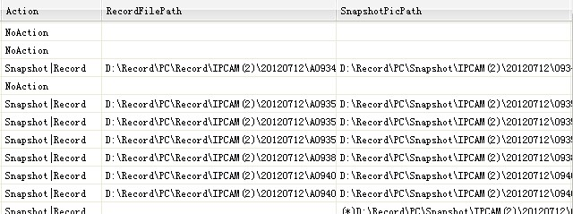

Capture the image path column, double-click to view captured images path to view the pictures of the scene when the alarm.

2.16 alarm file upload management

Click on the Control Panel → alarm file upload management
In the client software, motion detection alarm / external alarm upload to FTP or E-mail, use this feature. Can check whether a file is being uploaded to an FTP or E-mail.
2.17 masking block set
Turn on the camcorder masking block set functions:
"Preview" interface, select the desired channel camera, set the masking block set device settings click on the toolbar → video and audio, click on
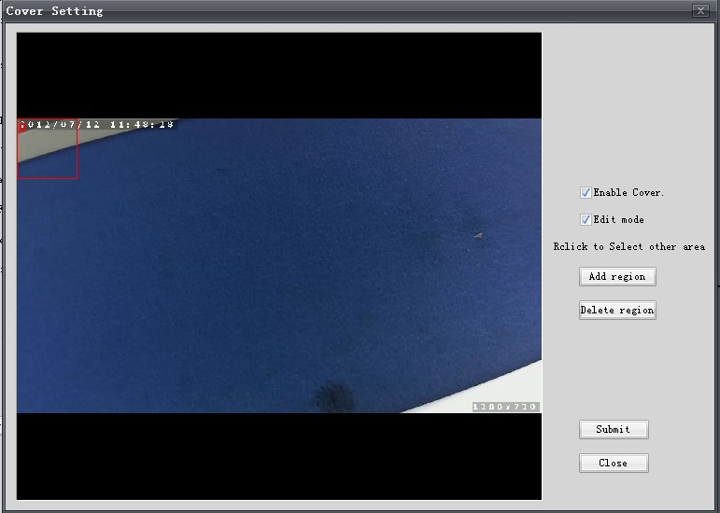
Check the "Allow the masking block, area edit mode, simply click the" add a new area "shelter box, draw the image you want to shelter locations, the first frame is 0, then if you want to add shelter box Click to add a new area, then the second box, you want to add and so on, can add up to five hidden areas. "Delete the current zone will be set up before the shelter box one by one to delete. After setting and then click "Submit". As shown below:
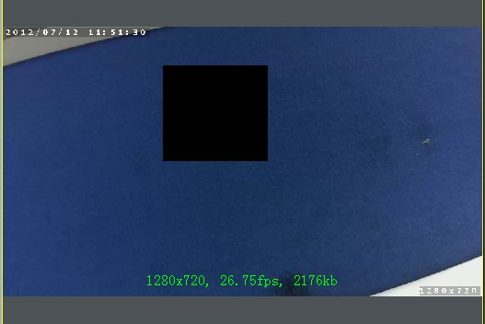
2.18 lock screen

Click on the "lock screen" toolbar interface in the "Preview screen will be locked.
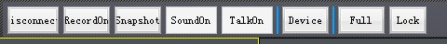
Want to further action will pop up a prompt window (see below), you must authenticate to unlock.
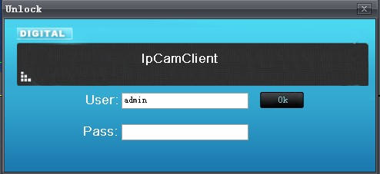
3 additional features of the client software

3.1 Control keyboard settings

"Control Panel" -> "System Settings" -> "Control keyboard settings, the following picture shows the control keypad to set the interface:
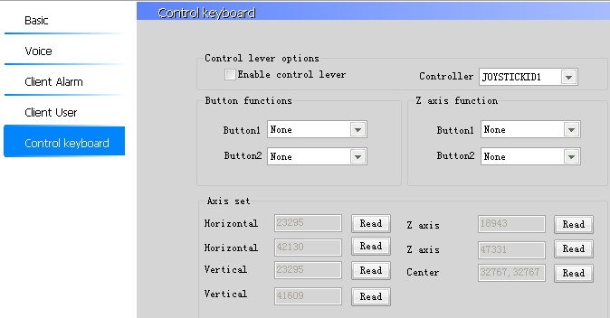
The expansion of the ball machine using the USB control keyboard support functions.
4 Use Notes
User operating the client may be due to the input data does not match the requirements of the operation is not standardized, the software may make mistakes, including the following aspects and precautions:
1, during the operation to start playing all channels or stop playing all channels, if the camera a lot, connect the camcorder takes time, so please be patient connection after their operation, to prevent errors;
2, the software platform PC CPU utilization reached 100%, you may display frame rate is abnormal, the software runs also abnormal, so please limit the management cameras, according to the platform PC configuration to ensure that the CPU utilization does not exceed 85%;
3, an automatic search for add camera functionality must have a network connection can use, make sure the network connection;
4, the timer recording program with alarm recording scheme can not be carried out;
5, save the camera option is set, the board-side restart takes time, so please be patient;
5 Frequently Asked Questions

5.1 client software how to achieve two-way voice intercom

A: The principle: camera → computer:
The front-end video camera connected headphones or pickup, complete voice input, sound transmission through the network cable to the computer monitor screen, complete the sound output through the computer audio.
Computer → camera:
The computer above the microphone (or headphones) connected to the computer to complete the voice input, sound transmission through the network cable to the front of the camera, complete the sound output through the headphone speakers or speakers of the camera above.
Note:
Before carrying out two-way voice intercom test, we must first ensure that the headset (including microphone of the headset above) or pickup is good, the computer's sound card and sound card driver is installed correctly. Hardware and software settings to be checked.
In the client software, cameras to 192.168.1.136, for example:
(1) in the client software, open the sound of the camera, concrete steps are:
Device Settings → video and audio stream 1, stream 2 open audio coding, in the "Audio Settings" option, select the Voice input type: linein mic differential, mic mono volume gain on behalf of the volume size: 100 Max. , 0 min. As shown below:
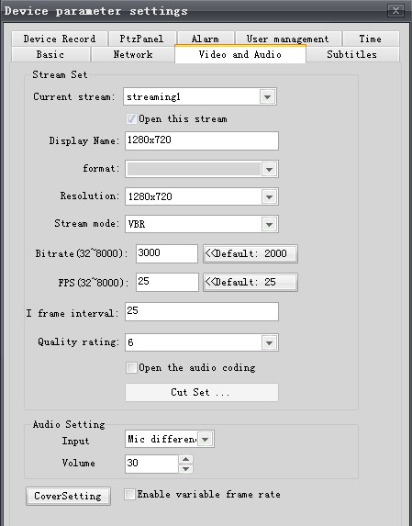
Description:
If there is noise, volume gain of the image above transfer of small, such as 30.
Otherwise indicated, the camera sound is not treated, the front-end monitoring center / camera to capture any sound, what kind of sound to the camera / monitoring center, if it sounds noises are generally environmental noise, such as monitoring center to access the microphone into the microphone inside the sound, are the ambient noise, if the microphone is replaced with the headset to test, you will find the noise basic reason is that the microphone inside the sound too much, all noise and network cameras are not related.

Client monitor screen software, intercom and sound functions to open, as shown below:
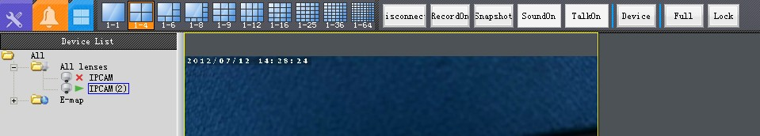
Then connected to the headset.
3 Right-click the computer's volume control Open Volume Mixer to adjust the volume of the client software into the largest

Note:
If the current screen, a number of road cameras, such as 3-way in the following figure, if the 3-way two-way voice all the open front of the camera can be heard, then spoke of the monitoring center, and how to achieve one-to-one intercom function is in the monitoring center, to speak in front a road camera, 2-way camera to hear, as follows:
Camera two-way voice 1 channel to open, two-way voice of another 3-way camera off, you can, you need to which the road which road
5.2 A total of which video type
A: The video in general, divided into two categories: front-end video (recorded in the camera SD card) and client-side video (recorded on the computer hard drive)
Front-end video motion detection, external alarm recording, the recording of the plan, are set in IE, are recorded on the SD card above, specifically how to use, see this document 6.4 SD card file description. In IE Settings -> Video Settings, you can set the front-end video programs. Because of the limited capacity of the SD card, the front end all the video, each finish recording some will automatically upload to monitor the computer's hard drive.
Client video motion detection recording, external alarm device recording, scheduled recording, manual recording, the specific differences and use occasions as follows:
Motion detection video: screen detected moving objects, video on the computer above, see 2.5 of this manual motion detection settings.
External alarm equipment, video monitoring software to start recording: refers to an external alarm device to trigger the alarm when 2.6 client, see this manual alarm settings.
Plan video: You can do daily / weekly scheduled recording, in a future point in time, time recording, see 2.12 of this manual local video.
Manual recording: usually not recorded, according to need when recorded.
The path of the above four videos in the "Control Panel" -> "Video Management" settings.
Note 1:
(Video letter): \ record below, there are two file folders, a folder in the Device, the video data which is passed over from the front, another file folder is PC, which is the video information of the client computer.
Note 2:
From the above description, we can see that the front end and the client can set up motion detection, scheduled recording, the difference is:
The front-end video settings in IE, the video is saved in the top of the SD card, client video is set in the client software which video is stored in the monitor computer.
Note 3:
If the camera does not have a SD card, the front-end motion detection and scheduled recording function is not valid.

5.3 screen color ribbon
As shown below:
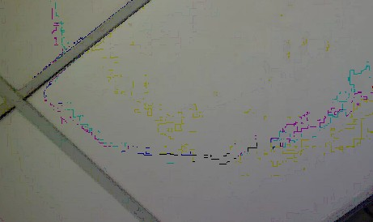
A: in the system settings, modify the graphics display mode, as shown below:
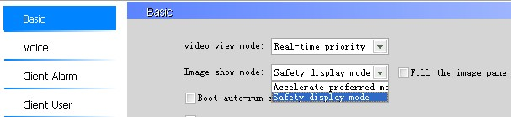
5.4 DVR space calculation

The larger the stream, video, temporary hard disk space is greater

(1) when the CIF resolution, accounting for about 512kbps:

Per second, accounting for 0.5Mb bandwidth per hour, accounting for 0.5Mb * 3600 = 1800Mb = 225MB (B on behalf of bytes, b represents a bit 1B = 8b)
(2) When the resolution of 4CIF, about 1M ~ 2Mbps, below 1M calculation
Accounted for 1Mb bandwidth per second per hour accounted for 1Mb * 3600 = 3600Mb = 450MB (B on behalf of bytes, b represents a bit 1B = 8b)
(3) When a resolution of 1 million, accounting for about 2M ~ 3Mbps, the following calculation according to the 2M
Per second, accounting for the 2Mb bandwidth per hour, accounting for 2Mb * 3600 = 7200Mb = 900MB = 0.9GB (B on behalf of bytes, b represents a bit 1B = 8b)
(4) When a resolution of 2 million, accounting for about 3M ~ 4Mbps, the following calculation according to 4M
Accounted for 4Mb bandwidth per second, per hour, accounting for the 4Mb * 3600 = 14400Mb = 1800MB = 1.8GB (B on behalf of bytes, b represents a bit 1B = 8b)
Requirements recorded 1 million effect if the 10-way high-definition camera, video kept for 15 days, then the video space is needed:
0.9GB * 24 hours * 15 days * 10 Lu = 3240GB = 3.24TB
Note:
The above calculation is approximate space because of the complexity of the screen occupied bandwidth and screen, how many have a relationship of moving objects, moving objects in the screen the less, the smaller stream, the more moving objects in the picture the greater the Code flow greater, not an absolute standard
If the high-definition cameras and more, also requested the video to save a long time, it is recommended to use the motion detection recording, screen, a moving object appears, start recording, does not move, you can not record.

5.5 How do I exit full-screen viewing mode
A: When the full screen view, press ESC to exit full screen mode.
5.6 How do I set the boot automatically connect the image, automatic video
A: automatically connect image: System Settings -> General, check the following functions, you can boot automatically connect image:
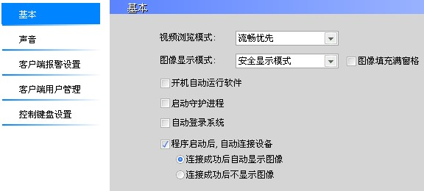
Automatic recording: In the Control Panel -> video management, set up a local video plans, set every day, recording such power, it will automatically recording.
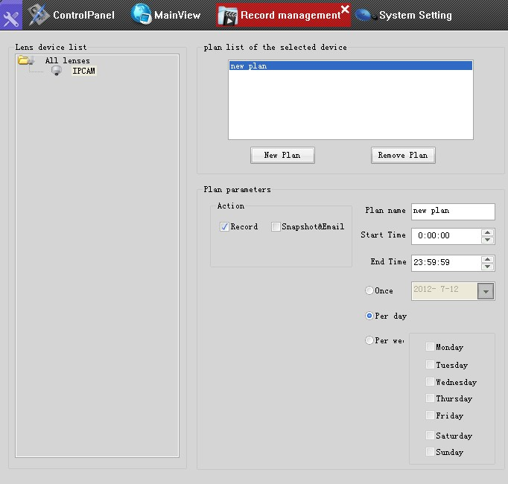
5.7 What is the difference above client software users and user of the camera above

A: The two are not the same, above the user of the client software used to log the client software to the user permissions, enter into force for all cameras. As shown below. In which the monitoring software, system settings -> client user management inside, you can modify the administrator password, you can add users and give the appropriate permissions, you can delete the user.
Camera above the user is used to log on to the camera, a video camera to take effect, such as IE to log on to the camera, enter your user name password sector, as shown below. Using IE to visit our cameras, point to Settings -> User can add or remove users, the total number of new users over 10.
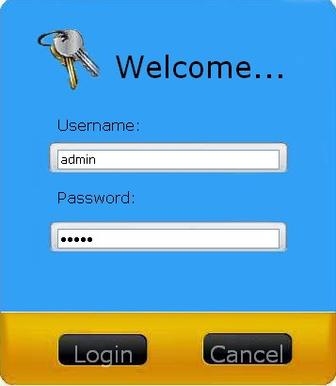
5.8 when the access of multiple camera monitoring software often get stuck or interface does not respond to how to do
A: Firstly, to ensure that computer hardware and software compatibility is better, that is, when our software is not running, the system open other software must be very smooth and do not card, be sure to install the recommended computer configuration with See this document 1.2 operating environment requirements.
Second, we must ensure that the structures of network cabling is no problem if the front of the camera's IP address is 192.168.1.128, use the following command ping 192.168.1.128-l 800-t, to ensure that all front-end camera time to return value <1 ms - l, l is a lowercase L, on behalf of the size of the packet-representatives have the ping time return value in more than a few ms, indicating that the network cabling is a problem, of course, in our monitoring screen card .
Exclude the above reasons, if the picture card, do the following checks:
A computer CPU utilization can not exceed 60%, if exceeded, with dual-stream software to watch.
Enable dual-stream: how to enable the dual-stream viewing detailed in this document 5.9 client software.
If your computer CPU and graphics card configuration is high, your computer hardware acceleration, as follows:
Computer start menu run type dxdiag, and click the "Show all choose to enable Directx function.
3 If your computer was previously installed an older version of client software, the hardware of the camera is the latest, there will be such a problem, please uninstall the old software before, and then registered under the master clean-up windows optimization table inside information, and then install the latest client software.
Note: must use Windows to optimize the registry inside the master clean-up, otherwise, the old software information left in the registry inside the old program is still running, will go wrong.

5.9 client software, how to enable dual-stream to watch
A: The point system is set in the monitoring software -> basic, "whether the intelligent selection of stream for optimal playback" check can be achieved SD HD automatically switch this feature is turned on by default, the software factory, explained in detail below (Note: large stream to the stream, a small stream the stream 2):
(1) When only the stream 1:00 to watch, stream 1, the background video in stream 1.
Monitoring software, the default stream is open, the stream must be two open you can use the dual-stream. Way open stream: "Device Settings" -> "audio" page, the current stream selected stream 2, and check to enable the stream, as shown below:
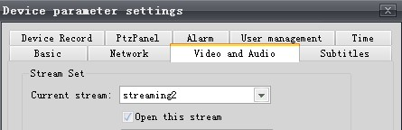
(2) enable dual-stream, regardless of what stream to watch the background all the stream video. This is software which has been fixed, the customer change.
An example (if it is one million high-definition camera):
Current screen 36 screen, to see a small stream in CIF resolution, I now want to watch the way the screen, then double-click on this picture will be full-screen display, and to distinguish stream of 1 million or 2 million rate display. Here you can automatically switch of the SD to HD.
Advantages:
Save computer CPU resources, when viewing a computer can watch more cameras, background video, still high-definition effect.

5.10 video playback when the bad is what

A: Yes were recording the reasons, in order to allow a computer to be able to see more cameras, our software supports dual-stream function with a small stream, a stream 1 (stream), a stream 2 (small stream). When the small window screen display with a small stream, double-click all the way to the screen, single-screen large-screen display large stream. For the video, whether it is manual recording, local program video, or motion detection recording, be sure to check the "System Settings" -> "basic" -> "smart stream for optimal playback, only large stream video.
6 Annex
6.1 Network Knowledge Introduction
6.1.1 The basic knowledge about IP addresses
(1) What is the IP address
Now the network, IP addresses into public IP and private IP addresses. The public IP is the IP address, use the Internet and private IP address is used in the LAN IP address.
(2) What is the private IP address
IP address in a class of special, known as private IP addresses. Let's look at the private IP address.
Because we are using IP V4 protocol restrictions, the number of IP addresses is limited. In this way, we can not be resident in each computer in the network assigned a public IP. Therefore, each computer in the LAN can only use private IP addresses, such as our common 192.168.1. * Is a private IP address.
The private IP address is for a reserved IP address. Just use the LAN, the Internet is not in use.
(3) private IP address range:
10.0.0.0 - 10.255.255.255 large networks used in
172.16.0.0-172.31.255.255 medium-sized networks in use
192.168.0.0 - 192.168.255.255 small network used
(4) What is the IP address of the network segment
IP address Sec numbers, such as a computer's IP is, 192.168.2.100, then the 192 is the first paragraph numbers, 168 is the second figure, he is the third paragraph of digital, 100, fourth paragraph of the digital . Our main aim is to see the third paragraph numbers, the third paragraph 2, then the IP address of 192.168.2.100 is the two segments;

Another example is
192.168.0.101 is the IP address of the segment 0
192.168.1.101 IP address of a segment of
192.168.2.101 IP address of two segments
192.168.3.101 IP address of segment
6.1.2 The small and medium-sized network topology and ADSL Internet access
1, small and medium-sized corporate network topology
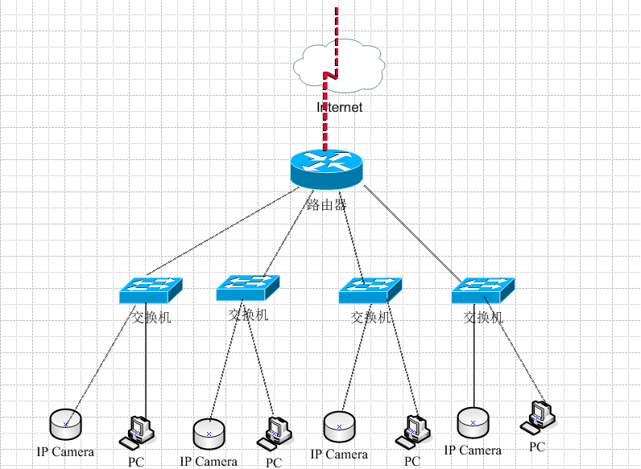
6.1.3 How will we access the camera to the existing network
1, we must first ensure that our camera and monitor computer physically in the same network.
2, each camera has a fixed IP address, with the cable interface through a network cable connected to the switch or router below.
Note:
Simply put, if only, including network viewing, only need to be connected to the switch on it; If you need remote viewing, you need to access the router.
3, modify the IP address of the camera, the camera IP and monitoring computer in the same network segment.
Each camera to the factory default IP address is 192.168.1.128, but the IP address can be modified. If you and your monitoring computer not on the same network segment, such as your network is 192.168.0. * 0 segment of the IP address you need to modify the IP address of the camera, for example, changed to 192.168.0.128, assurance and monitoring The computer in the same segment.
Note: how to modify the camera's IP address, reference 6.5 search software, instructions for use
4, the computer Start menu click Run, type cmd, and then click OK
5.In the figure below, this ping192.168.0.128 camera IP, can ping, can-t represent have been ping
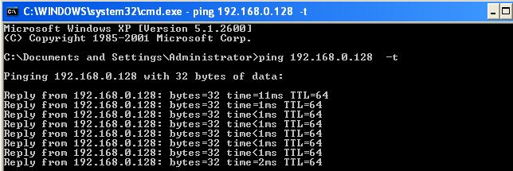
Note:

If you still can not ping, check the network cable and the first crystal, it is recommended to test with the new cable and crystal head. The faster a solution: the computer a static IP address, cameras and computers directly connected, the middle of the cable to use a crossover cable, crossover cable is the cable one is 485A, the other one is 485B, if you are unsure crossover cable how to do so, and went to Computer City to sell the cable, buy a cross bar on it.
6.2 "motion detection alarm and send a message"

In the client software which, when the motion detection alarm, then screen capture down, and be able to send to the mailbox, the functional requirements on the camera board-side version is 2.3.1.0 and above. The setting is as follows:
1, open the camera plate side alarm function:
Click on the toolbar in the main preview interface "Device Settings" → "alarm, check to open the alarm function, this function when the alarm on motion detection or external alarm device to trigger the alarm is valid.
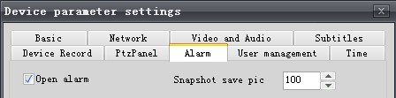
2.Click on the main preview interface toolbar motion detection settings, add one or more of the monitored area.
3, the inside of the client software, the System Settings -> client alarm settings, do the following settings:
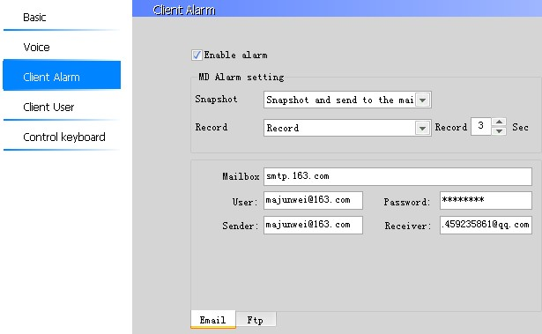
The figure above, assume that the 163 E-mail e-mail, incoming mail with QQ-mail:
E-mail server address: write 163 E-mail address of the sending server, smtp.163.com
E-mail user name: Write the sender mailbox
Password: write Sender E-mail Password
From: to write the sender's Email address majunwei@163.com
Attn: write the recipient's Email address 1459235861@qq.com
1, when the above completely set up correctly, when motion detection is triggered to open the recipient's mailbox, you can see the alarm e-mail messages.
2, open the mailbox, and can view detailed alarm information, and picture downloads.
Attachment:

Common e-mail server name

Mail server | pop3 server address | Smtp server address
Gmail（google.com） | pop.gmail.com | smtp.gmail.com
21cn.com | pop.21cn.com | smtp.21cn.com sina.com
sina.com | pop3.sina.com.cn | smtp.sina.com.cn
tom.com | pop.tom.com | smtp.tom.com
163.com | pop.163.com | smtp.163.com
263.net | pop3.263.net | smtp.263.net
X263.com | pop.x263.net | smtp.x263.net
263.net.cn | pop.263.net.cn | smtp.263.net.cn
elong.com | pop3.elong.com | smtp.elong.com
china.com | pop.china.com | smtp.china.com
sohu.com | pop3.sohu.com | smtp.sohu.com
etang.com | pop.etang.com | smtp.etang.com
yahoo.com | pop.mail.yahoo.com | smtp.mail.yahoo.com
yahoo.com.cn | pop.mail.yahoo.com.cn | smtp.mail.yahoo.com.cn
Mail.qq.com | pop.qq.com | smtp.qq.com
6.3 "motion detection alarm uploaded to the FTP

The client software, motion detection recording, and capture uploaded to the FTP server, the principle described below:
The camera detects a moving object in the picture, the client software will capture images and video Image capture is complete and videos completed, it will be uploaded to an FTP server. Total of the following aspects to be set up before they can achieve this functionality. In addition, the feature requirements on the camera board-side version is 2.3.1.0 and above.
One: to build a good FTP server, set up FTP user rights
(1) above in windows 2003 operating system, Serv-U to build a FTP server.
(2) create a new FTP user, give this user write (upload) and download permissions, and sometimes need to remove permissions, such as the space is full, then upload the video is uploaded to their.
Two: the settings in the client software
An open client software, Device Settings → Alarm → motion detection settings, and add one or more of the area to monitor
Client software which system settings -> client alarm settings, do the following settings:
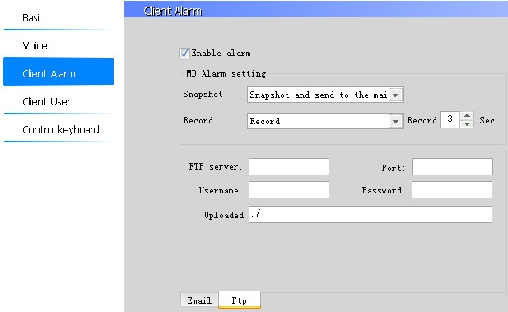
The image above meaning is as follows:
FTP server address: the address of the FTP server, if the public network IP, please write a public IP address
Server port: Default is 21
Login Username: the FTP user name above
Login password: password of the FTP above user name
Uploaded to the directory: Refers to upload to the root directory of the FTP user to the root directory is /
Description:
To connect to the FTP server, monitor computer firewall to be switched off, or FTP port open can. If the FTP over the public network, then the inside of the firewall access rules, you want to allow FTP through can, otherwise, would be rejected by a firewall, the data could not be uploaded to the FTP server above.
: View the photos above capture the FTP
Internet Explorer which login to the FTP server, enter the user name, password
In its root directory, you can see the data upload over
Description:
If the IE which can not be downloaded, delete pictures, use a professional FTP client software, such as cuteftp, connect to the FTP server, so download the delete is very convenient.
If the FTP server above, did not receive the uploaded images or videos, may have the following reasons: FTP whether the user has the appropriate permissions, the following FTP user's space is full, whether the firewall is blocking FTP upload.
6.4 SD card using the File Description

Our camera support motion detection alarm and external alarm input device alarm when the camera detected more than two kinds of alarm signal, video and capture to the top of the SD card to 192.168.1.128 cameras, combined with motion detection to illustrate how to use the (external alarm input device of the alarm and this)
A: Camera settings
With IE to log on to the camera, the "Settings" -> "events" -> "Motion Detection".
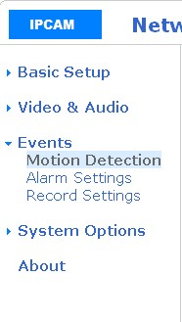
Two. Motion Detection page, set the motion detection area:
First click the Start button, and edit the mobile region, such as the need to set up multiple motion detection areas, and then point increase button, and then the end of the button, check the "open motion detection, and click Save.
Set up, when a moving object in the picture, the motion detection area will blink.
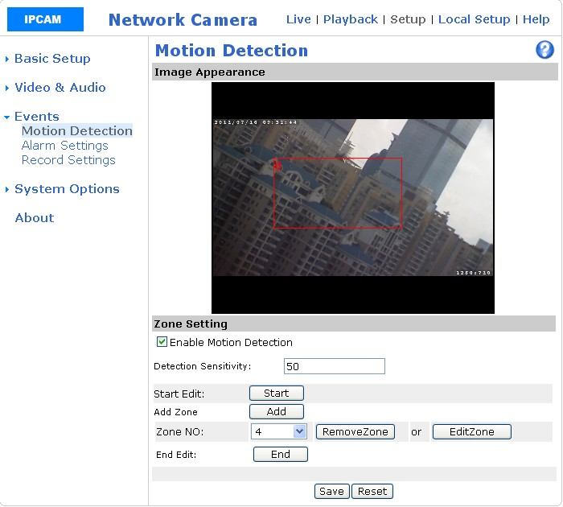
In the "event" -> "Alarm Settings" page, make the following settings, then save
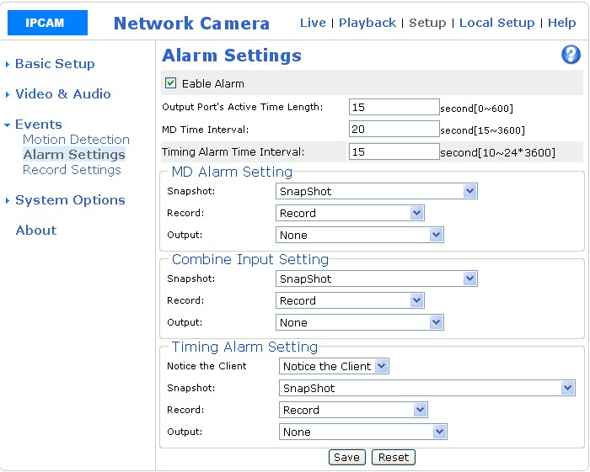
Capture is to capture pictures on the SD card, the video refers to video recorded on SD card.
: How to view the SD card recording data
Two cases, if the camera version 2.3.1.0 and above (in the camera search tool, you can see the camera version number), the front-end SD card above the video and pictures will be automatically uploaded to the monitoring center PC side; If the camera The version is 2.3.0.0 or 2.2.4.1, the front-end SD card above the video and pictures, is not uploaded to the monitoring center PC side, front-end SD card the above information via FTP; camera version 2.2.4.1 below does not support the function of the SD card
(A) version of the camera in 2.3.1.0 and above
General camera video recorded video record file in the root of each drive letter, if recorded in the D: drive by default. Open D: \ record, the following will have two folders, a PC folder, inside the store is a local computer video, and a Device folder, which is stored from the top of the front-end SD card, upload it to the monitoring center videos and pictures, the front-end is a new video and pictures, are immediately uploaded to the monitoring center to
(B) of the camera version is 2.3.0.0 or 2.2.4.1 There are two ways:
The first method is: use IE to open, follow these steps:
(1) in IE, enter ftp://192.168.1.128, the user name admin, password admin
Ftproot / SD path, there are two folders, one for the record, and store a local video file, a snapshot, used to store the image file to capture the both folders there is no need to alarm settings reset, then power to restart the camera, sometimes you want to power outages several times before. At the same time refresh the IE page, just the video picture to come out.
(2) select the file, right can be downloaded to your computer, if the image files, directly watch; if the video file, the client software that comes with the player play. Snapshot folder in the file, delete will prompt an error, because the default which only holds 5 pictures, new pictures, photographed by the motion detection will overwrite the previous picture, equal this image is being used, if we delete will be error, refresh the current page can
The second method is: monitoring client software to open, follow these steps:
Open monitoring software in the camera list, right in front 192.168.1.128 cameras, select the login to the FTP
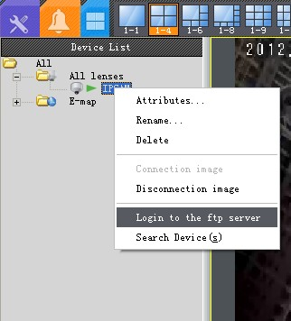
Note: If the FTP login not possible that when you add the camera, the camera's user name, password is not correct (the default user name and password are admin)
2 SD path, there are two folders, one record, store the local video file, a snapshot, used to store the image file to capture the two folders did not come out, you need to alarm settings reset , and then power-off restart the camera, sometimes power outages several times before. At the same time refresh the IE page, just the video picture to come out.
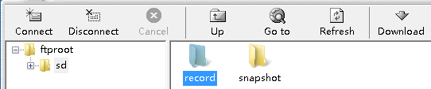
Description: The right front of the FTP title bar point, you can switch the FTP language, as
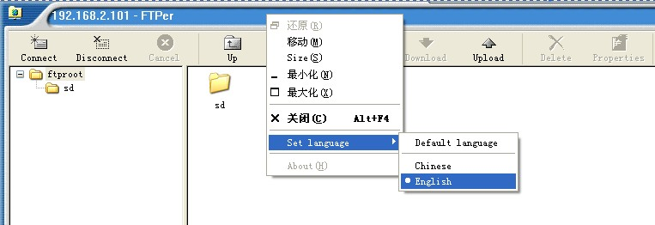
(3) select the file, right-can be downloaded to your computer, image files, directly watch; if the video file using our client software that comes with the player play. Snapshot folder in the file, delete will prompt an error, because the default which only holds 5 pictures, new pictures, photographed by the motion detection will overwrite the previous picture, equal this image is being used, if we delete will be error, refresh the current page can
Description:
A camera support 32GB SD card 32GB SD card has not been tested to support standard SD and high-speed SD card (SDHC) with our camera 4Mb / s write speed, no problem. In addition to the regular SD card manufacturers, such as a modern brand of SD card.
Capture on the SD card 2. Motion detection recording period of 60 seconds, to capture each trigger (moving objects), front-end a new video and pictures will be immediately uploaded to the monitoring center. Will be automatically deleted when the SD card is full, the early videos. Capture the picture above the SD card up to keep only 5, 6 screen over, will cover a picture, and so on.
(3) in IE, the above video to the SD card, the method, there are three:

First, the plan videos recorded on SD card above.
Second, IE inside motion detection recording, recorded on the SD card above, will not be recorded in the computer above, IE inside the motion detection is used with the SD card.
Camera external alarm input devices, alarm recording, is also recorded on the SD card above.
Description:
Usually watch will not be recorded to the SD card above, if you usually watch videos, can be set in IE, see the following four step-by-step instructions in the inside of the client software, the video can also be recorded on the computer above.
In IE settings on the computer video, real-time images in IE -> "Local Settings":
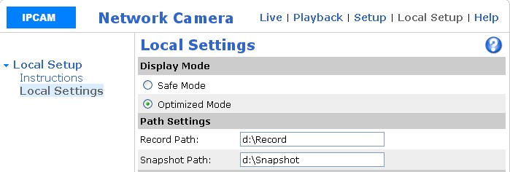
Video path and capture path can be modified.

5.32GB of SD card continuously recorded in a few days
When the CIF resolution, 32GB video about 6 days
When the resolution of 4CIF, 32GB video 3 days
When a resolution of 1 million, 32GB video 1.5 days
Calculated as follows:
When the CIF resolution, accounting for about 512kbps:
Per second, accounting for 0.5Mb bandwidth per hour, accounting for 0.5Mb * 3600 = 1800Mb = 225MB (B on behalf of bytes, b represents a bit 1B = 8b)
When the resolution of 4CIF, about 1M ~ 2Mbps, the following calculation 1M
Accounted for 1Mb bandwidth per second per hour accounted for 1Mb * 3600 = 3600Mb = 450MB (B on behalf of bytes, b represents a bit 1B = 8b)
Resolution of 1 million, accounting for about 2M ~ 3Mbps, the following calculation according to the 2M
Per second, accounting for the 2Mb bandwidth per hour, accounting for 2Mb * 3600 = 7200Mb = 900MB = 0.9GB (B on behalf of bytes, b represents a bit 1B = 8b)
6.5 search software for use "
Search software (DeviceSearch.exe) can search for all cameras in the LAN, can modify the IP address of the camera MAC address modification, display the software version, the player preview operation.
Description:
Put the computer search, turn off the firewall, windows 7, for example, the network icon on your desktop point, right attribute (if your computer desktop Network icon, then the computer the bottom right corner there will be), in the open or close the windows firewall features page , close off the windows firewall can.
A: software start
Double-click on the desktop Shortcut key to run the program
Second: the main interface
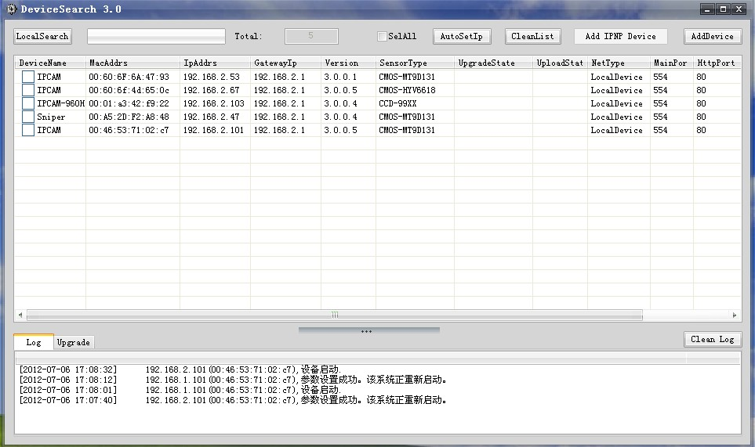
The first open search software, the interface is in English, click the title bar of the search software right set language → Cn, can switch to Chinese interface, En English interface. As shown below:

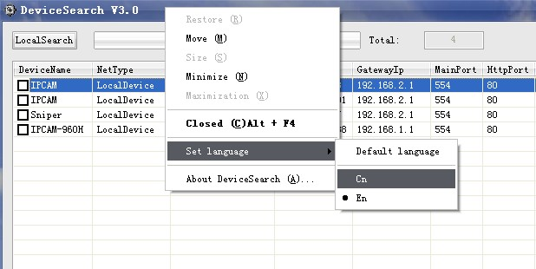
Click To all cameras in the LAN can search, search computer firewall should turn off after a search, a line shows a camera information. The camera's IP address, the default is 192.168.1.128. The camera port number is the number of client access to the camera port, the default is 554, the port number can be modified. HTTP port number is the port number of the camera IE, using IE to access the camera, with the port number, default is 80, the port number can be modified. The version number is the version number of the camera board side.

Third, the software features

3.1 Image Preview

Can preview playback of the camera, the PTZ camera PTZ operation (position and lens zoom), and can switch control on the camcorder two-way voice.

[Achieve] search camera search results are displayed in the regional double-click the camera to preview or click on the selected need to preview the video camera, click the right mouse button, select an image preview in a pop-up menu, as shown below:
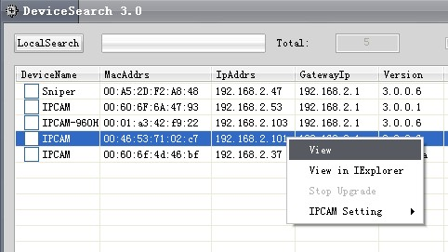
Into the camera preview screen. As shown below:
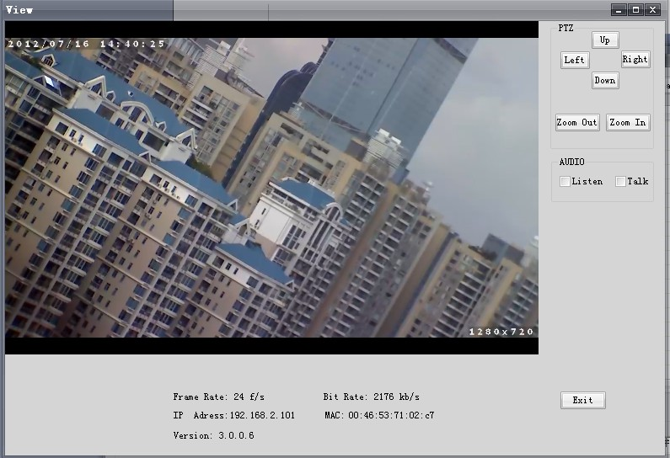
Double-click the picture for full-screen viewing, double-click the screen again to exit full screen or press esc to exit full screen
3.2 Play in IE

Regional click to select the camera needs to be played in IE, right click in the search results are displayed and selected in the pop-up menu, enter your user name and password, click on the "Login" button to enter the main interface (the default user when the camera factory name is admin, password admin) as shown below:
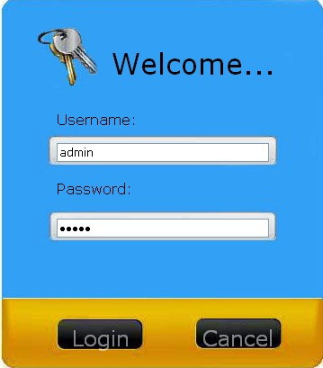
Main interface, as shown below:
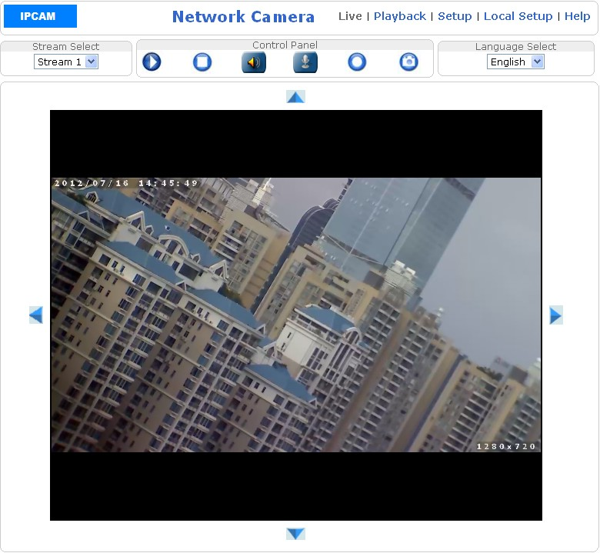
3.3 camera configuration

Can modify the camera's IP address, MAC address, product information, sensor type, functional configuration.
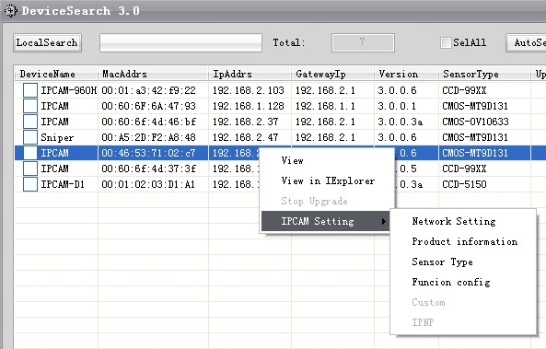
3.3.1 modify the camera's IP address, MAC address

All cameras to the factory default IP address is 192.168.1.128, LAN, multiple cameras, you want to modify the camera's IP address to IP address does not conflict; if the camera and monitor computers not on the same network segment, to modify the camera's IP address and gateways, such as monitoring the computer's IP address is 192.168.2, gateway is 192.168.2.1, then you want to change the camera's IP address as 192.168.2., camera gateway 192.168.2.1. Modify the camera's IP address in two ways:
Method One: regional click on the selected need to modify the camera's IP address, MAC address of the camera, click the right mouse button, pop-up menu, select Camera Configuration → Network Settings, enter the IP address changes, the MAC address of interface in the search results. As shown below:
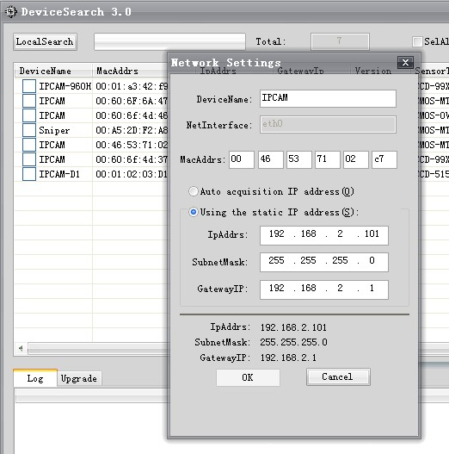
MAC address by the numbers 0-9, letters a-f, 12, divided into six groups, of which the first group must be composed by 00. As shown below:
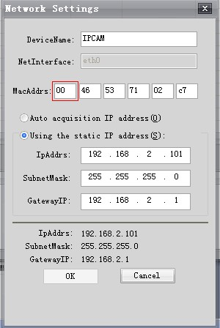
Methods: the search results display the region check the need to modify the IP address of the camera
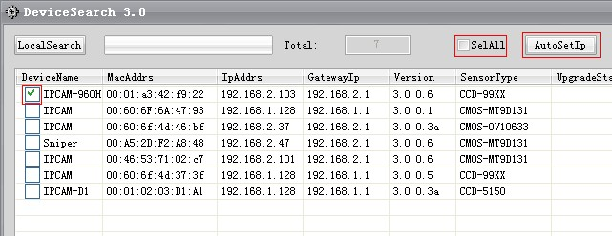
If all changes check the "Select All" then click on "Auto assign IP
Note: Save the modified, modify the information displayed in the message list area;
(2) modify the IP, MAC address, restart the camera about two minutes, please be patient.
3.3.2 Products
Region click on the selected camera need to check the product information, click the right mouse button, and camera configuration in the pop-up menu, select → product information, as shown in the search results:
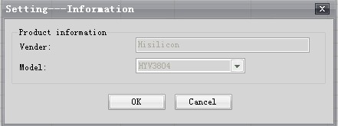
3.3.3 sensor type

Region click on the selected need to see the camera sensor type, click the right mouse button pop-up menu, select the camera configuration → sensor type, as shown in the search results:
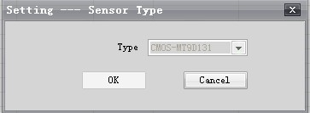
3.3.4 Function Deployment

Region click on the selected need to check the functional configuration of the camera, click the right mouse button, pop-up menu, select the camera configuration → Function Deployment, as shown in the search results:
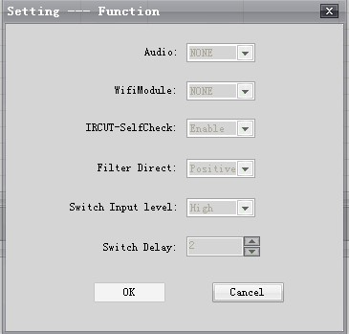

Plug and Play (IPNP), user-defined function is not yet enabled

3.4 camera software version upgrade

A camera upgrade process takes about 2-3 minutes, and upgrade the interface does not respond, Do not power this process, otherwise the camera program will crash when you upgrade, be sure to pay attention to this.
(2) during the upgrade process, should firewalls and antivirus software turned off, because it is unknown procedures had been blocked, or the inside of the firewall rules, we add to the trust can.
Click in the search for software interface Into the camera software version upgrade interface, as shown below:
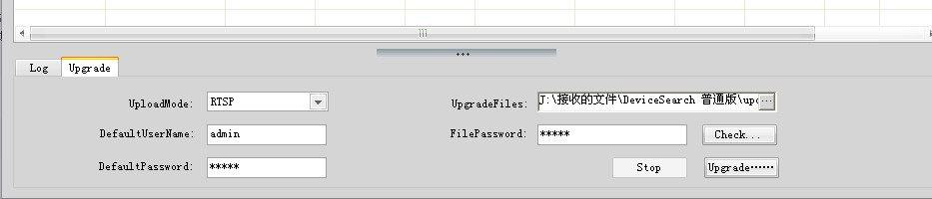
Do not upgrade you can visit Hidden Camera software version upgrade interface, and then click When the camera software version upgrade interface will be displayed.
Two. In the search results show that the region Click to check the camera you need to upgrade. As shown below:
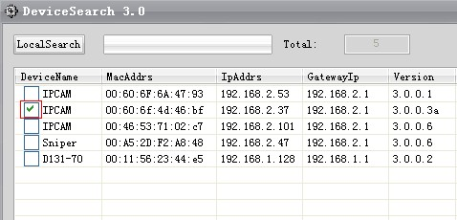
If you need all the upgrades you can visit
And then choose the upgrade package to the path:
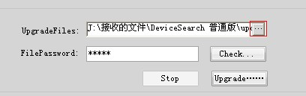
3. Upgrade packages where the path is found, click Open:

4. The proposal will upgrade package directly on the C: or D: root directory, if the upgrade package path contains Chinese characters, and may not be the linux system to identify, resulting in a failed upgrade.
5 Click Upgrade will be prompted during the upgrade process. As shown below:
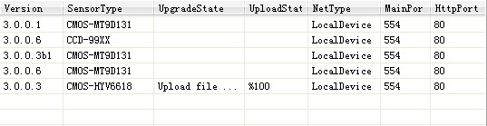
Will be prompted to upgrade is successful. As shown below:
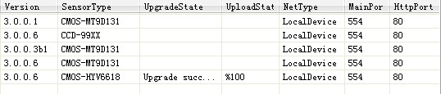
Description:
Upgrade is complete, the cameras do not have power, re-search under the camera, you will see a new version number, if you upgrade the WIFI to upgrade the package, the version number of the camera there is no change, but in IE, it will increase the WIFI Page Setup.
6. The upgrade is complete, and sometimes the camera stay for one minute before the beginning restart the middle about 3 minutes, please be patient, must not be power outages, or internal procedures crash

3.5 Diary
Click in the search for software interface Query the camera to modify the boot record
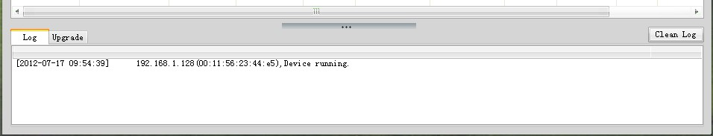
3.6 Add the Plug and Play devices
This feature is not yet enabled

3.7 Add the device
Click in the search for software interface
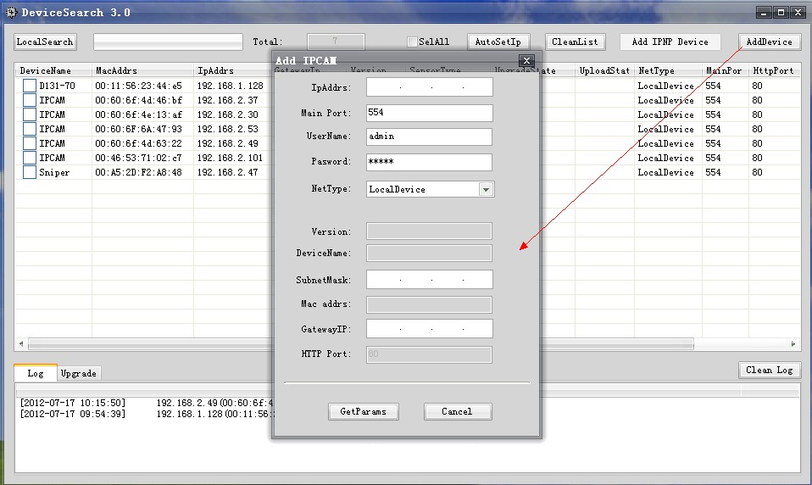
If there is a camera's IP address is 192.168.2.101, the primary port number is 554, the type of network is a local device, the default admin user name and password are to be added to the list, click on Enter the IP address, click Obtain the parameters, as shown below:
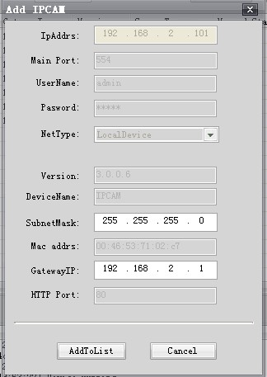
Click The camera will be added to the search results are displayed in the list. As shown below:
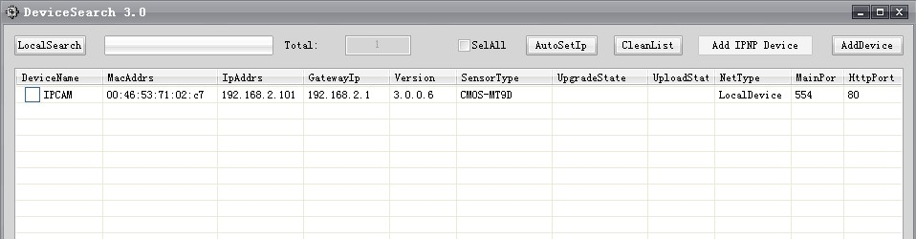
6.6 Network ball machine in the client software to set the auto-cruise

Description:

Preset point, the vast majority can be used to set the preset position, but few have a special definition, used to manage the preset position, as:

33 | start to head the 360-degree scan (low speed)
34 | To start the scan head 360 degrees (medium speed)
35 | Start PTZ 360 degree scan (high speed)
41 | Stop the the PTZ scan, line scan, patrol function
36、133 | Set line sweep the left limit
37、134 | Set line sweep right limit
42 | Start the inspection teams, a
43 | The beginning of the inspection teams, a position set
44 | Inspection teams, a stay in the beginning of the time setting
45 | The end of the inspection teams, location or time settings
46 | Inspection teams, one to restore the factory settings
We illustrate how to set auto-cruise in the client software, if there are three places you want to monitor, stay on the 1st patrol point 5 seconds 10 seconds on the 2nd patrol point to stay on the 3rd patrol point residence time of 20 seconds ( each place to stay the default is 5 seconds), preset point in the client software interface is as follows:

First open the client software, device settings - "head, check there PTZ camera factory default protocol parameters are: protocol PELCO-D, baud rate 2400, the address code, as shown below:
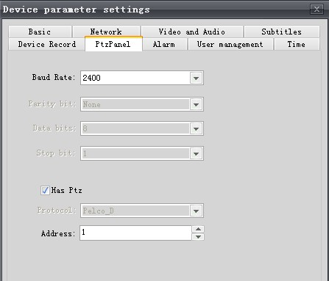
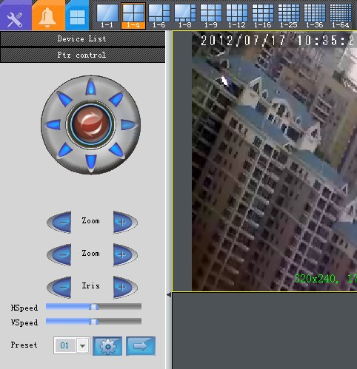
 Related to the preset buttons are here
The figure above the level of speed and vertical speed, control the rotation speed of the ball machine, it is recommended that the right onto the largest.
Then set the following steps:
: We first set up three preset positions, turn the head to the place you want to monitor.
The preset position In, Enter the number 1, then set Button.
The same way, we turn the ball machine to the two monitoring points in the preset point, enter the number 2, then the Settings button.
The same way, we turn the ball machine to the three monitoring points in the preset point, enter the number, then click the Settings button.
: To the inspection teams, a patrol route is set to 1 → 2 → 3 (set up inspection teams in front of the preset bit has been set)
43 preset points is called inspection teams set to (enter the number 43 Click Go to key)
A call on the 1st preset point setting a patrol point (enter the number 1 Click the go button)

, Call on the 2nd preset settings 2 inspections (enter the number 2 Click the go button)

3, calling on the 3rd preset set of three patrol points (enter a number click to the button)
5 Call No. 45 preset points out the inspection teams, location settings (enter the number 45 click to the button)
6, No. 42 preset points (enter the number 42 click to the button) is called to start the inspection teams, head scan inspection route 1 → 2 → 3
7, 41 preset points (enter the number 41 click to the button) is called, or to move the keyboard joystick to stop the tour
: Residence time of inspection teams, one each patrol point be modified on the 1st patrol point to stay for 5 seconds, 2 visits point to stay 10 seconds residence time of the 3rd patrol point for 20 seconds (one for each local stopover at least five seconds), then the operation is as follows:
Call 44 preset points to the inspection teams, time settings (enter the number 44 click the go button）
1 on the 5th preset point is called a patrol point dwell time is set to 5 seconds (enter a number click the go button)

2, the same way, calling on the 10th preset 2 inspections residence time is set to 10 seconds (enter a number click the go button)

, Call on the 20th preset points to three patrol points dwell time set to 20 seconds (enter the number 20 Click the go button)

4, call the 45 preset exit inspection teams retention time settings (enter the number 45 Click the go button)

Note:

A. 16 patrol points can be set up an inspection group

2.46 preset point inspection teams to restore the factory settings, referring to the inspection teams, one for each patrol residence time, back to the default of 5 seconds
3. Document, the steps and methods of automatic cruise settings, for H.264 ball machines are applicable (and front-end ball machine relationship, and the network board is not related to)
4 different ball machine manufacturers, ball machine preset number is not the same, the document first preset position is defined, for our ball machine, but its principle of operation is the same.

6.8 How to use the Plug and Play (IPnP)

See the "IE Manual" "7.10 how to use the Plug and Play (IPnP)

