1 product description
Search software (DeviceSearch. Exe) can search to local area network all the cameras, cameras are IP address to modify, MAC address modification, display software version, played preview etc operation.
Finish installing the software, computer Start menu-> in work-> \ VMPlat, a Device is by Search tools. As the chart
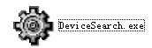
Explanation:
If \ VMPlat Program under the group does not have this search tools, please use the installation path search tools, the default in C: \ Program Files \ IPCAM \ Ipcam_Cilent_Cn \ DeviceSearch

2 Software the interface
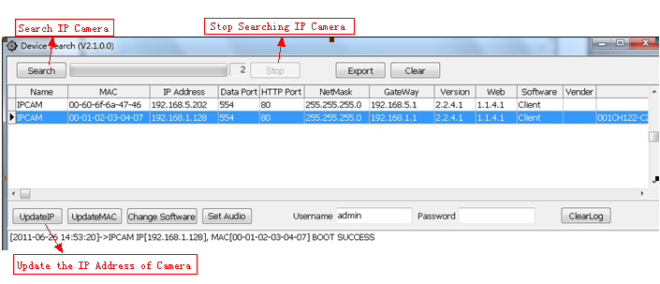
When search ,please close the firewall of the computer.After the search, a line to display a camera information
After the search, a line to display a camera information, meaning as follows:
IP camera IP Address after: the default is to 192.168.1.128
Port: the camera is the Data Port, is the client visit with the camera, the Port, the default is 554, the Port can be modified
HTTP Port: the camera IE Port, it is to use IE visit the camera, use the Port number, the default is 80, the Port can be modified
Version: the camera plate Version number
Web: the camera IE the version number
Software: Software type
Device ID: plug and play (IPNP) serial number

3 Software functions

[modified IP address], [modified MAC address], [play preview]
3.1 modify IP address
All the camera the IP address of the factory default is 192.168.1.128, when local area network to have many cameras, in order to IP address not conflict, to change the camera IP address; If the camera and monitor computer is not the same segments, is to change the camera IP address and gateway, such as monitoring the IP address of the computer is 192.168.2. *, the gateway is 192.168.2.1, so to change the IP address of the camera for 192.168.2. *, camera gateway for 192.168.2.1
Search to the camera, selected need to modify the IP address of the camera, and click on the button ，To modify the IP address interface. The following figure:
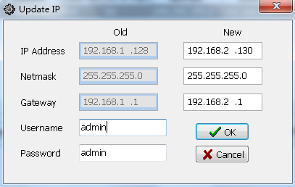
Note: 1. Save after a change, change the information would be in the information list region shows;
2. Because the camera needs to be restarted, please be patient.
3.2 modify the MAC address
Search to the camera, click on the button
，Can modify MAC address of the camera, and the factory has set a MAC address, need not to move
3.3 the camera preview
But for the camera to preview playing, yuntai cameras are simple tilt of the operation (location and zoom-in camera), and to the relay, two-way video camera speech switch control, can also upgrade the camera software version.
【 realize 】 search to the camera, in search results display area need preview video camera click on selected, click the right mouse button, in the popup menu choices ，Into the camera preview interface. The following figure:
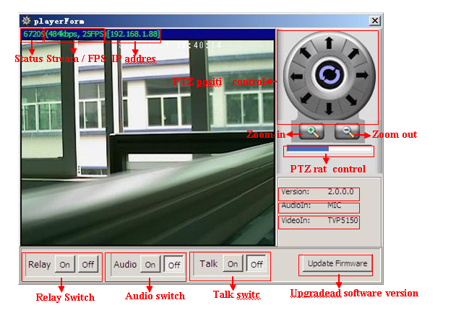

3.4 the camera software version to upgrade
Search to the camera, selected need to upgrade software version of the camera, click the right mouse button, in the popup menu choices ，Into the software version to upgrade interface. The detailed operating please refer to CD FAQ folder in the plate in the program to upgrade (search tools in)"

