Principle:
Cameras-" computer:
Front camera meet headset or pick-up, complete voice input, sound through the cable transmission to the computer monitor screen, through the computer audio complete voice export.
Computer-" cameras:
The computer on the microphone (or connecting a computer to complete the headset) voice input, sound through the cable transmission to the front camera, through the camera on the headset or pick-up complete sound output.
Note:
In a two-way voice talkback test, to ensure that the first before headset (including headphones on the microphones head) or pick-up is good, the computer's sound card and drivers installed correctly. Is The software and hardware Settings to check.

We 192.168.1.50 this camera, for example:
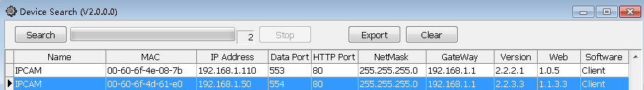

1 In IE, set the procedure is as follows:
1.1 Open the IE, input the camera's IP address:
1.2 the input video camera user name and password admin, into the admin cameras:
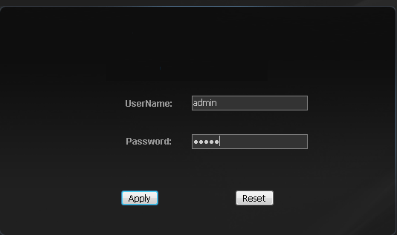
1.3． In the following pages, point and installation of.download OCX OCX control:
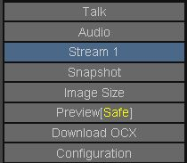
1.4 In the following pages, some configuration option card:
Explanation:
Please use streaming 1 to test, streaming 2 temporary not support two-way voice, if is ADSL, please will be streaming the bandwidth of the 1 control at 350 KBPS less than.
1.5 In the following page, click on the Audio Video sites, and the Audio input function open:
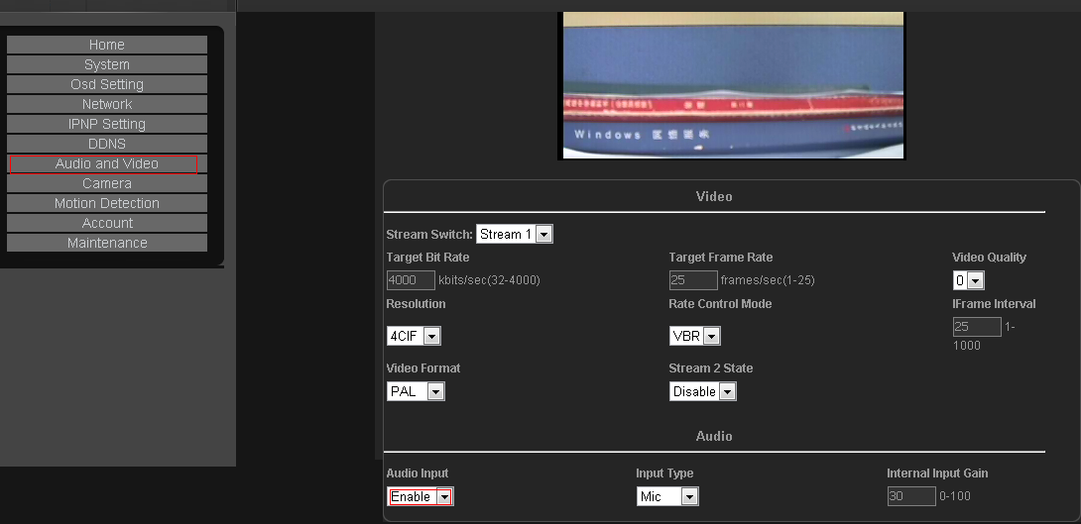
1.6.Input Type：Headset Mic, choose Line pick-up In; In addition, no (electrical) that the mic, have chosen the source (electric) source choice of Line In. Gain representative volume size: 100 is the largest, 0 minimum. We with headphones for example
1.7 In the Home screen, checked, Audio option card, Talk below:
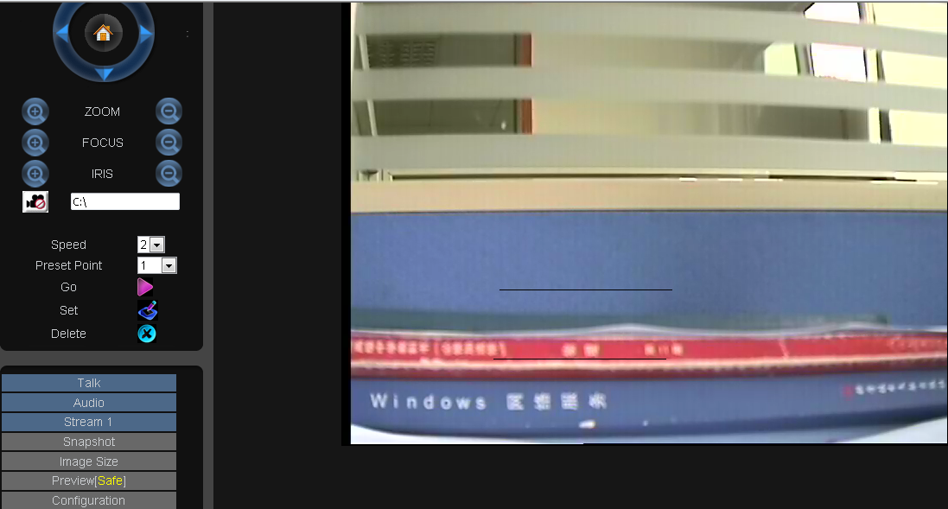
1.8 Then plug in your headphones, earphones red line, take on the chart the voice input, headphones above the line of black, the chart the sound output: answer
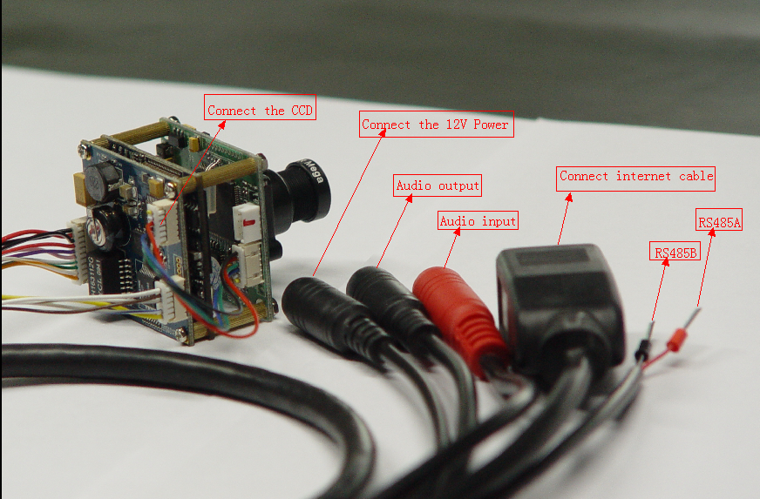
1.9 Open computer volume control:，Turn down the volume to the maximum

2 the client software, and how to implement the two-way voice talkback
2.1 in IE browser, open cameras voice function, specific steps are:
Configuration of video, Audio- Audio Input will Enable, Input: headset Mic, chosen by Line pick-up In; Gain representative volume size: 100 is the largest, 0, and then Apply: at least
2.2 in the client software, will be monitoring menu intercom and sound function, as the chart: open
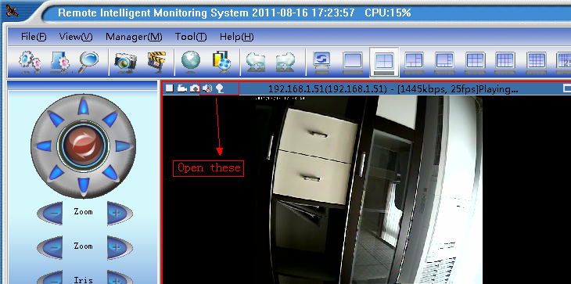
2.3 Manager menu—》Device Setting—》Audio，Open the audio coding：
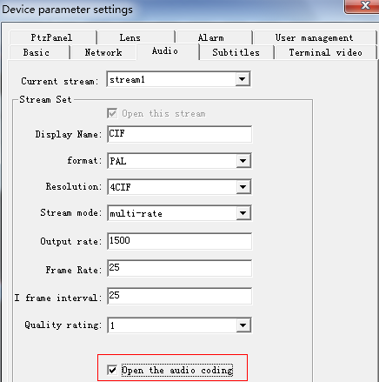
Explanation:
Please use streaming 1 to test, streaming 2 temporary not support two-way voice, if is ADSL, please will be streaming the bandwidth of the 1 control at 350 KBPS less than.
2.4 Computer volume attribute move into is the largest
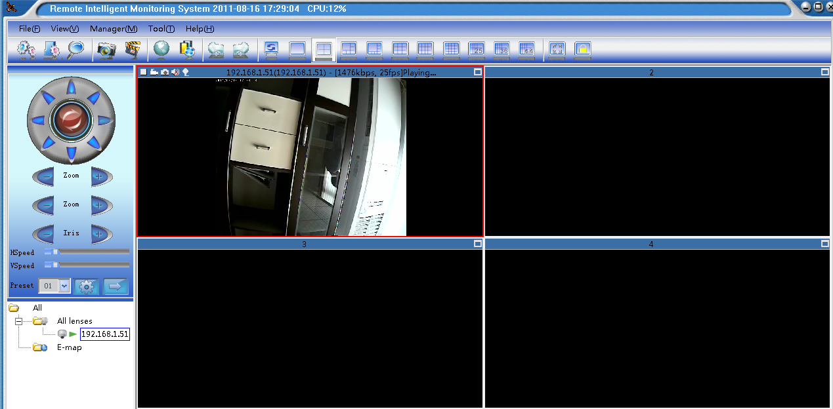
Note:
If the current pictures, and have the multiple cameras, for example, four of the way, if the four two-way voice open all the way, then in the monitoring center to speak, the front camera can hear, how to realize the function of the intercom, one-on-one? Is the monitoring center, the first road to the camera, can't let the other three speech way to hear, the method is as follows: camera
1 the way the camera open up other two-way voice 3 road two-way voice close, camera, need what drove all the way which way

