Some customers will use plug and play (IPNP) remote monitoring function. Below is IPNP web site in our work.
1. With IE browser login http://www.goipcam.com or http://220.243.139.8:9000, and to apply for the registration of a user name, if we here have already registered a test10 users.
2. To enter your user name and password, and input test picture, as the chart verification code:
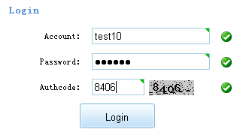
3. In the following pages, the first new group, a group to exist, new equipment to add success.
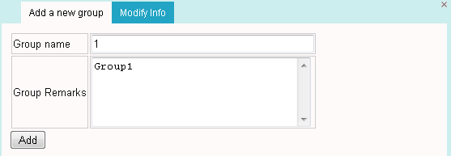

4. In the following pages, the choice of equipment in the group, will we leave the factory's serial number one to copy in.

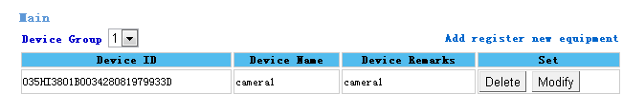
Note 1:
Add new equipment must receive when don't write wrong; The content of the remark this place, can't be empty, but write what all can，Name less than 8 characters.
Note 2:
The serial number of the IPnP by digital, English letters and-composed of 26 altogether, for example, a 001 CH428-C20112304130BA0DD, how to check the serial number of the IPnP:
use IE visit our cameras, in the Configuration page, under the System, a Device ID, display is IPNP serial number, as follows, Here the serial number can copy.

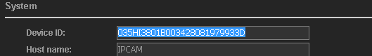

5. Login in IPNP click on that
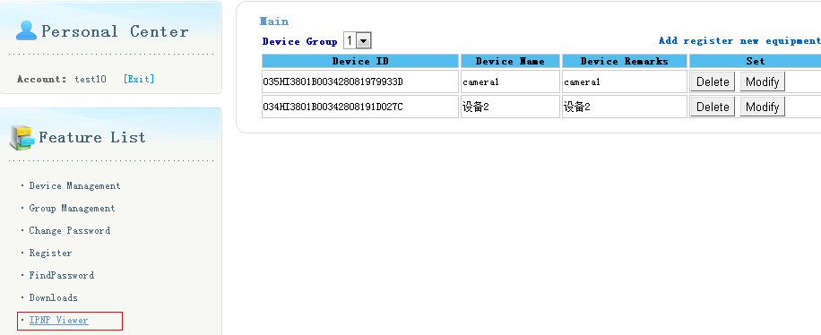6. In the pop-up interface, operation load control of the diagram below:
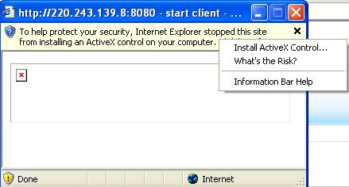
Note: if no see the picture above, shall be in IE Intenet options, adjust the tools of the level of security, to install OCX control. Details of the document "see CD IE Operation for your DNS setting"
7. Install the controls
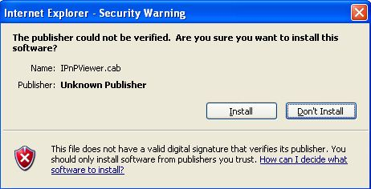
8. Click on the IPCAM this way can see pictures. Camera
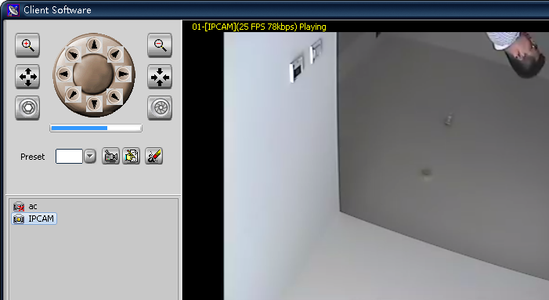
Explain 1:
If a display device offline, the reason there are six: one is to ensure that the camera gateway and the monitoring network computer gateway consistently; 2 it is above the router, do the IP and MAC address binding. Three is where the camera network router or firewall to allow cameras out public network, if not permitting, the router or a firewall, streaming video will be lost, this, please contact a camera in the network of the administrator, apply for the privileges; . Four is the customer network has a problem, the network is relatively slow, Five is the device name description is too long, Name less than 8 characters. Six is IPNP function may not to use a camera, want to use IE login camera, point Settings, in IPNP option, to check IPNP function can, as the chart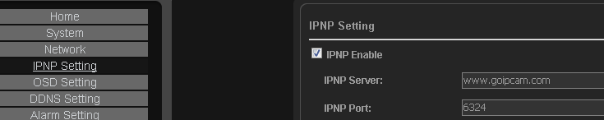
Instruction 2:
If a display device, but no online image, two reasons: it is a must in IE Intenet options, adjust the tools of the level of security, to install OCX control, detail see "the watch, with IE IE associated Settings". Two is that the nets bandwidth is used not quite, the proposal with streaming 2 see, for streaming 2 takes up less bandwidth, the following steps

9. To the camera, to choose the right point Device Option, Enable Stream 2, and Variable, will be streaming 2 bandwidth control at 350 KBPS less than

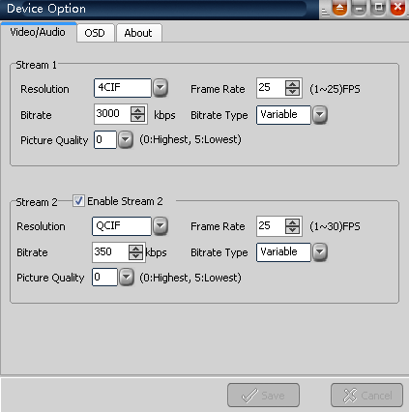

10 Optin Link with streaming 2 watch can
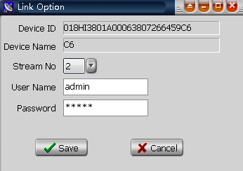
So when your machine in the company or home, in other place, as long as you can get to the Internet, log on to our website, can remote watched (premise is Internet bandwidth used quite). No need to apply for these peanut shells, also need not on a router configuration, can do trival remote monitoring function.

Important note:
1. The connection when there are many cameras use IPnP, its total upload bandwidth must be enough to, or remote monitoring of some pictures couldn't see, when can be transferred to the picture to reduce its occupied CIF bandwidth.

2. To use IPnP words, must ensure network is open to Suggestions, at least 4 M more bandwidth, some customers can connect our IPnP server, but no pictures came out, a local network environment is bad reasons.
Can the ping www.yahoo.com.cn-l 800-t network environment test:
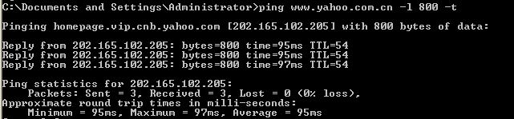
In the image above, the return time in 100, and Lost within ms Lost = 0, explain the network or the more normal

3. The camera a factory, want to have IPnP function, to use, or not use IPnP plug and play function.
4. Support the same user name in different places, such as in the login factory monitoring computer is logged in, and now away on business, still can login, factory computer monitor screen is still in real time. So, the same user name, let a person also can use, also can let other people have access to use.
5. Applications
For that is to realize the remote monitoring, and distribution in several different places, and when the camera is for a little while and the requirement of customers function just monitoring and video, can use IPNP.
Advantage is:
(1) can be several different branch camera, concentrated in a computer on a remote monitoring
(2) need not apply for DDNS these things, and not on the job in the configuration of trival do
(3) new monitoring the client software, can add IPNP camera, see the client software instructions

