With our client software to see, the camera without a problem, but use IE see the camera (including remote watch), image picture sometimes can not come out this and IE browser Settings relevant.
Important note:
Our camera does not support the Firefox browser, please use window system comes with IE browser to watch, in addition to turn off the kingsoft Internet security, yahoo Internet assistant these stop installation IE plug-in tools.
1, in order to let the video in IE browser plugin, is the work of safety must modify the IE browser, in IE browser "which menu, select" on the Internet..." , as shown in figure 1.1 shows, in addition to the yahoo Internet off, assistant these things will stop IE plug-in installation.
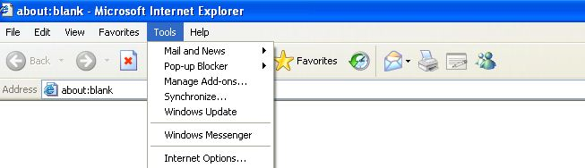
Figure 1.1
At this time will show on Internet, choose the "Security", as shown in figure
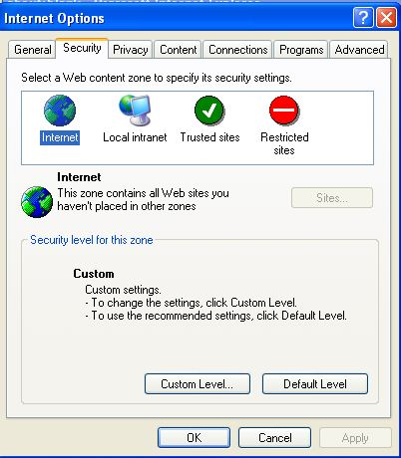
Figure 1.2
2 click "and Level..." Button, open Internet security Settings form, in "unsigned ActiveX Conrols of.download", "signed", Conrols ActiveX of.download-ActiveX Control "Initialize script marked as" not choose the "monitors prompt", then click "OK" button, as shown in figure 1.3 and 1.4
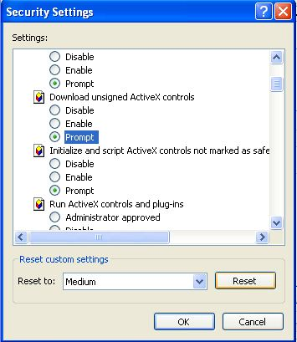
Figure 1.3
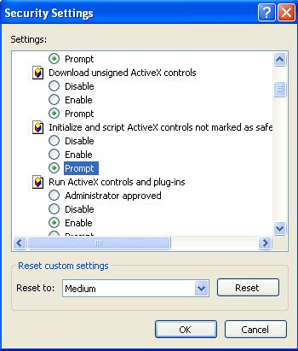
Figure 1.4
3. In one Resrticted Sites and Local (figure 1.2), repeat above a few steps Settings.

