QuickTime Player is the company's Player software, Apple, it's the most authoritative RTSP protocol testing software. Through this software, can test out our camera RTSP whether to support the agreement.
If a camera IP is 192.168.1.50, we, the camera the default data port is 553, and RTSP agreement default is 554, so first of the camera is changed to 554 data port, the method is as follows:
- Open the IE browser, in the address bar http://192.168.1.50 , input below:

2 the input video camera user name admin password admin, as the chart, :
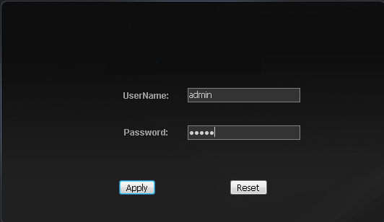

3 into the camera, the camera's data port 553 this for 554, the following graph:
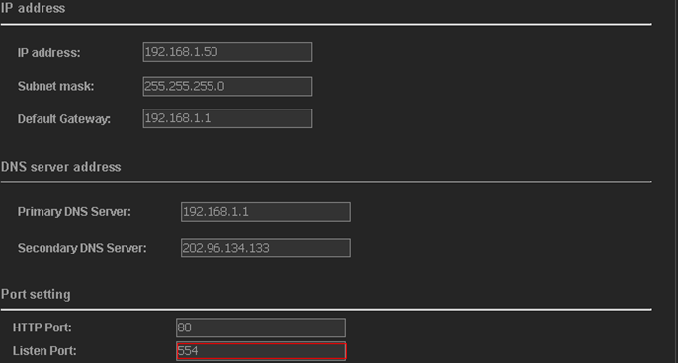

4 There are two kinds of users, the camera a is administrator account admin, additionally one kind is ordinary users user, the ordinary users user name and password, all set to empty the diagram below:
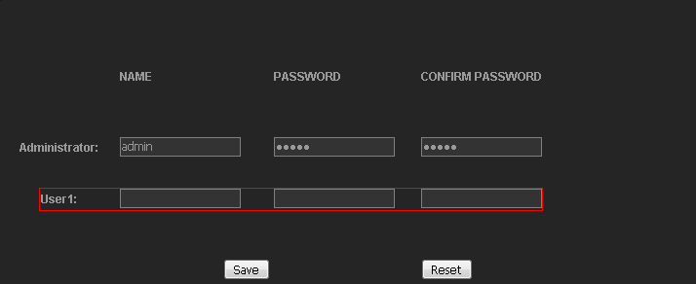
Note:
Because of the camera is not the same as the version that the above interface may not be the same, at the user interface (some camera version is in the System of interface), allow anonymous access, as the chart:
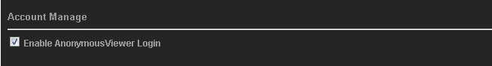
5 download and install QuickTime Player RTSP test software:

6 QuickTime Player, open the File open menu, as the chart:
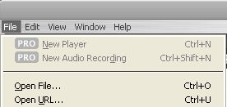
7 In the URL in the dialog box and enter this in such as:
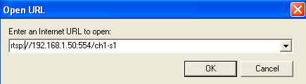
Among them: RTSP representative, 192.168.1.50 RTSP agreement is the IP address of the camera, 554 is the camera's data port, on behalf of the first channel ch1, s1 said the first all the way streaming

8 and then click on the menu-> Preferences-intended-> QuickTime Preferences, as the chart:
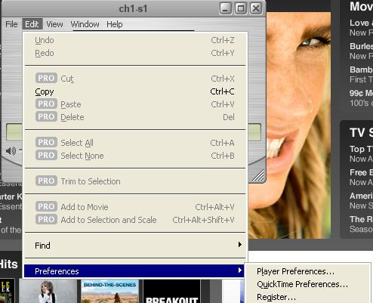

9 In the picture, select
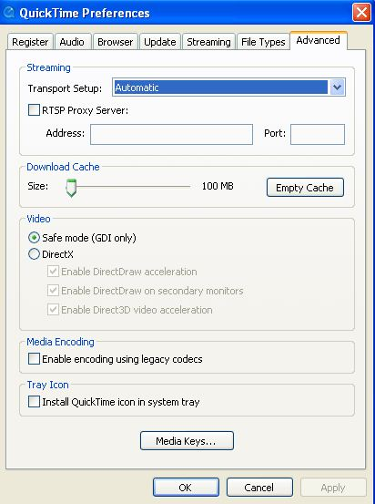
10 Click OK, video screen will come out, explain our cameras use is the standard RTSP agreement, the following is video screenshots:
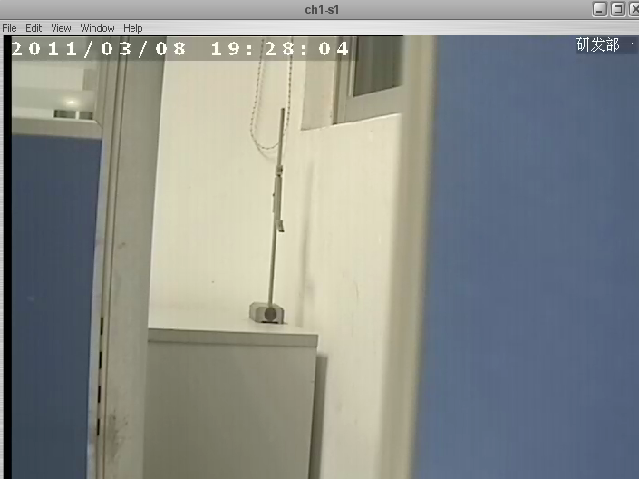

It is about the connection in the inside of the test RTSP agreement, so how to test the connection of the network through this camera RTSP whether to support the agreement?
Procedure is as follows:
1. The first change 192.168.1.50. This camera, the port because we camera the default data port is 553, and RTSP agreement default is 554, so first of the camera, at the same time instead of data port 554 HTTP port this for 802, the following screenshots:
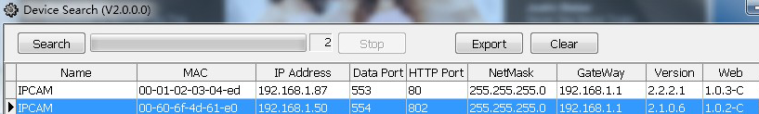

2 to TP-Link router as an example, the router port mapping above (see below), will the screenshots mapped to the camera on public network, the premise is has applied to the dynamic domain name DDNS here, we apply for dynamic domain name is ipcam188. Gicp.net, How to do port mapping, reference "How assumptions to visit to the Internet Wan cameras" this document
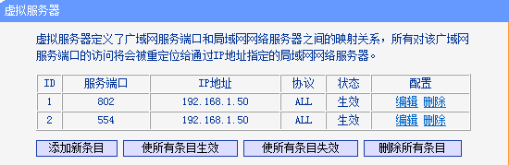

3 ensure DDNS and port mapping was right configuration, test the method is as follows:
  - ping ipcam188.gicp.net To the ping expert
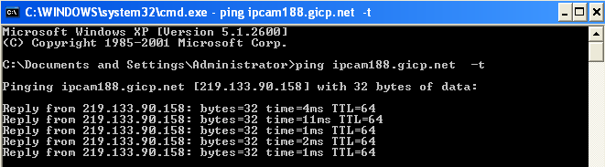
3.2 Through the IE browser can access to the cameras, in IE browser inside http://ipcam188.gicp.net:802 ,the login screen can out, what that DDNS and port mapping was right configuration
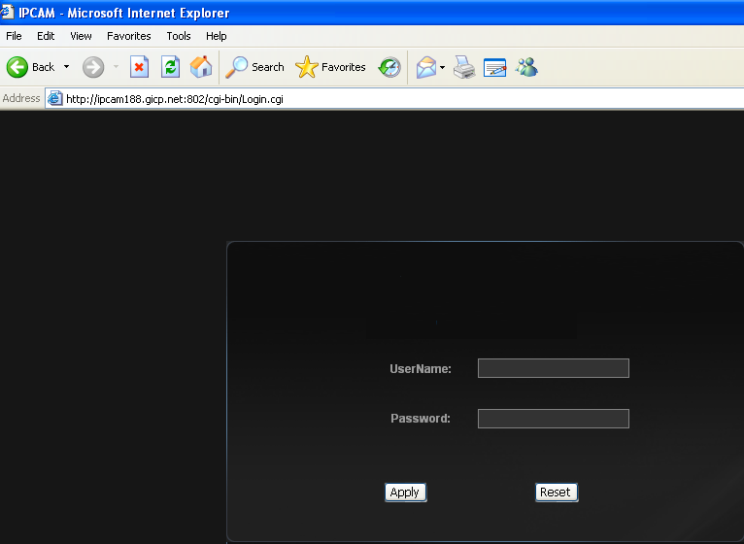
4 download and install QuickTime Player RTSP test software

5 Open the QuickTime Player, open the File menu, as the chart:

6 In the URL in the dialog box and enter this in such as:
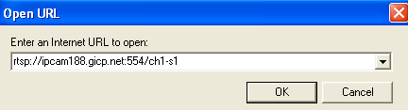.
Among them: RTSP representative, ipcam188 RTSP agreement. Gicp.net corresponding to 192.168.1.50 this camera address, 554 is the camera's data port,
On behalf of the first channel ch1, s1 said the first all the way streaming

7 then click on the menu-> Preferences-intended-> QuickTime Preferences, as the chart:

8 In the picture, select

9 Transmission Settings selected HTTP configurable, the port for 802, the following screenshots:
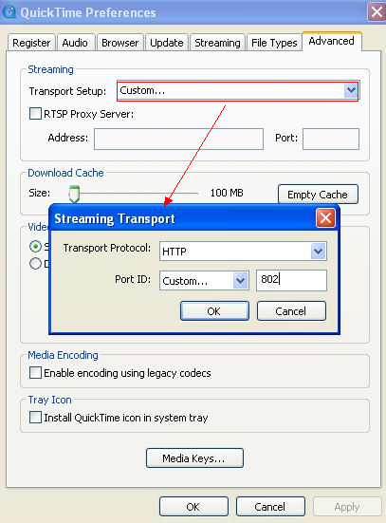

10. Click ok, QuickTime Player began to establish a connection and camera, then consult on the communication, configuration, read a series of movements, such as information more than 10 seconds after video screen will come out, explain our cameras use is the standard RTSP agreement, the following is video screenshots:
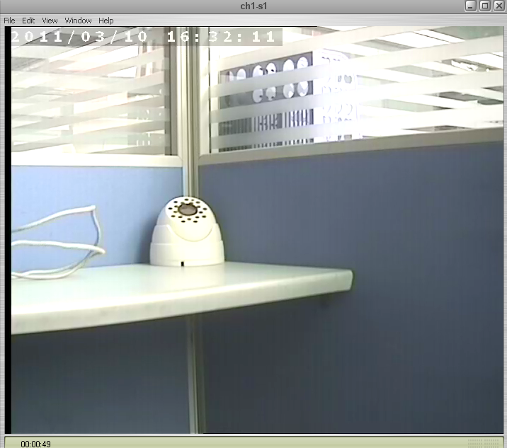
Explanation:
Because the nets visit from the camera, so must ensure network bandwidth used quite, done in bandwidth and 0.5 M above, the resolution of the camera Settings for best CIF, streaming also control in 350 KPBS, because others from the nets see, the video camera will upload data, take up the uplink bandwidths, and most users connect of domestic ADSL, is only 512 KPBS, namely every 0.5 M bandwidth

