VLC Media Player is a streaming media player software, which can be used to test the RTSP protocol.With this software, you can test out our camera is supported RTSP protocol. The proposal with VLC1.1.11 above version to test RTSP agreement.
If a camera's IP is 192.168.1.50, we, the camera is the default data port 553, and RTSP protocol the default is 554, so first change the camera's data port 554, as follows:
Open the IE browser, in the address bar http://192.168.1.50, as shown below:

1.Enter the camera's user name admin, password admin, as shown below:
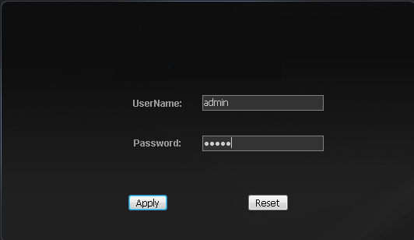

2. Into the camera, Configuration→ Network, the camera data port 553 this for 554, the following graph:
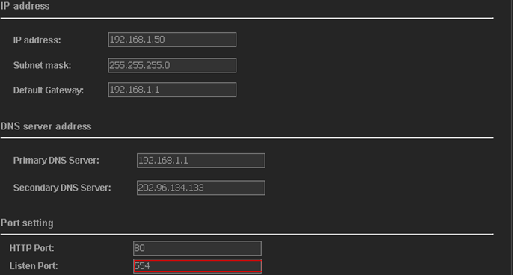

4.Download and install VLC MediaPlayer：

5.Open VLC MediaPlayer, Open Network Stream ... below:
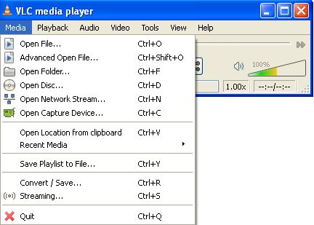
- Select RTSP，add the details as following ：
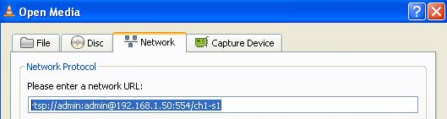
Here: RTSP representative RTSP agreement, admin and admin is the camera user name and password, 192.168.1.50 is the IP address of the camera, 554 is the camera data port, ch1 represents the first channel, s1 said the first all the way streaming.

7.After you click OK, the video screen will be out of the camera that we use is the standard RTSP protocol, the following is the video capture:
