Our camera double Stream (i.e. support Stream1 and Stream2), which Stream1 takes up bandwidth is larger, the connection is applicable to real time picture Stream2 occupied, watch less bandwidth, apply to the network real-time picture watch.
If the connection in the camera is 192.168.1.50, as the chart, how to use double Stream?
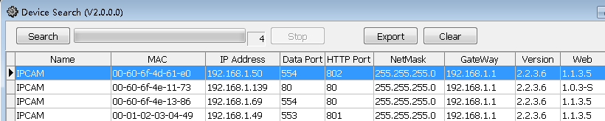

- In IE browser, the camera's IP address, as follows:

2 Will Stream2 open, in this as follows:
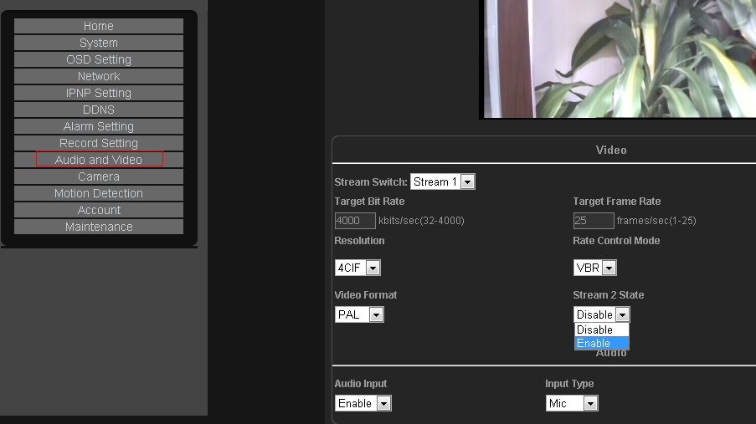

3 The connection to watch in the point Stream1, as follows:
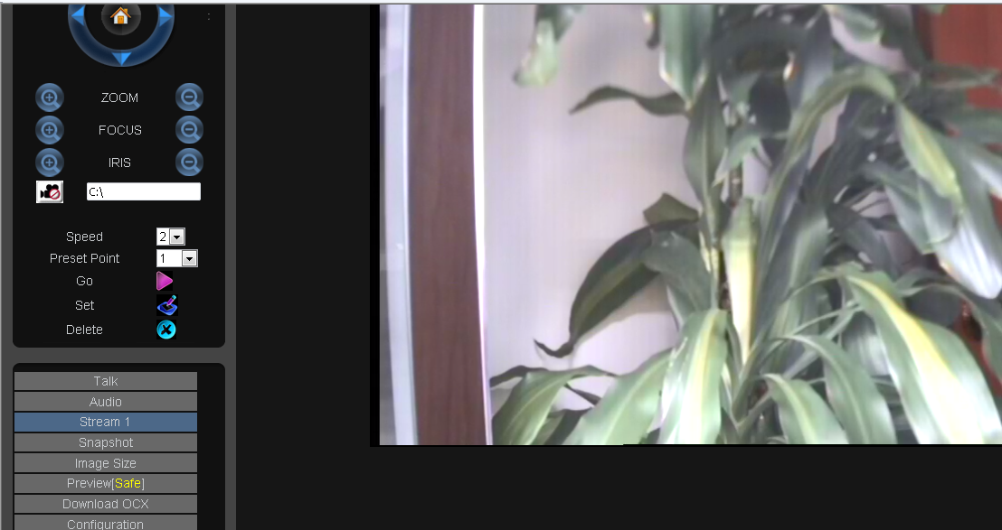
Note: the Stream1 maximum resolution is 4 CIF, the biggest streaming down to 4000 BPS, namely 4 M.
The following is through the network, we visit 192.168.1.50 this camera, and its corresponding peanut shells domain is http://ipcam188.gicp.net:802 < >, of which 802 were 192.168.1.50 this camera IE port. Don't know how to use the network connection camera, please visit word reference "how to set on a router remote access" this document.
1. In IE browser, input the camera domain name, as follows:
2. To enter your user name and password admin, as follows: admin
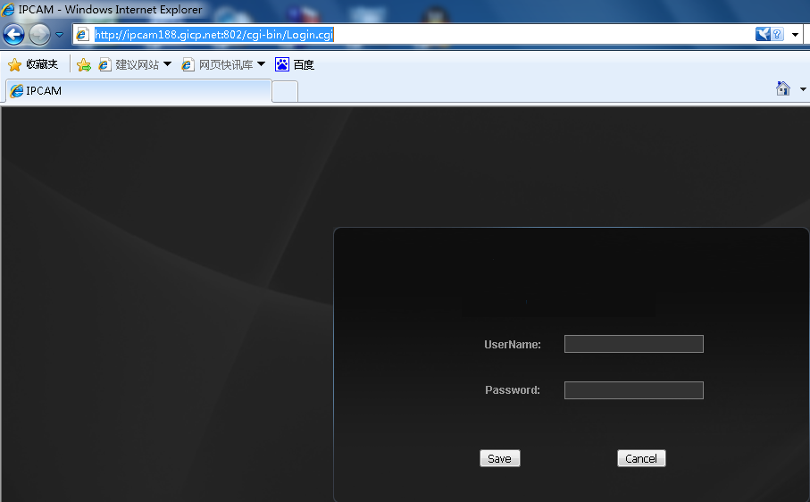
- In Stream2, the current, points StreamStream will switch into Stream2 to watch:
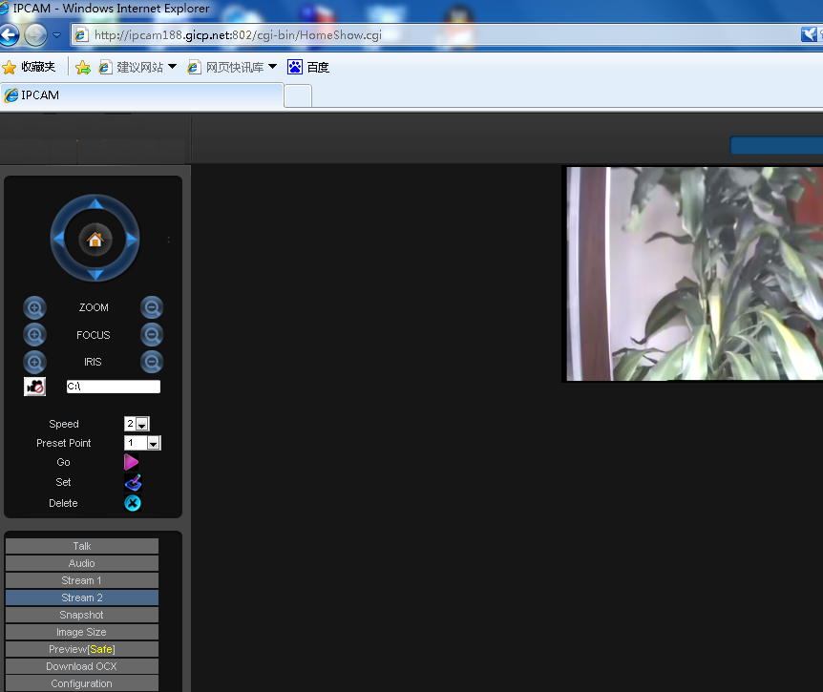
Note: the Stream2 maximum resolution is CIF, the biggest streaming can only be transferred to 350 KBPS, which is less than 0.5 M, less than ADSL uplink bandwidths 0.5 M, suitable for ADSL ordinary Internet users

