Configure remote access method has two kinds, one kind is on a router configuration, and DDNS on a router port mapping, the second do method is in DDNS configuration, and then on the camera on a router port mapping do, two kinds of methods to router connection port mapping above, will be to public network can above. This document is about how to configure DDNS on camera. Our camera only support www.3322.org < http://www.3322.org > or www.dyndns.org two kinds, we take 3322 as an example.

1 web site in http://www.3322.org above, apply for a dynamic DNS
1.1 http://www.3322.org website, registered a user
1.2 download 3322 client to a computer, and installation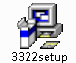
1.3 Open the 3322 clients, the dynamic test application domain name is available, as the chart shows, ipcam188.3322. Org is can use

2 In the above DDNS configuration, camera 192.168.1.49 for example
2.1 with IE login to the camera, and some Settings, some DDNS Settings, as follows
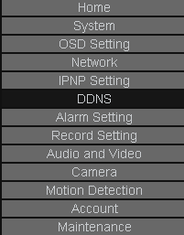
2.2 in DDNS page, fill in your web site in 3322 above the registered user name and password and click save
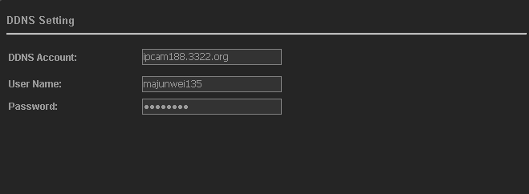
2.3 In the network Settings page, modify the camera listening socket (also called data port) and HTTP port (behind with router to do port mapping)
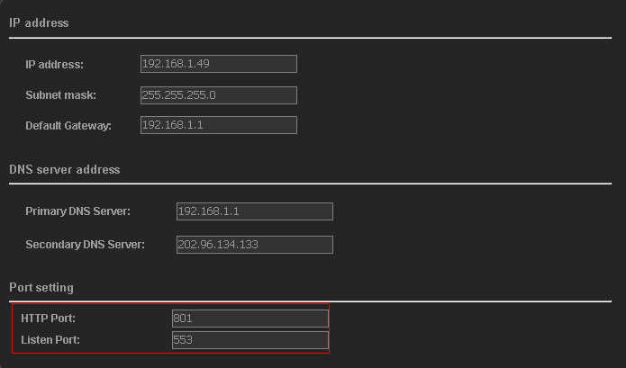

3. In the router port mapping above, TP-for example. Router LINK
3.1 Open the forwarding rules-> virtual server
3.2 Will 192.168.1.49 this camera HTTP port 801 and monitor port 553 ALL add up, choose ALL type of agreement
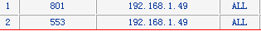
Note: if still have a 2, such as 192.168.1.50 this camera, need from the nets access, is still in IE modify HTTP port and inside the port number, listen here HTTP port modified into 802, listening socket modified into 554, and then in the diagram above, add 192.168.1.50 this camera forwarding rules
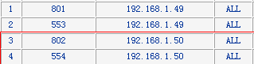
If still have 3 sets, 4 cameras need from the nets access, the same, which in turn analogy method...

4 the network access, there are two ways, one is the IE visit, and the second is the client software access
4.1 through the IE visit
4.1.1 In IE input http://ipcam188.3322.org:801 >, < inside the corresponding to the internal network 192.168.1.49 this camera
4.1.2 below interface, input the camera user name and password admin can. admin
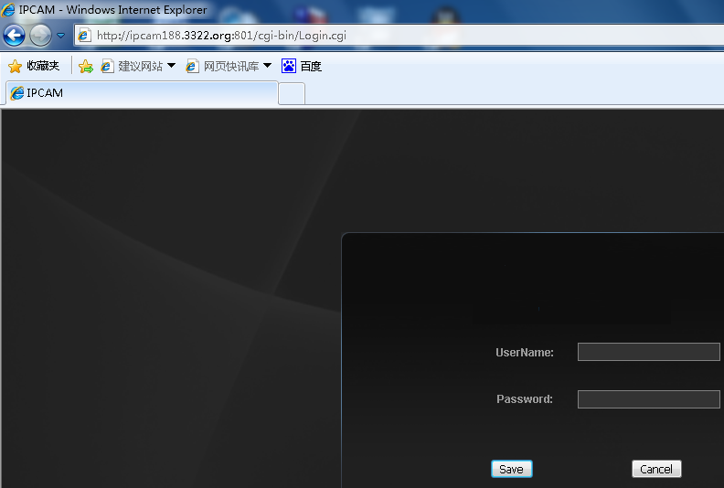
4.1.3 the same method in IE input http://ipcam188.3322.org:802, can visit inside the connection to the 192.168.1.50 this camera, and so on, in order to visit Taiwan 3 4 camera...
Note: in that case, every time only in a IE inside the camera, and that if see all the way in a picture in and see the multiple remote access, how to do, be about to use the following method。

4.2 in the client software interface inside, can see the multiple remote camera, no longer use 80 port, we use is the camera data port
4.2.1. Open the client software, add 192.168.1.49 this camera corresponding domain name ipcam188.3322. Org, port 192.168.1.49 this camera with the corresponding data port 553
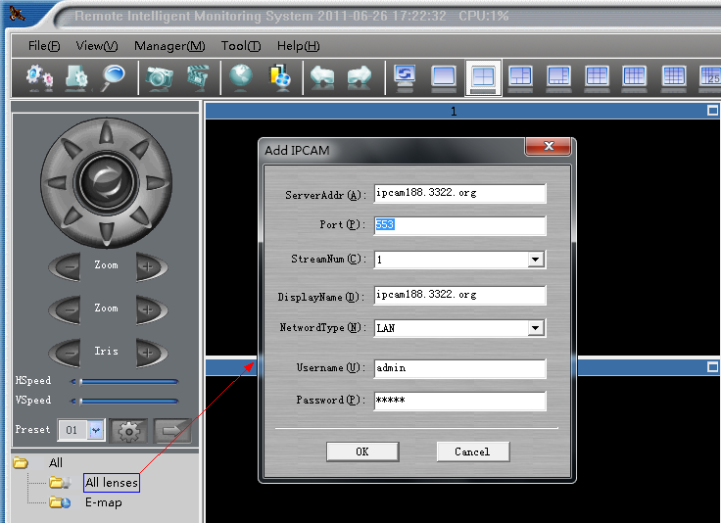
4.2.2. Add finished, can see 192.168.1.49 this camera screen
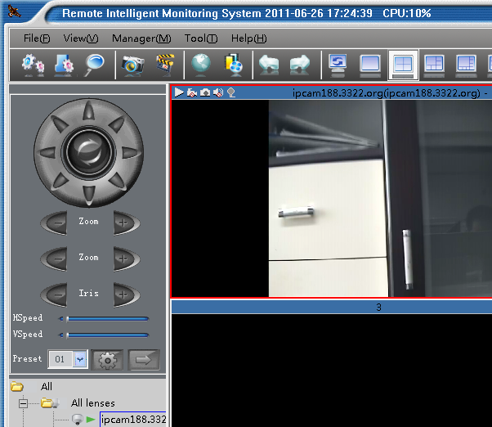
4.2.3. Add 192.168.1.50 this camera corresponding domain name ipcam188.3322. Org, port 192.168.1.50 this camera with the corresponding data port 554
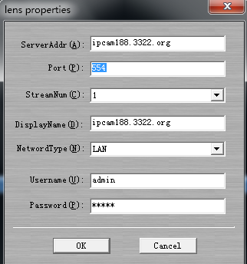
4.2.4 the same method, add 192.168.1.51 this camera corresponding domain name ipcam188.3322. Org, port 192.168.1.51 this camera with the corresponding data port 555, which in turn on...

4.2.5 such word, the client software, can be watched at the same time the multiple remote cameras, as long as you Internet uplink bandwidths used quite

Explanation:
1. If the router over IP and MAC binding function, need to open the camera IP and MAC address add up.
2 for ADSL the bandwidth of the uplink only 512 KBPS, which more than 512 KBPS of words, the images will not to come out, so when through the network access camera, the need to reduce after the camera bit flow rate, and adjust the code, to ensure that all the camera flow of take up the nets bandwidth of more than 512 k.
3 when the cameras are too, the optical fibre line access recommended.
4 use 3322, then must be installed on the computers in monitoring 3322 client software, 3322 dynamic domain name can be access to the network. If you just apply for 3322, even if the user name dynamic domain name the correct password, if not to install 3322 client software, still be the network can't visit, because a router is not active found 3322 server, must be installed 3322 client can.
5. Free 3322 is not stable, in order to achieve stable effect, please register charge 3322 dynamic domain name
6. For ADSL uplink bandwidths only 0.5 M, when the camera is remote monitoring of high-speed ball, the screen will appear high speed rotating pause phenomenon, because ADSL uplink bandwidths caused, in the connection is not enough, won't have such a phenomenon.
7 If the camera in the network installation network (hardware) firewall, need to open the camera on the firewall HTTP port (revised) and is port (revised), agreement choose ALL types (including TCP and UDP).
8 remote access the network video cameras, tip can not open web pages
Reason has the following may: one is the router to forward the above rules not added correctly, HTTP port and is to add port; 2 it is on the router IP address and MAC address binding; Three is the camera are installed in the network (hardware), network firewall to prevent camera HTTP port and is, see the step through port instructions; Four is the local network connection speed is relatively slow, Five DDNS user name password is not correct.
9 remote access the network video cameras, IE can open, but no picture
Reason has the following may: one is the IE not to use OCX control, inside of the document reference CD "IE operation instruction"; 2 it is the code above router flow restrictions, uplink bandwidths enough; Three is the camera streaming is too big, the proposal with streaming 2 to watch, and put the code in 350 KBPS flow control within, for ADSL uplink bandwidths only 0.5 Mbps; Four is the forwarding rules on a router has been added to the correct, HTTP port and is to add port. Five is the camera are installed in the network (hardware), network firewall to prevent camera HTTP port and port, and, behold, it is through step 3 instructions;
10 the connection when video cameras in the process visit, IE can open, but for a while have no pictures. For a while, pictures
Reason has the following may: a router is the code above restrictions, uplink bandwidths flow enough; 2 it is the camera streaming is too big, the proposal with streaming 2 to watch, and put the code in 350 KBPS flow control within, for ADSL uplink bandwidths only 0.5 Mbps, if there is DuoRen with network at the same time, the router it will appear crowded real-time video of the data, can't get forward in time, and of course there will be the above picture situation; Three is the camera are installed in the network (hardware), network firewall corresponding port is not open, see a top step 3 instructions;

