We support the camera motion detecting alarm and external alarm input device, the alarm when the camera to the above two alarm detection signal, can video and captured on SD card to 192.168.1.128 this camera, for example, combined with the move to detect explained how to use (external alarm input equipment method and the alarm as)
1 the camera Settings
1.1 with IE login to the camera, and some Configuration
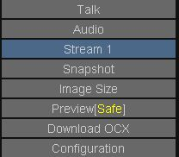
图1
1.2. In Detection page, set amount Motion detecting area:
The first point detection functiont amount Enable checked, and then point Start button, draw a or DuoGe mobile zone, then some Add button, and then some End button, and brings a set.
Set up, when a picture of a moving object detection area, the cell will flickering.
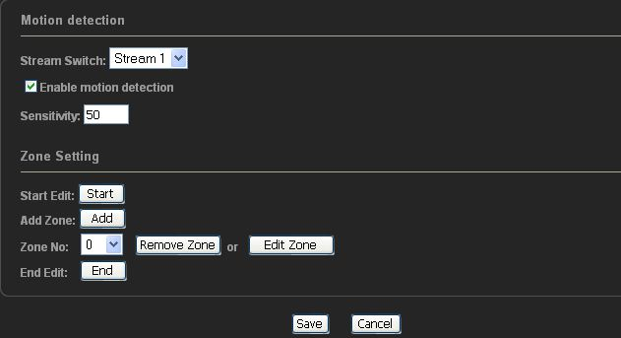
图2
1.3. For Alarm in page, make the following Settings, other places don't set, and then brings a point
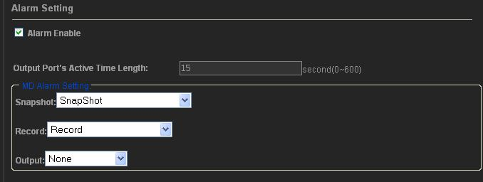
Explanation:
If is external alarm input devices, also in alarm page alarm in setting, as follows:
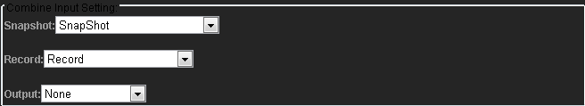
SnapShot to pictures captured in SD card, to Record video recorded in the SD card.
After the completion of the above process, must pull electricity to restart the camera.
2 how to view the SD card video material
Divide kind of case, if the camera in 2.3.1.0 and its above (version in the video camera in search tools, can view camera version number), and at the front end of the SD card above video and pictures, will be uploaded to the monitoring center PC end; If the camera is 2.3.0.0 or 2.2.4.1 version, SD card on the front end video and pictures, is not posted at the monitoring center, the PC to FTP view through the front of the above information, SD card The camera in the following, 2.2.4.1 version does not support the SD card function
2.1 the camera in 2.3.1.0 version and above
General default video cameras recorded in each set of documents video record root operator, if recorded in the D: disk. Open D: \ record, below will have two folder, a PC folder, it is the local computer store is video, a Device is inside the store folder, from the front end is SD card above, to the monitoring center of the video and pictures, a new front video and pictures, will immediately to the monitoring center.

2.2 as of version is 2.3.0.0 machine or 2.2.4.1, method has two:
The first kind of method is: use IE open, procedure is as follows:
1. In IE, input inside ftp://192.168.1.128, user name admin, password admin
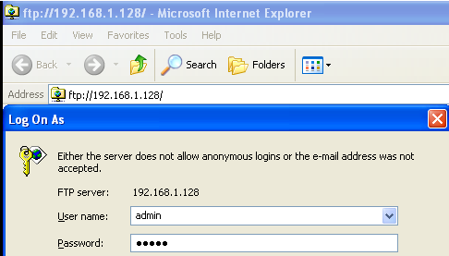

2. In ftproot/SD path, there are two folder, one is the record store, local video files, a snapshot, used to store is captured image files, if the two folder has not come out, will need to figure 3, the operation to Settings, and then restart the camera, and sometimes to power a few times can. Power At the same time, just page refresh IE video pictures to come out.
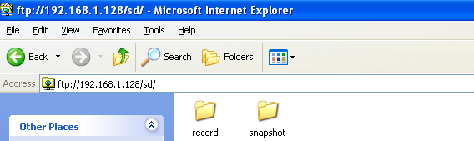
3. Select the file, right can download to computer, if is image file, direct looked; If is video files, with our client software own player play. Snapshot of files, delete folder will tip error, and because the default inside store only five pictures, motion detecting took pictures, will cover before new pictures of the pictures are using, equal to, if now remove, will give that error, in the current page refresh, they can be

The second kind of method is: with monitoring the client software open, steps are as follows:
1. Open the monitoring software, in the camera list, to 192.168.1.128 this camera point right mouse button, select Login business
FTP server
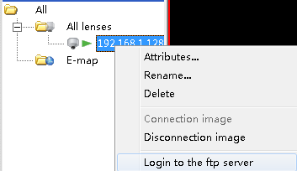
Note: if the FTP,, may be added in the camera, video camera user name, password is not correct (the default user name and password, all is the admin)
2. In SD path, there are two folder, one is the record store, local video files, a snapshot, used to store is captured image files, if the two folder has not come out, will need to figure 3, the operation to Settings, and then restart the camera, and sometimes to power a few times can. Power At the same time, just page refresh IE video pictures to come out.

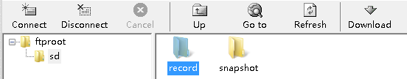
1. Select the file, right can download to computer, if is image file, direct looked; If is video files, with our client software own player play. Snapshot of files, delete folder will tip error, and because the default inside store only five pictures, motion detecting took pictures, will cover before new pictures of the pictures are using, equal to, if now remove, will give that error, in the current page refresh, they can be

Explanation:
1. Our camera support 32 GB SD card, more than 32 GB SD card not had a test, ordinary SD card and high-speed SD card(SDHC) are supported, With our camera 4 Mb/s largest of writing, no problem. Rate
2. Motion detecting video 60 seconds, captured a trigger (have a moving object) are captured in SD card, a new front has video and pictures, will immediately to the monitoring center. When the SD card full, the early video will be deleted. Paparazzi pictures of SD card above only keep most five tickets, when picture 6 over, will cover the first picture, and so forth.
3.
4. In IE inside, SD card to video above, there are three ways:
A plan is recorded in the video above SD card.
2 it is IE mobile video, is to detect it recorded in the SD card above, not recorded in the computer, IE above the inside of the motion detecting is with the SD card use.
Three is the camera external alarm input devices, alarm, is also recorded in the video above SD card.
Explanation:
At ordinary times is not to watch the SD card recorded above, if at ordinary times, can be in to watch video in IE, see below set the step 4, suggests that the client software inside, can also will be recorded in the computer video above.
5. In IE set in the computer, video in IE real-time monitoring picture:
C: on behalf of the video in the disk C, behind of video path can be modified
32 GB SD card can continuous record for a few days?
When the resolution for CIF, 32 GB video 6 days or so can be
When the resolution for 4 CIF, 32 GB video 3 days or so can be
When the resolution for 1 million, 32 GB video 1.5 days or so can be
Calculation methods are as follows:
When the resolution for CIF, accounting for about 512 KBPS:
That accounts for 0.5 Mb per second bandwidth, every hour of 0.5 Mb * 3600 = 1800 Mb = 225 Mb (B represent bytes, B is for a 1 B = 8 b)
When the resolution for 4 CIF, accounting for about 1 M ~ 2 Mbps, according to 1 M below calculation
That is for 1 Mb per second bandwidth, every hour for 1 Mb * 3600 = 3600 Mb = 450 Mb (B represent bytes, B is for a 1 B = 8 b)
When the resolution for 1 million, accounting for about 2 M ~ 3 Mbps, according to the 2 M calculation
That accounts for every second 2 Mb per hour of bandwidth, 2 Mb * 3600 = 7200 Mb = 900 Mb = 0.9 GB (B represent bytes, B is for a 1 B = 8 b)
6. how to check the use of SD card?
Answer: use IE visit our cameras, Settings—》Record Setting,we can view the use of SD card, the following screenshots:
