With the software inside, when moving the detection alarm, need to put the picture was down pat, and to send to the mailbox, this function to the camera requirement is 2.3.1.0 board version and above. Set specific as follows:
1. Open the client software, Manager-" Montion detection Settings, and add a or DuoGe to monitor the area
In The software, The System Settings-" in The Settings for The following Settings, alarm
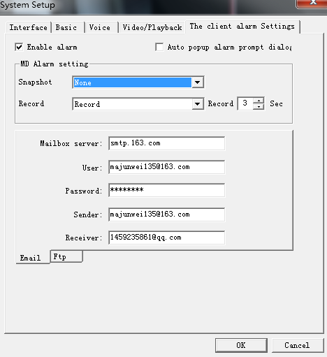
In the image above, and that by 163, E-mail E-mail with QQ mailbox get the mail:
Server: write it 163 email address of the server address, SMTP. 163. Com
User: write the sender email
Password: write the sender email the Password
Keep sending people write: the Email address, majunwei135@163.com < mailto: majunwei135@163.com >
Receiver: write the recipient Email address, 1459235861 @qq.com < mailto: 1459235861 @qq.com >

1. When it set correctly, when completely after triggered motion detecting, open the recipient mailbox, can see alarm mail message:
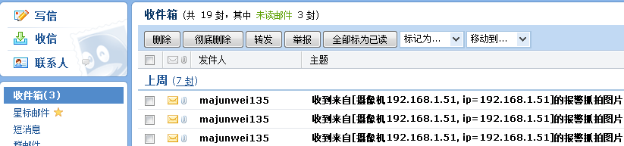

2 open the mailbox, can view detailed pictures alarm messages and download, etc.

Add:
Commonly used E-mail server name
Gmail (Google.com)
POP3 server address: pop. Gmail. Com
SMTP server address: SMTP. Gmail. Com

21 cn.com:
POP3 server address: pop. 21 cn.com
SMTP server address: SMTP. 21 cn.com sina. Com:

Sina. Com:
POP3 server address: POP3. Sina. Com. Cn
SMTP server address: SMTP. Sina. Com. Cn

Tom.com:
POP3 server address: pop. Tom. Com
SMTP server address: SMTP. Tom. Com

163 com:
POP3 server address: pop. 163. Com
SMTP server address: SMTP. 163. Com

263 the.net:
POP3 server address: pop3.263.net
SMTP server address: SMTP. 263. The.net

X263.net:
POP3 server address: pop. X263.net
SMTP server address: SMTP. X263.net

263 the.net. Cn:
POP3 server address: pop. 263. The.net. Cn
SMTP server address: SMTP. 263. The.net. Cn

Elong.com:
POP3 server address: POP3. Elong.com
SMTP server address: SMTP. Elong.com

China. Com:
POP3 server address: pop. China. Com
SMTP server address: SMTP. China. Com

Sohu. Com:
POP3 server address: POP3. Sohu. Com
SMTP server address: SMTP. Sohu. Com

Etang.com:
POP3 server address: pop. Etang.com
SMTP server address: SMTP. Etang.com

Yahoo. Com:
POP3 server address: pop. E-mail. Yahoo. Com
SMTP server address: SMTP. E-mail. Yahoo. Com

Yahoo. Com. Cn:
POP3 server address: pop. E-mail. Yahoo. Com. Cn
SMTP server address: SMTP. E-mail. Yahoo. Com. Cn

E-mail. Qq. Com
Pop3 server address: pop. Qq. Com
SMTP server address: SMTP. Qq. Com

