The client software inside, motion detecting video and shot to the FTP server, introduced the principle as follows:
The camera to a picture of a mobile testing objects, the software will be captured pictures and videos, pictures and video shot after the completion of the completed, will be promptly to the FTP server. In the following several aspects to set up good, can realize the function, in addition to the function requirement is the camera plate version 2.3.1.0 and above.

1 set up good FTP server, set good FTP user permissions
1.1 we here in Windows 2003 operating system with Serv-U above, and built a FTP server, the IP address is 192.168.1.15, subnet mask is 255.255.255.0, the gateway is 192.168.1.1.
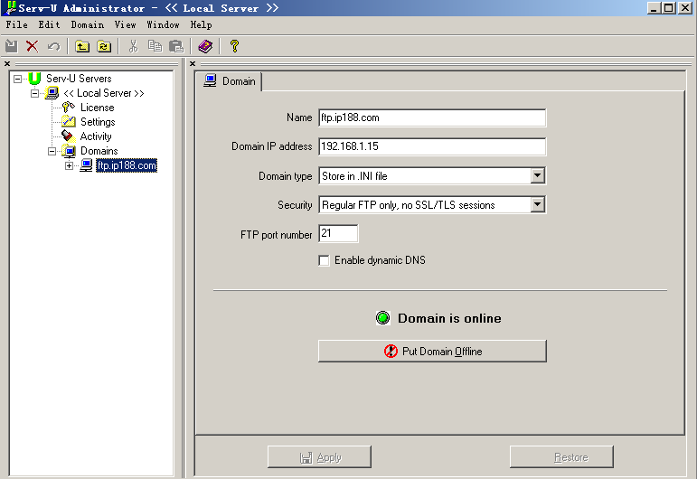
1.2 new a FTP users, user name is user1, the password is 111111, the users to upload and download () the limits of authority, sometimes you should remove permissions, such as the user space material already full, need to delete some things.
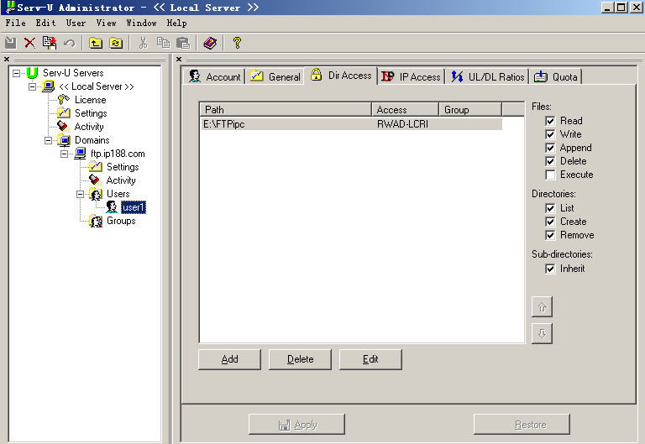
2 the client software inside associated Settings
2.1 open the client software, management-" motion detecting Settings, and add a or DuoGe to monitor the area

2.2 with the software inside, system Settings-" the client alarm Settings, do the following Settings:
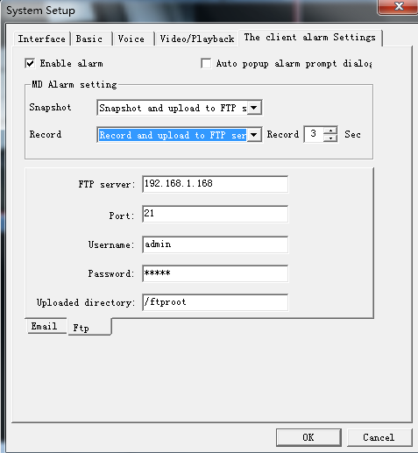
In the figure above meaning as follows:
FTP server address: refers to the FTP server address, here is 192.168.1.15, if is public IP, please write public IP address
The server port: the default is 21
Login user name: FTP above the user name user1
Password: FTP above the user name user1 password
To the directory: refers to the FTP upload the root directory of the user user1 to go under, the root directory is /
Explanation:
To be linked to the FTP server, monitoring the firewall to turn off the computer, or FTP port open can. If a public words to FTP, firewall rules to allow access inside, FTP through the can, otherwise, will be a firewall to refuse, material will not be able to top the FTP server.

3 check shot above picture FTP data
3.1 IE inside login to FTP server, to enter your user name and password user1 111111
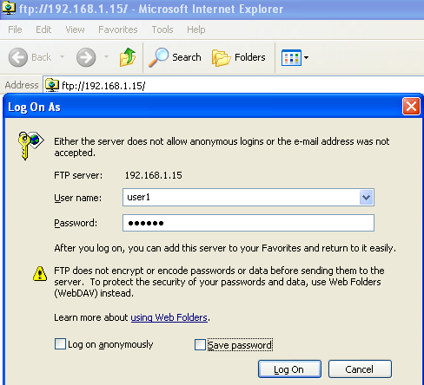
3.2 in the root directory, can see come over material. Upload
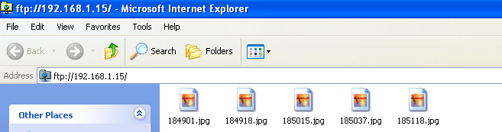
Explanation:
If IE it couldn't download, delete picture material, etc, please use the professional FTP client software, such as cuteftp, connected to the FTP server, such download delete is very convenient.

