Explanation:
- Many are users to upgrade, upgrade it, see no reaction, upgrade interface then pull out electricity to restart the camera, and in fact the camera in the background, and the results camera restart down, so upgrading, must pay attention to this point, before and after 3 minutes time to upgrade is complete
- The upgrade process, the firewall and antivirus software off, because it is unknown to program that blocks the, or in the firewall rules inside, our program can be added to the trust.

If 192.168.1.139 this video cameras to upgrade
1. Open the IE, http://192.168.1.139 , the input of the input video camera user name and password admin admin
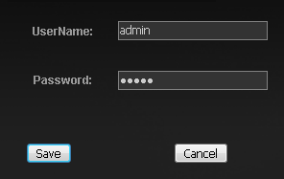

2. After some Configuration, into the IE
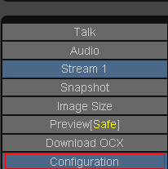
3. And then point located
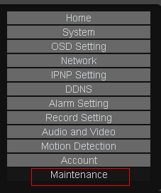
4. In the following diagram, select upgrade file
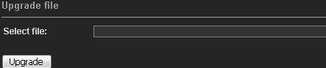

Suggestions will upgrade package direct put on C: or D: root directory, if upgrade package pathway, contain not English characters, may not be Linux system identification, cause upgrade failure.
5. Click upgrade button to upgrade
6. Upgrade is complete, cameras, among the restart will probably be a 3 minutes, please be patient, must not without electricity, or internal procedures will fall

Explanation:
Many are users to upgrade, upgrade it looked at upgrade interface not responding, having to restart the camera, but in fact the camera in the background, and the results camera to restart down, so upgrading, must pay attention to this point

