Explanation:
- Many are customers to upgrade their upgrade it, see, upgrade interface not responding, having to restart the camera, but in fact the camera in the background, and the results camera to restart down, so upgrading, must pay attention to this point, before and after 3 minutes time to upgrade is complete
- The upgrade process, the firewall and antivirus software off, because it is unknown to program that blocks the, or in the firewall rules inside, our program can be added to the trust.

If have a camera is the IP address of the 192.168.1.49, as the chart:
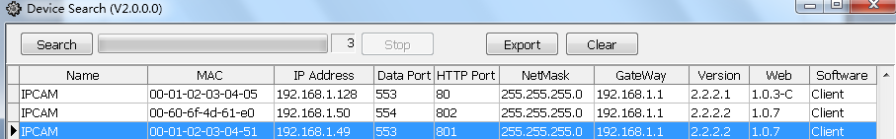
This camera is too old to the plate program, need to upgrade, the operation procedure is as follows:
1. We are generally choose the Update by right Update:
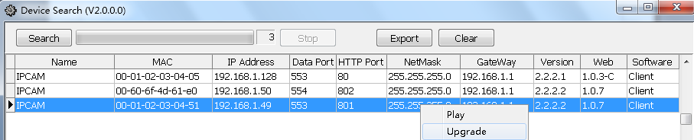
2. Then select upgrade package where the path:
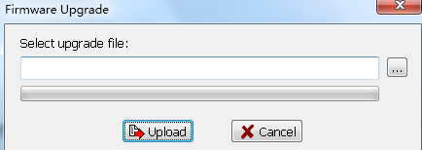
3. Find upgrade package where the path, click open:
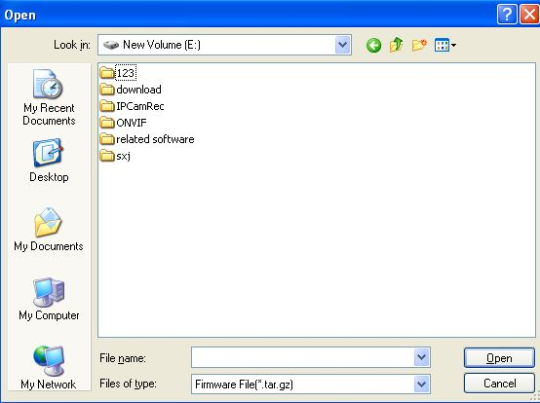
The extension is upgrade package tar. Gz, is a compressed package, don't decompression; Suggestions will upgrade package direct put on C: or D: or E: root directory, if upgrade package pathway, contains Chinese characters, may not be Linux system identification, cause upgrade failure.

4. Click upgrade fast:
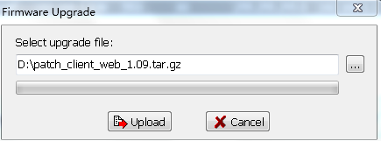
After the upgrade was successful in search tool, empty space, can have the Update tip, meaning is signing upgrade success:

5. After the upgrade is complete, cameras, among the restart will probably be a 3 minutes, please be patient, must not without electricity, or internal procedures will fall

Explanation:
Many are customers to upgrade their, he looked at upgrade upgrade interface not responding, having to restart the camera, but in fact the camera in the background, and the results camera to restart down, so upgrading, must pay attention to this point

