IE interface instructions for use

Date of update: 2012/06/16

Directory

First, before landing IE settings

1.1 camera factory default values
1.2 IE plug - related settings
Second, log
Third, real-time image

3.1, real-time image viewer

3.2 PTZ control area
Four, playback

Five, set
5.1 Basic Settings
5.1.1 users
5.1.2 TCP / IP
5.1.3 Time
5.1.4 Video and audio
5.2 Video and audio
5.2.1 Video stream
5.2.2 Cover set
5.2.3 Image Settings
5.2.4 OSD setting
5.2.5 PTZ settings
5.3、Event
5.3.1 Motion Detection
5.3.2 Alarm settings
5.3.3 Video settings
5.4 System Options
5.4.1 TCP/IP
5.4.2 Wireless
5.4.3 E-mail
5.4.4 DDNS
5.4.5 IPNP
5.4.6 FTP
5.5.6 Maintain
5.5 On
Sixth, the local settings
6.1 Local settings
Seven、IE FAQs
7.1 IE, how to achieve two-way voice intercom
7.2 How to video in IE
7.3 Board-side program to upgrade in IE
7.4 IE to go, but no screen display
7.5 SD card does not take
7.6 Search for less than a camera IP address
7.7 Camera all the way up to allow several users to simultaneously view
7.8 Garbled language switch in IE, how to solve
7.9 How to restore the camera factory settings
7.10 Network ball machine in IE to set the auto-cruise

Description:
A network camera like a computer belonging to the high-tech products, testing and use of the process, not to frequent power outages, or internal procedures will be problems, the camera is normal to start to be 2-3 minutes from power to power-off interval of at least more than three minutes.
(2) the network camera is more complicated, if you are using the network camera for the first time it is strongly recommended to read the Network client software manual "basic knowledge" because to some knowledge of the network camera will use the network.
3 IE development of our camera that comes with Windows-based system, in order to achieve a better viewing experience, Windows system comes with the IE browser to watc
IE set at a landing
1.1 camera factory default values
Default IP: 192.168.1.128
Subnet Mask: 255.255.255.0
Default Gateway: 192.168.1.1
PTZ protocol: PELCO-D
Baud Rate: 2400
Address code: 1
User Name: admin
Password: admin
1.2 IE plug - related settings
A video plug-ins run in the IE browser, you must modify the security of the IE browser, in IE's "Tools" menu select "Internet Options ...", as shown in Figure 1.1, put another 3721 Internet Assistant switched off, these things will stop the IE plug-in installation.
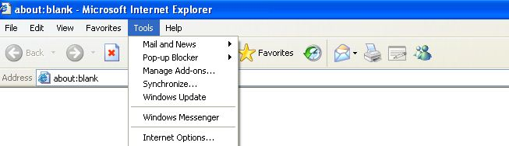
Figure 1.1
The Internet Options box, select the "Security", shown in Figure 1.2
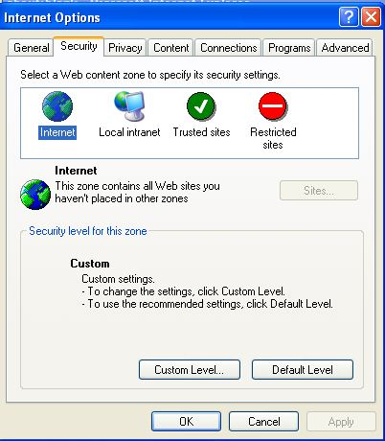
Figure 1.2
2, click the "Custom Level (C) ..." button, open the Internet security settings form, in the "Download unsigned ActiveX controls", "Download signed ActiveX controls, ActiveX controls not marked as safe initial and script "" allow the status bar head updates via script ", select" Enable ", then" OK "button to determine, as shown in Figure 1.3, 1.4 and 1.5
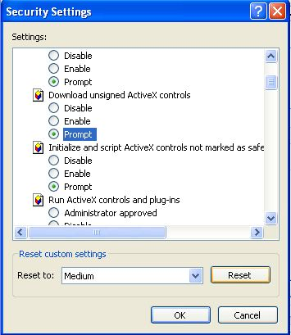
Figure 1.3
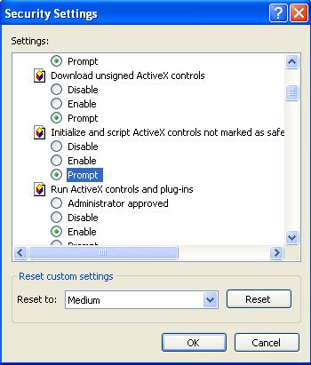
Figure 1.4

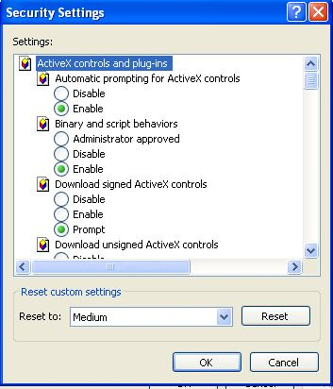
Figure 1.5
3. Local Intranet and Restricted sites (Figure 1.2), repeat the above steps set.

Second, log

1, in the IE browser address bar enter the ip address of the camera, the camera default IP address is 192.168.1.128 shown in Figure 2.1
Figure 2.1
2, in IE, the following window, shown in Figure 2.2, enter the user name and password, click on the Button to enter the main interface (camera factory default user name is admin, password is admin). If this is the first viewing may not display images, this time in IE will be prompted to install the OCX control, install the IE cache after cleanup, the image can be displayed. If the OCX controls are not installed successfully in the main interface, click on the entry of local settings in the options click on the local settings to download and install.
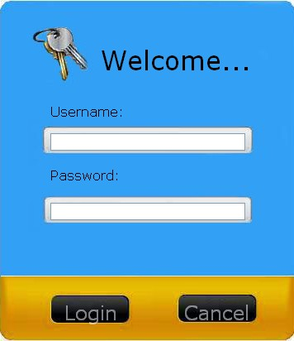
Figure2.2
3, the main interface, shown in Figure 2.3
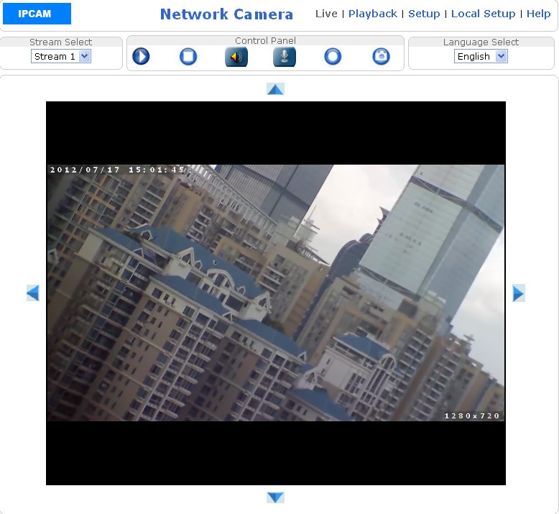
Figure 2.3
4, if it is the first time into the main interface to display the English version can be switched into Simplified Chinese or Traditional Chinese, as shown:
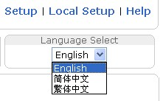
Figure 2.4
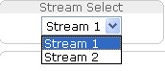 ：Select stream 1 or stream 2 watch
： Broadcast
： Stop playing
：Two-way voice intercom
：Manual recording, click on the video icon will turn，Start recording, click again Will stop recording
：Capture.video capture save path, see "6.1 Local Settings"
Third, real-time image
3.1, real-time image viewing. Figure 3.1:
Figure 3.1
Double-click the picture for full-screen viewing, double-click the screen again to exit full screen or press esc to exit full screen

3.2 PTZ control area

Click on the icon in Figure 2.5 Will show the PTZ control region, as shown in Figure 3.2.
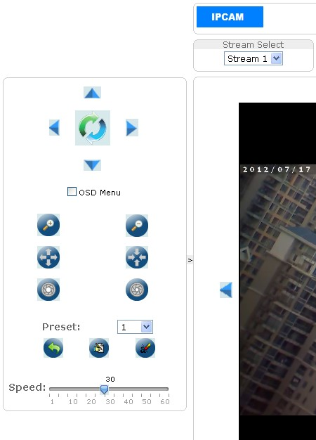
Figure 3.2
- through Button on the PTZ control up and down
- through Button on the lens zoom adjustment, with one ball machines have this feature.
- through Button to adjust the lens focus distance.
- through Button to adjust the lens aperture size.
- through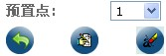 Button to preset settings.
- PTZ speed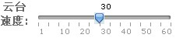：Is the speed of head rotation
Note: This feature is effective for the camera with PTZ.

Four, playback
Playback in real-time image "Click" into the video playback interface. Figure 4.1
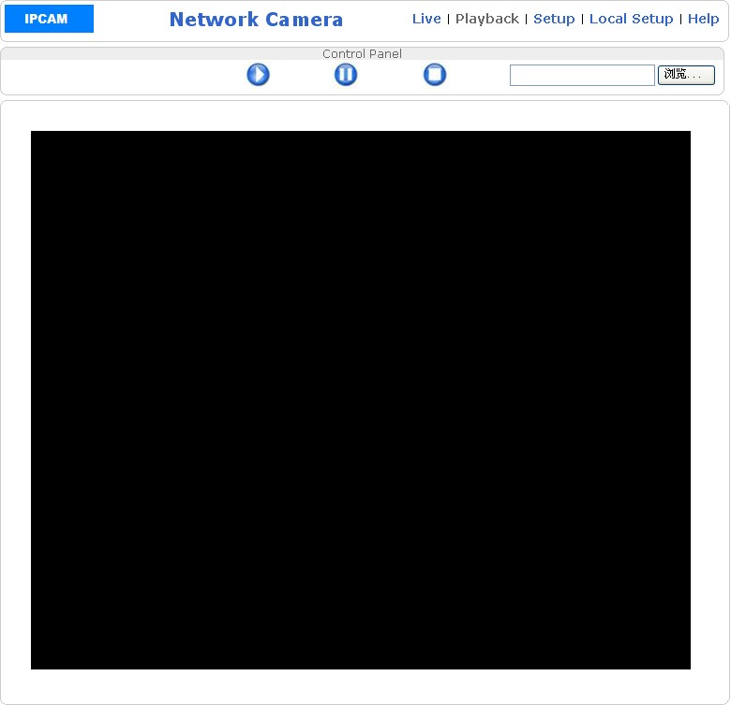
Figure 4.1
：Broadcast
：Pause
：Stop
：Click Browse to open the specified video file for playback.
5: Set
In real-time image "Click" settings "and enter the settings interface. Figure 5.1
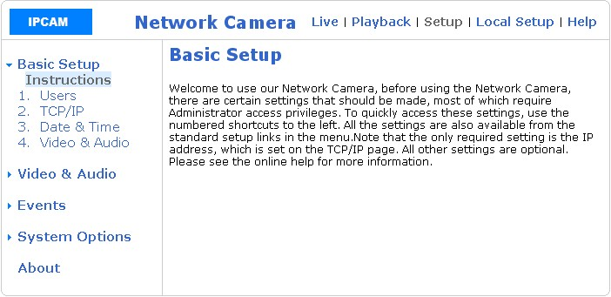
Figure 5.1
5.1 Basic Settings
5.1.1 users

Click on the "user" and enter the user settings interface. Figure 5.2
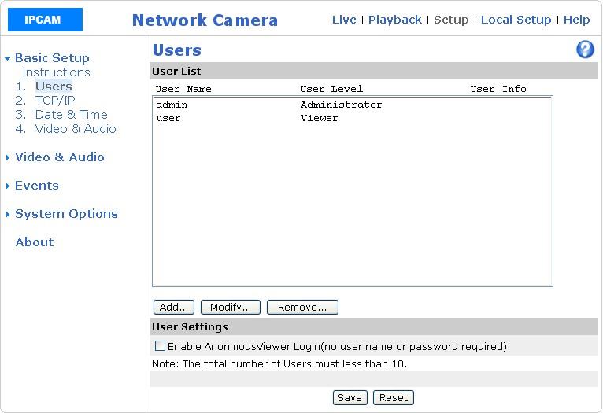
Figure 5.2
Supports three user rights management, the administrator: the highest authority, can perform all operations of the camera; operator: You can view and video, can also modify the configuration of the inside, such as resolution, but there are two points can not, one can not add / delete users, but can modify their own password, and second, the camera can not restore the factory settings; Observer: You can only watch, in addition to any right
：The user can increase / modify / delete the user name.
5.1.2 TCP / IP
Click the "TCP / IP TCP / IP settings interface. Figure 5.3
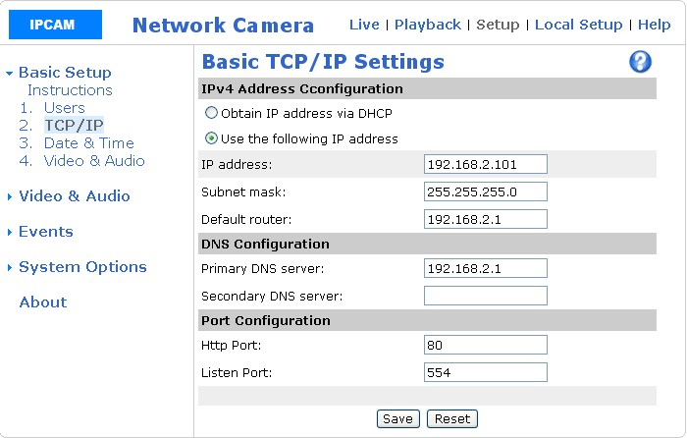
Figure 5.3
1, automatically obtain an IP address: This feature is not recommended, many customers obtain an IP address, can not find which cameras, it is recommended to use a static IP address.
2, use the following IP address: You can set the camera's ip address, subnet mask and default gateway, the IP must monitor the computer in the same network segment,
Network IP is not very familiar with, be sure to look in the client software manual network basic knowledge introduced
DNS settings: Primary DNS server address and server address can be set, generally do not set.
Port settings: our camera a total of two ports, HTTP port number is the port number used in the IE viewing, listening port number is the client software
When viewed with the port number, HTTP default port number is 80, and the listening port number is 554, these two ports can be modified
These parameters modify the camera will restart.

5.1.3 time

Click on the "time" to enter the time setting interface. Figure 5.4
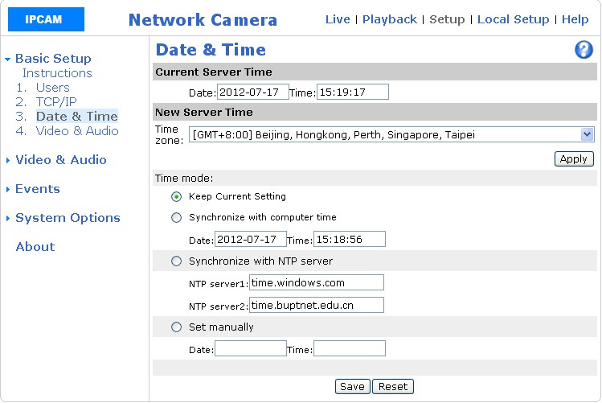
Figure 5.4
A time zone: can be set to display the current time of the currently selected time zone. Click Apply in the current server time "column shows
2, save the current settings: check the function, the camera time with the current server time synchronization.
3, the synchronization of computer time: check the function, the camera displays the time and computer time synchronization.
Synchronized NTP server time: check the function, the camera displays the time with the NTP server time synchronization.
5, manual settings: check the function, can be customized to set the camera to display the time.
* Note: The effect Click "Save". Modified time will be displayed in the current server time "column

5.1.4, as the audio

Click on the video and audio into the video and audio settings interface. Figure 5.5
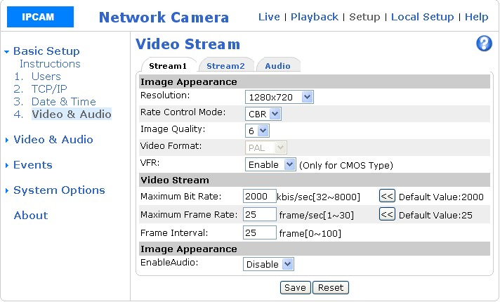
Figure 5.5
Resolution: change the current resolution of the camera.
2 Rate Control Mode: change the stream and a constant stream,
The role of the variable bit-rate: less moving objects in the picture, the stream will automatically be down, when a moving object in the picture for a long time, the stream will automatically rise, and the result is basically the same, it is recommended to use variable bit-rate, you can save network bandwidth external network monitoring.
: Regardless of the screen, moving objects, the number of stream constant, a constant stream.
3, the image quality: You can set the camera's picture quality settings, 1, 2, 3, 4, 5, 6 ，6 option 6 for the most clear, 3 medium, 1 is not clear
4 ，image format: You can set the video format (NTSC or PAL) for the CCD camera.
5，Variable frame rate: Open, when fewer moving objects in the picture, frame rate will automatically down a moving object for a long time, the frame rate will automatically rise
6, the maximum bit rate: that limit the camera stream.
7, the highest frame rate: the CCD camera, PAL system for all resolutions up to 25 NTSC resolution 30; the CMOS millions of cameras, only PAL system, up to 2 million 15 1 million 4CIF, CIF highest is 25
8, I frame interval: keyframe interval, the shorter the time, the shorter the time interval between key frames, image Delay smaller, code rheology. Instead, the key frame interval the longer image delay larger yards rheological small (relatively).
9, Open Audio: open two-way voice intercom.
10, click on the stream into the stream 2 set interface. Figure 5.6
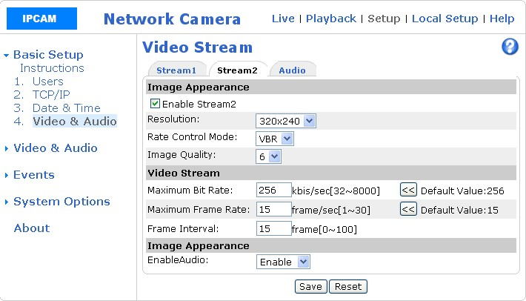
Figure 5.6
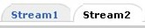 Here is the set stream 1, stream 2, is not a stream switching, the user should pay attention to the settings here.
11, click on the audio for audio settings. Figure 5.7
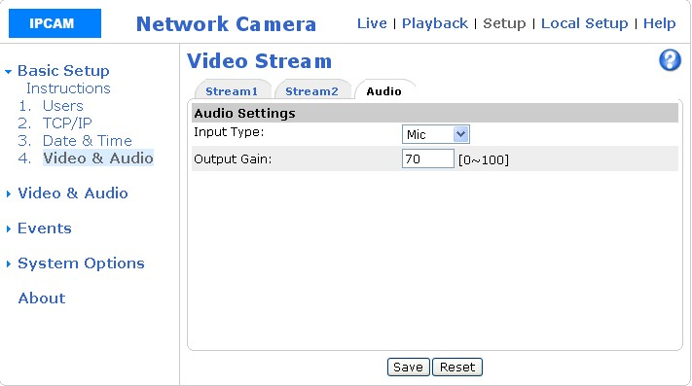
Figure 5.7
The input type line input and microphone input. Volume gain (you can set the output volume, range 0-100);

5.2 as the audio
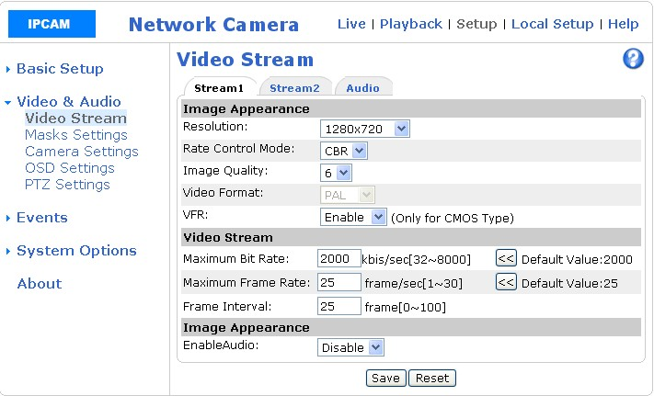
Figure 5.8
5.2.1 video stream
The video stream is set with 5.1.4 video and audio.

5.2.2 cover setting
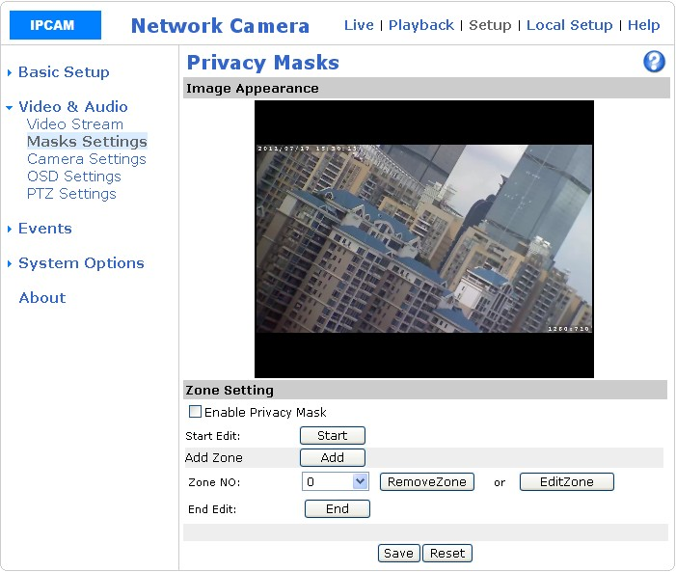
Figure 5.9
Click "Start" in the image you want to cover position to draw the cover box, the first box is 0, then if you want to add the cover box, click Add, then the second box, and then you want to add and so on can add up to 5 cover region. If you want to delete or re-edit area, area code need to remove or re-edit area, click the "Delete area" or "edit area", set up after clicking "end", click on the "end" and then check Open the privacy cover "function and click" Save settings cover the region will become black. Figure 5.10
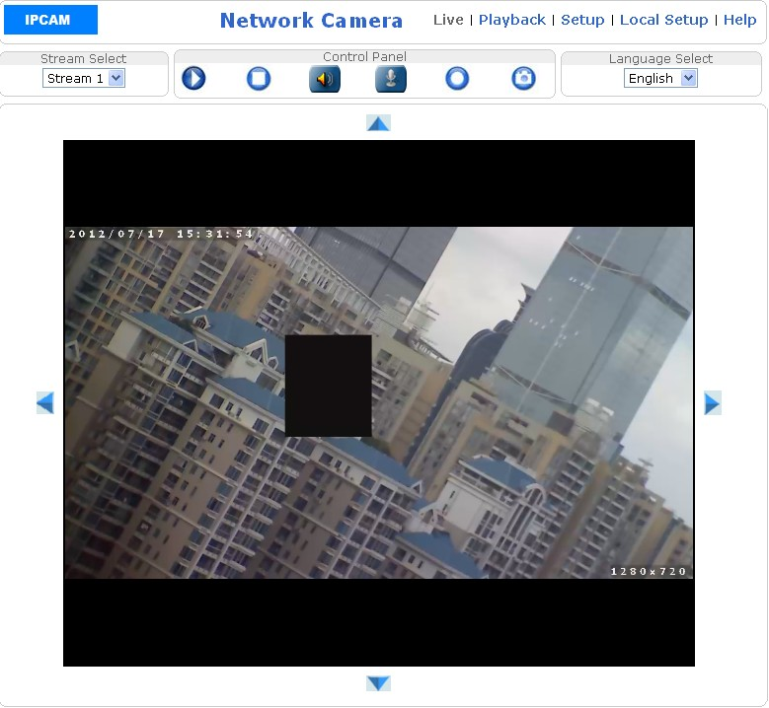
Figure 5.10
5.2.3 Image Settings
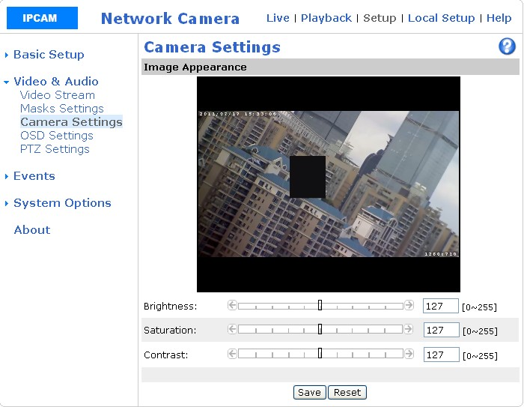
Figure 5.11
Brightness: set brightness, the default is 127

Saturation: Set the saturation, the default is 127

Contrast: set the contrast, the default is 127

Image set is to be effective for the CCD camera, the CMOS million camera brightness / contrast / saturation in the software which can not adjust the

5.2.4 OSD settings
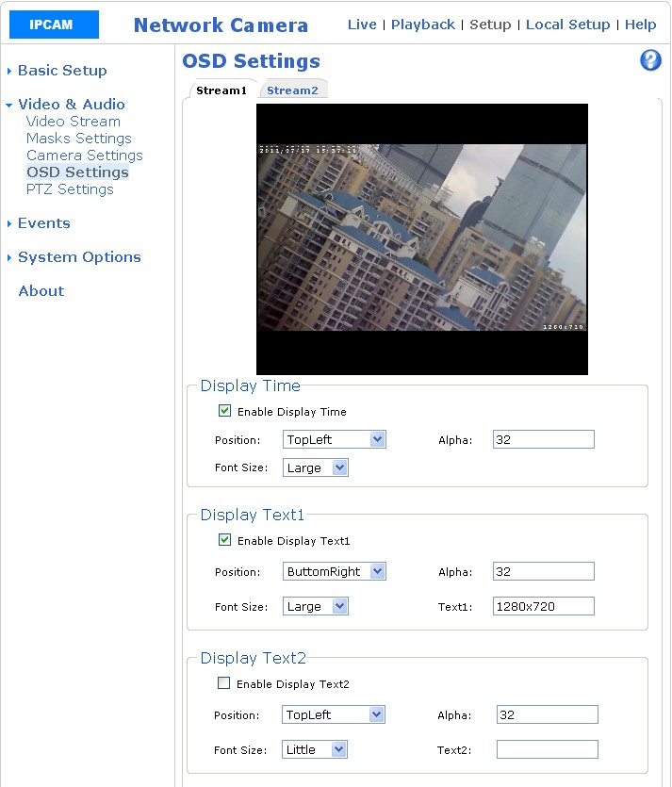
Figure 5.12
Customize the display of text and time on the channel, OSD character overlay function. This page can set the OSD display, position, transparency, OSD content (except for the time OSD) and font size.
Show time: check the "allow the display time" set the display position, transparency (Alpha), font size (large and small).
Display the text: check the "allow the display text of a" set display position, transparency (Alpha), font size (divided into large and small), text (OSD content), can set up three text.

5.2.5 PTZ settings
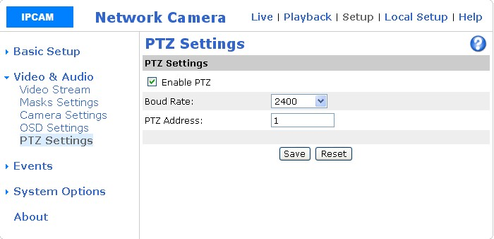
Figure 5.13
Camera pan and tilt settings for the ball machine.
Our camera default values ​​are as follows:
PTZ protocol: PELCO-D, Baud Rate: 2400, address code: 1. The baud rate can be adjusted, and ball machine control panel can be agreed before.

5.3, the event
5.3.1 Motion Detection
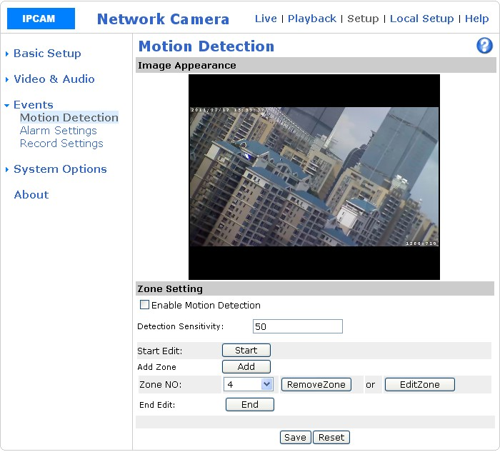
Figure 5.14
Draw detection box click "Start" position in the image you want to detect the first frame is 0, if you want to add the detection box, click Add, then the second box, and then you want to add and so on, can add up to a 5 detection area. If you want to delete or re-edit area, area code need to remove or re-edit area, click the "Delete area" or "edit area", set up after clicking "end", click on the "end" and then check open motion detection feature and click "Save.

5.3.2 alarm settings
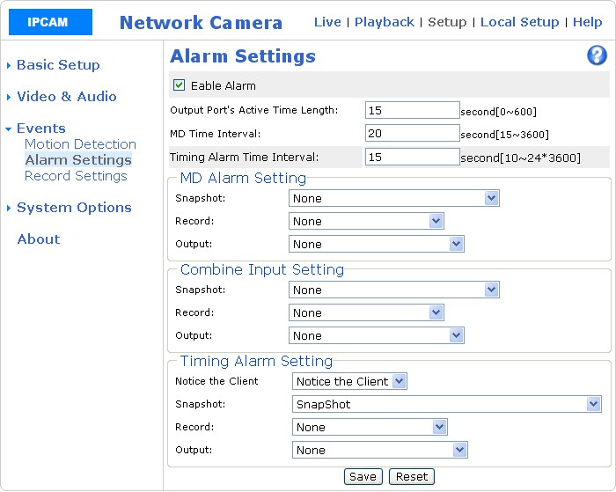
Figure 5.15
First introduced to the police under the concept of alarm: the alarm input and alarm output.
Alarm input and motion detection alarm, you can also alarm input devices, such as smoke, access control, temperature control, infrared alarm detector, provided that these devices give us the camera a switch connected to the camera, alarm input hardware interface on.
Alarm output device, the market above the alarm host, and these devices to give the camera a switch, connected to the camera alarm output hardware interface.
Default is one alarm input, one alarm output. The small number of cameras is a two-channel alarm input, no alarm output.
Open the alarm function, alarm function page, page subkey function, introduced as follows
1, the length of the activation time of the output port, the default is 15 seconds, time can be modified.
2, the motion detection time interval, the default is 20 seconds, time can be modified.
3, regular alarm time interval, the default time is 600 seconds, the time can be modified.
, Snap: refers to the camera detected motion detection, video cameras to take snap action, a total of five options
(1): refers to the camera detected motion detection does not take any action
(2) capture: camera detected motion detection Image capture to SD card. In more detail, refer to the client software manual "" SD card using the documentation "
(3) capture and sent to the mailbox: see the document "client software manual" "motion detection alarm to send an e-mail
(4) capture and sent to the FTP: the reference documentation for the client software manual "motion detection alarm uploaded to either an FTP
(5) All of the above features: refers to the capture, capture and sent to the mailbox, snap and sent to the FTP at the same time
5 Video: refers to the camera detected motion detection, video camera to take video action, there are three options
(1): refers to the camera detected motion detection does not take any action
(2) Video: refers to the camera detected motion detection, video recording to SD card. In more detail, refer to the client software manual "" SD card using the documentation "
(3) Video sent to FTP: reference document, "client software manual" motion detection alarm uploaded to the FTP
Output: refers to the camera detects motion detection, camera and an external alarm output device linkage, there are four options
(1): and an external alarm output device linkage
(2) output to port 1: The camera's external port 1
(3) output to port 2: The camera's external port 2
(4) output to port 1 and 2: output to the external port of the camera 1 and 2

5.3.3 video settings
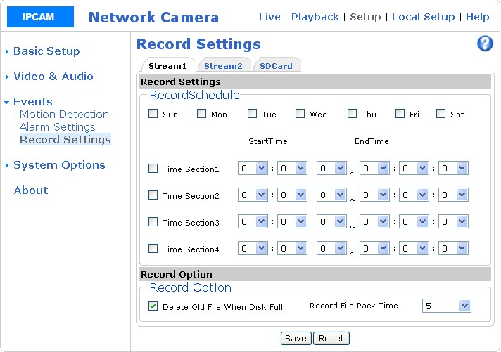
Figure 5.16
This function module is on the SD card camcorder, if you buy a camera with SD card, this part do not understand.
A plan video stream: our camera supports dual-stream within the network monitoring, stream 1, stream a better bandwidth; when RMON external network bandwidth is not enough, video stream 2 to stream 2 bandwidth is smaller.
2, SD card: click on the SD card to view the camera SD card information, set up to capture image files to retain the number. Figure 5.17
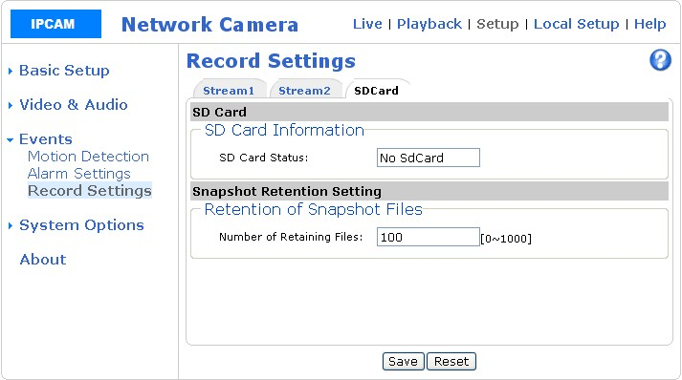 Figure 5.17
3, video programs: a weekly time to video, all video is recorded on the SD card
, Video options: as needed, can check and delete the old files when the disk is full, select the video file packaged length minimum of one minute period of maximum 60 minutes a period.
5.4 System Options
5.4.1 TCP / IP
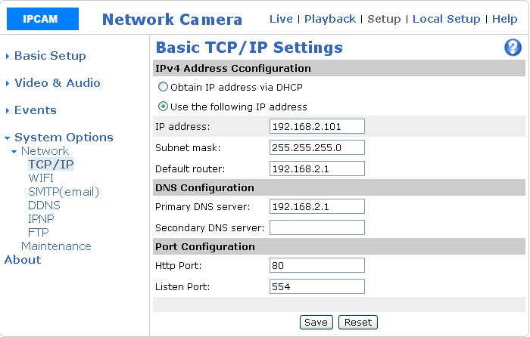
Figure 5.18
TCP / IP settings with "5.1.2 TCP / IP" the settings.

5.4.2 Wireless
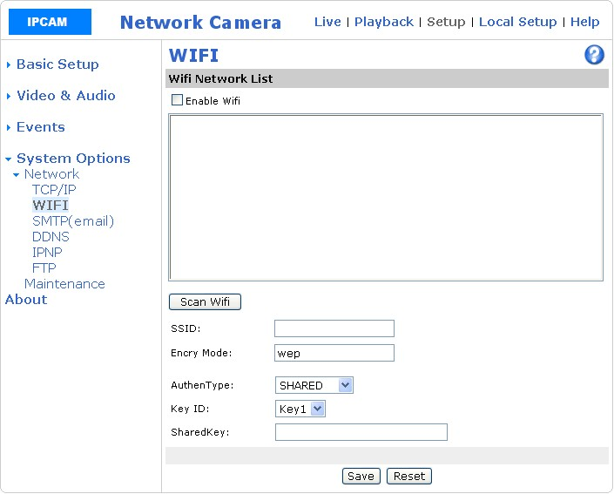
Figure 5.19
This function module is a WIFI camera, if you buy the camera without WIFI, this part do not understand.
Check the "open wireless network, and then click on the search, in the following figure, the search to two wireless networks, this WIFI wireless network, for example:
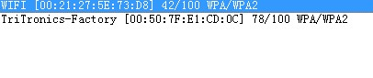
Figure 5.20
A WIFI, that is the name of the wireless network is WIFI, three 42/100, represents the wireless signal strength is 42%, if the middle across the walls and other obstacles to block the wireless signal attenuation is very powerful, it is recommended that do not have any objects separated block.

Using WIFI wireless network, double-click it, SSID, security mode will automatically add, then enter the wireless network password "Sharedkey" stay two minutes (the camera you want to save the information of the wireless network), the camera power supply and network unplug (and sometimes power off several times before the entry into force), and then re-power on the camera is powered on, the process, do not access the network cable, the only way the camera to use the wireless network; If you are a first access network line, and then power-on, the camera detects that a network cable, you will not use the wireless network, which keep in mind.
Description:
A wireless network connected, followed by cable and still use wireless, cable is no longer used, the network of cameras to power, first detected prevail.
Due to the instability of the wireless network, the stream is large, screen delay, it is recommended:
① The high-power wireless router
② the largest stream of each camera control in 1200kbps within, if the stream is too large, picture cards, or even not connect.
③ wireless router and camera closer the better, and the middle do not there is an obstacle to an unobstructed

5.4.3 e-mail
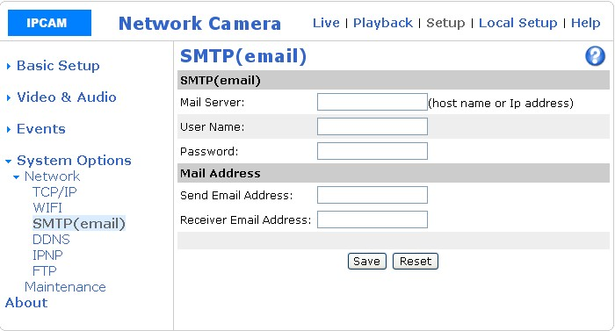
Figure 5.21
A mail server: write E-mail address of the sending server
2 User Name: Write the sender mailbox
3, Password: write the sender mailbox password
4, send e-mail address: Write the sender's Email address
5 Receive e-mail address: Write the recipient's email address
Above completely set up correctly in 5.3.2 Alarm Settings to select capture and sent to the mailbox, open the recipient's mailbox when the motion detection is triggered, you can see the alarm e-mail messages, see "client software manual "motion detection alarm to send an e-mail."

5.4.4 DDNS
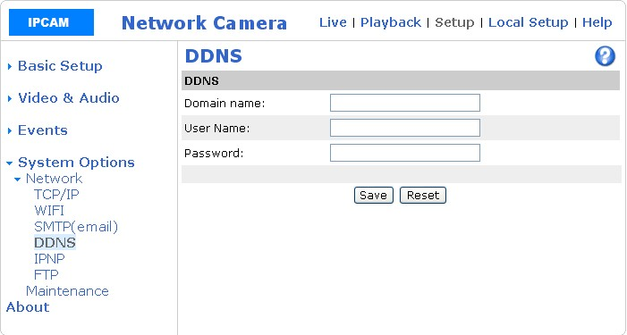
Figure 5.22
Www.3322.org or www.dyndns.org above for a free domain name, for example, to apply to the domain name for the test.3322.org remember domain name and password of the camera support www.dyndns.org and www. 3322.org domain name services.
Will apply to the domain name (DDNS Account), the user name (User Name) and password (Password) after the fill, click the "Save";
Save the parameters of the camera will restart.
Need to know here, RMON until use.

5.4.5 IPNP
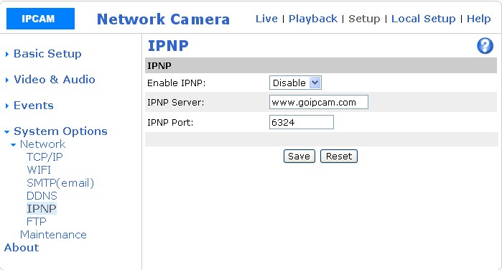
Figure 5.23
RMON when the Open IPNP "select" Open "," IPNP server "IPNP Port Leave the default value can be. See this document 7.10 how to use the Plug and Play (IPnP).

5.4.6 FTP
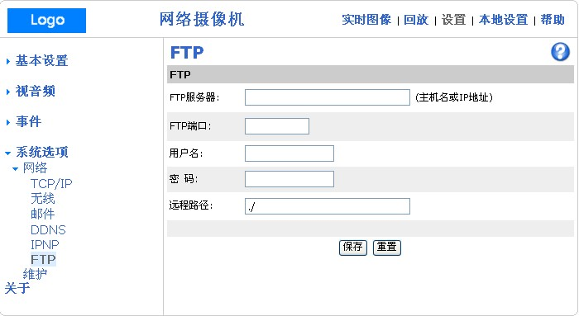
Figure 5.24
FTP settings see "the client software manual, motion detection alarm uploaded to FTP. The above completely set up correctly in the 5.3.2 Alarm Settings, select the capture and send FTP, video and sends the FTP when an alarm is triggered, open the saved path, you can see the alarm information.

5.5.6 maintenance
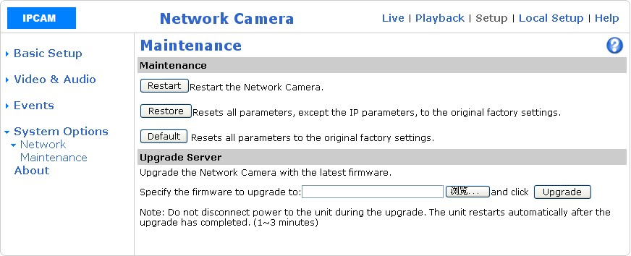
Figure 5.25
1, restart: restart camera
2, Reset: Restore the camera all the factory settings, in addition to IP,
3, restore the factory: to restore the camera all the factory settings,
Upgrade: Click Select the upgrade file, then click Update the camera firmware software

5.5 With regard to
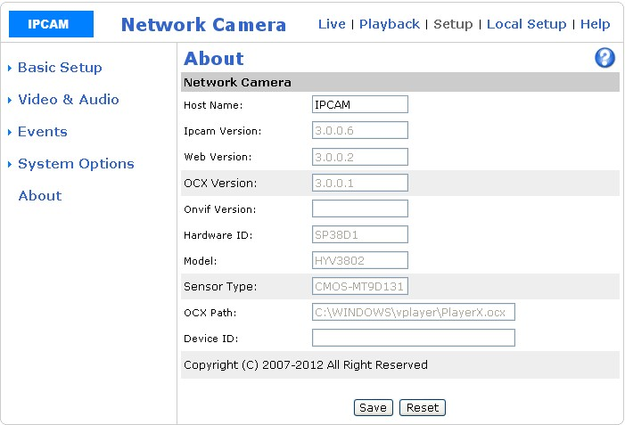
Figure 5.26
About: Displays the camera as a whole is probably information
Host Name: the name of the camera, when more than one camera in the network, you can modify the name of the camera to distinguish between, for example, room 1, room 2, etc.

Sixth, the local settings
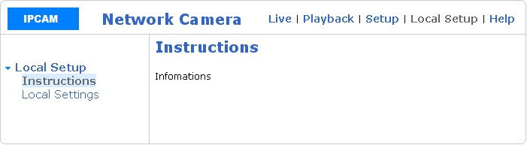
Figure 6.1
6.1 Local Settings
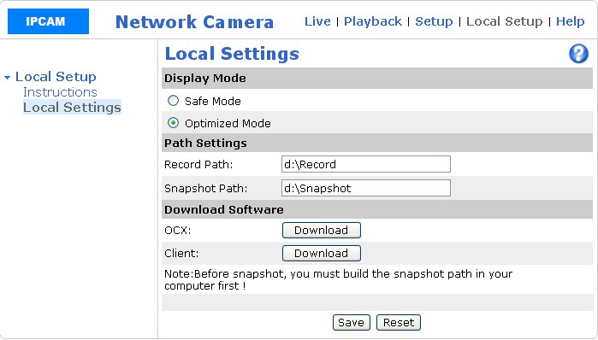
Figure 6.2
Safe Mode: use separate graphics card.
2, the optimization mode: use separate graphics card.
3, the path of video capture path: the user needed can set your own path.
4, OCX, client: You can download and install the OCX, the client.

7, IE FAQs

7.1 in IE how to achieve two-way voice intercom

Principle:
Camera - Computer:
The front-end video camera connected headphones or pickup, complete voice input, sound transmission through the network cable to the computer monitor screen, complete the sound output through the computer audio.

PC - camera:
The computer above the microphone (or headphones) connected to the computer to complete the voice input, sound transmission through the network cable to the front of the camera, complete the sound output through the headphone speakers or speakers of the camera above.

Note:
Before carrying out two-way voice intercom test, we must first ensure that the headset (including microphone of the headset above) or pickup is good, the computer's sound card and sound card driver is installed correctly. Hardware and software settings to be checked.
Two-way voice method there are two, one in IE, the second is in the client software, cameras to 192.168.1.136, for example:
A: In IE, the two-way voice intercom
- open IE and enter the IP address of the camera:
- enter the camera's user name admin, password admin, into the camera:
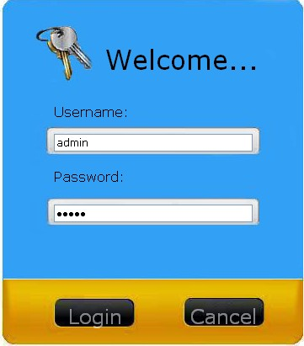
（3）In the following page, the setting options:
4 On the following page, click on "audio":
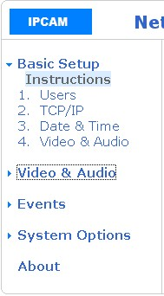
5 In the following pages, audio input capabilities of the stream 1 and stream 2 opens, and click Save:
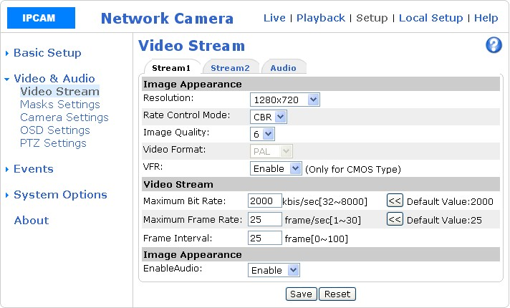
6. Click the "Audio", as shown in the figure above:
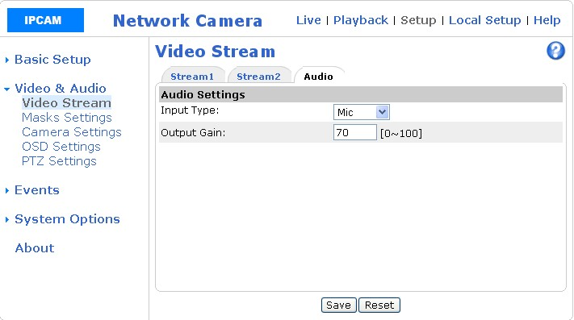
Audio input type: Microphone input (commonly used in a headset, microphone and other input), the linear input (commonly used in the active voice for front-end input), the volume gain on behalf of the volume size: 100 maximum, minimum 0.
Description:
If there is noise, the gain of the image above transfer of small, such as 30.
Otherwise indicated, our camera is the sound is not treated, the front-end monitoring center / camera to capture any sound, what kind of sound to the camera / monitoring center, if it sounds noises, general environmental noise, such as monitoring center to access the microphone into the microphone inside the sound, are the ambient noise if the microphone is replaced with the headset to test, you will find no murmur basic reason is that the microphone inside the sound too much, all noise and network cameras are not related.
Monitor the Home screen, click on the intercom, audio tab, as shown below:
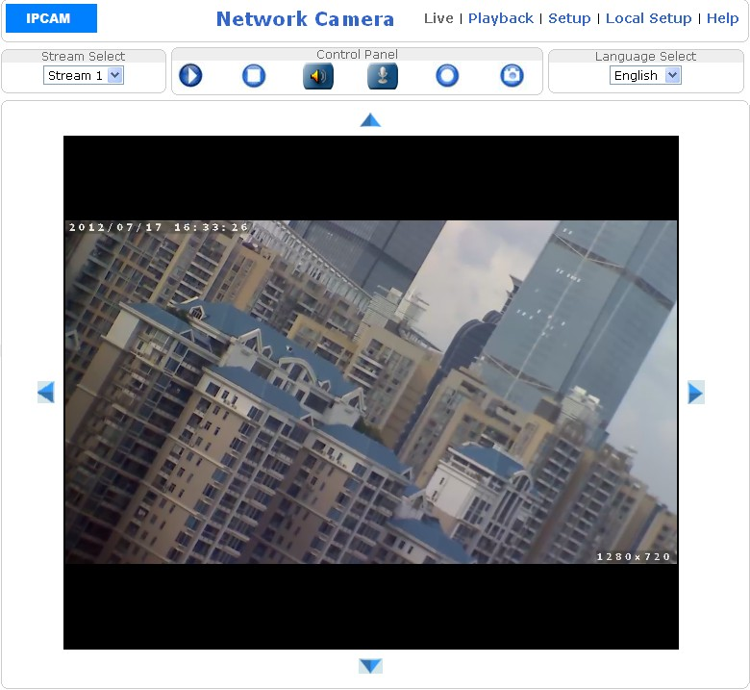
Click on the intercom, audio tab icon will turn，Said intercom, audio has been opened.
Description:
During the two-way voice test, ADSL Internet access, please stream bandwidth is controlled at less than 350kbps.
8. Right-click the computer's volume control，，Open Volume Mixer to IE the volume to the maximum
Note: If still no sound, Step 5 and Step 7 re-run.

7.2 IE how to video:

IE monitor screen, Button to the video / stop recording, the default was recorded in the d: under the root directory, the path can be modified. Modify the path to see "6.1 Local Settings." If you want to watch the video, then, to be special with our players to play.

7.3 in IE, the board-side program to upgrade:

Under normal circumstances, do not need to use this feature, will be used to upgrade individual cases.
Description:
1 camera upgrade process takes about 2-3 minutes, and upgrade the interface does not respond, Do not power this process, otherwise the camera program will crash, so when you upgrade, you must pay attention to this point.
(2) during the upgrade process, should firewalls and antivirus software turned off, because it is unknown procedures had been blocked, or the inside of the firewall rules, we add to the trust can.
If 192.168.1.139 this camera to be upgraded
- Open IE and enter http://192.168.1.139, enter the camera user name admin, password admin
2. Enter the IE, point to Settings → System Options → Maintenance
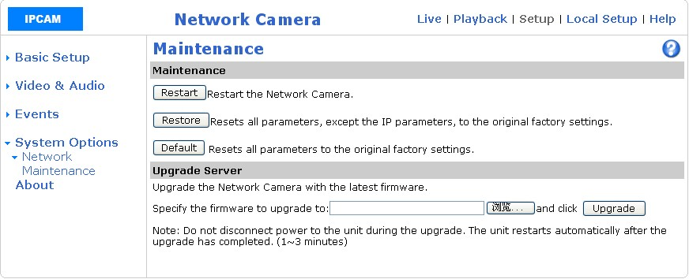
3. Click Select the upgrade file, it is recommended that the upgrade package directly on the C: or D: root directory.
4. Click the upgrade button Upgrade
5 Upgrade is complete, the camera will restart, the middle about 3 minutes, please be patient, must not be power outages, or internal procedures crash

7.4 IE can go in, but no screen display

A. IE browser's "Tools" menu, "Internet Options ..." is not set to allow control to install, re-setting the first chapter of this manual login before IE settings to explain.
Two. IE plug-ins OCX is not installed successfully, OCX controls in the IE browser, the player with the video image. IE in will be prompted to install the OCX control, install the IE cache after cleanup, the image can be displayed in the new set up the first chapter of this manual before landing IE settings, refresh the page. Or in the main interface, click on the local settings to enter in local settings option and click download and install OCX controls.

7.5 the SD card does not take

First, in IE, set → Events → Video Settings → SD card page inside to see the SD card is detected:
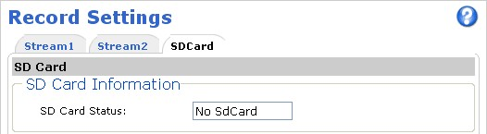
If not detected, that may be hardware issues, such as the SD module, or SD card poor contact, or SD card.

"SD card in the SD can be detected, but there is no video information, etc., that is not set, please refer to the" client software manual for instructions for use. "

7.6 Search is less than the camera IP address

The reason a lot of camera hardware, software, client network environment, switches, network cable, please check the following order:
A. Verify that the camera and monitor computers in a LAN inside.
Some sentinel sites computer more, in a large local area network which is divided a lot of small LAN, make sure the camera and monitor computers in the same small inside the LAN, the network division of VLAN, to allow the camera where the VLAN and computer between the VLAN to communicate with each other.
(2) turn off the computer firewall.
3. If the camera card data does not light, for the following reasons:
The cable is too old, RJ45 crystal head, or switch interface, it is recommended to do a test with the new cable;
If the camera card data lights bright, the search is less than the IP address, the following may
(1) The computer's IP address is a DHCP client, but to obtain the IP address is not valid.
(2) computer firewall is not related
(3) The computer may be a problem for a few good computer test
(4) switch entry aging, this time to pull power to restart the switch

(5) NIC lights, cameras inside some of the services did not fully start, have to pull power to restart the camera
Computer is set to static IP address, with a crossover cable to cameras and computers directly connected to the search, do not know what a crossover cable if you can find a place to buy computer accessories, to be a crossover cable, if the network not familiar with, and see to read the CD-ROM network basic knowledge introduced.
If the above method try it or not, may be the camera hardware problems, sent back the overhaul.

7.7 all the way to the camera up to allow several users to simultaneously view

When viewing the camera, mainly occupied by the camera CPU resources, the higher the camera resolution, occupied the greater the camera CPU resources. Has been tested and when the camera resolution is 2 million, two users can simultaneously view two to three users can simultaneously view when the camera resolution is 1 million, when the camera resolution is 4CIF 5 users can simultaneously watch when the camera resolution is CIF, 8 to 12 users can simultaneously view.

7.8 IE language switch garbled, how to solve

Internet monitoring screen in the margin point, right → coding, if it is the Simplified Chinese, on the selected Simplified Chinese (GB2312); if it is in other languages, in other selected the corresponding coding can be.

7.9 How to restore the camera factory settings

See "5.5.6 Maintenance

7.10 Network ball machine in IE set up automatic cruise

Description:
Preset point, the vast majority can be used to set the preset position, but few have a special definition, used to manage the preset position, as:

33 Or 130 | Start PTZ 360 degree scan (low speed)
34 Or 131 | To start the scan head 360 degrees (medium speed)
35 Or 132 | Start PTZ 360 degree scan (high speed)
41 Or 138 | Stop the the PTZ scan, line scan, patrol function
42 Or 141 | Start the inspection teams, a
43 Or 151 | The beginning of the inspection teams, a position set
44 Or 161 | Inspection teams, a stay in the beginning of the time setting
45 Or 165 | The end of the inspection teams, location or time settings
46 Or 171 | Inspection teams, one to restore the factory settings
PTZ control area
We illustrate how to set auto-cruise in IE, if there are three places you want to monitor, stay on the 1st patrol point 5 seconds on the 2nd patrol point to stay 10 seconds on the 3rd patrol point residence time of 20 seconds (every place stay the default is 5 seconds), then set the following steps:

a: We first set up three preset positions, turn the head to the place you want to monitor in the preset point Enter the number 1, then the Settings button.
The same way, we set up two monitoring points, turn the head to monitor the preset point, enter the number 2, then the Settings button.
The same way, we set up three monitoring points, turn the head to monitor the preset point, enter the number 3, then the Settings button.
b: To the inspection teams, a patrol route is set to 1 → 2 → 3 (set up inspection teams in front of the preset bit has been set)
43 preset points is called inspection teams set to (enter the number 43 Click Call the preset keys)
A call on the 1st preset point setting a patrol point (enter the number 1 click call preset keys)
, Calling on the 2nd preset points set two visits (enter the number 2 click to call the preset point key)
, Calling on the 3rd preset points set 3 patrol points (enter a number click to call the preset point key)
5 Call No. 45 preset points out the inspection teams, location settings (enter the number 45 click to call the preset point key)
6, No. 42, call preset points (enter the number 42 click to call the preset keys), start the inspection teams and inspection route scan head start to the 1 → 2 → 3
7, call No. 41 preset points (enter the number 41 click to call the preset key), or to move the keyboard joystick to stop the tour
: Residence time of inspection teams, one each patrol point be modified on the 1st patrol point to stay five seconds on the 2nd patrol point to stay 10 seconds residence time of the 3rd patrol point for 20 seconds (one for each local stopover at least five seconds), then the operation is as follows:
1, call the 44 preset points into the inspection teams, time settings (enter the number 44 click to call the preset button)
2, on the 5th preset point is called a patrol point dwell time is set to 5 seconds (enter a number, click to call the preset key)
3, the same way, calling on the 10th preset 2 inspections residence time is set to 10 seconds (enter a number click on call 10 preset keys)
4, call on the 20th preset points to three patrol points dwell time set to 20 seconds (enter a number click on call 20 preset keys)
5, call No. 45 preset points out inspection teams to stay in time settings (enter the number 45 Click to call preset keys)
Note:
A. 16 patrol points can be set up an inspection group
2.46 or 171 preset point inspection teams to restore the factory settings, referring to the inspection teams, one for each patrol residence time, back to the default of 5 seconds
3. Document the steps and methods of automatic cruise settings, H.264 ball machines are applicable (and front-end ball machine relationship, and the network board is does not matter)
4 different ball machine manufacturers, ball machine preset number is not the same, the document first preset position is defined, for our ball machine, but its principle of operation is the same. As for the definition of the ball machine factory presets, please contact the manufacturer of the ball machine.

