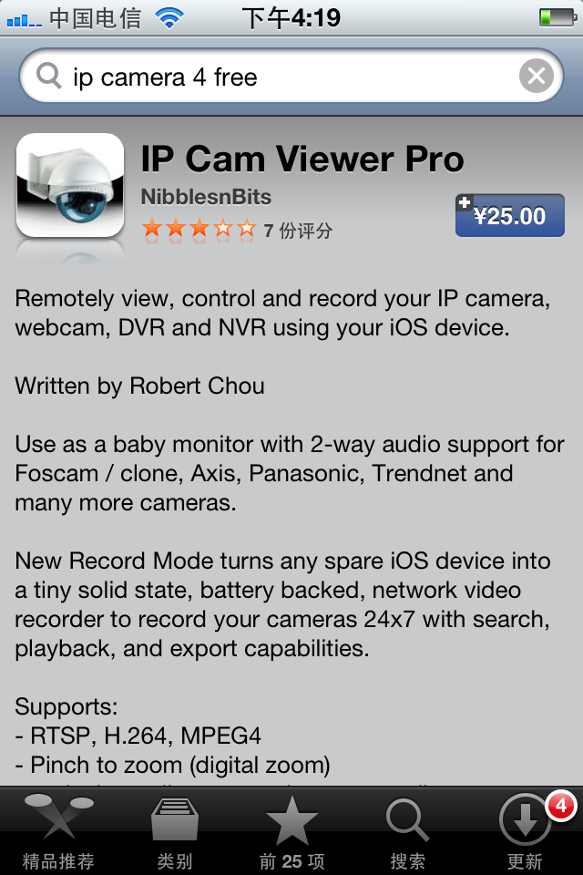
From iphone store, search “ip camera viewer ”. Buy the IP vision (3.9$.) and down load it.
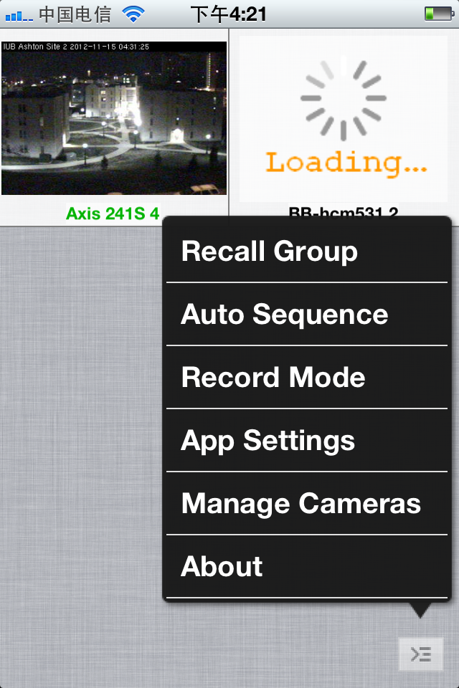
Manager camera and click “add cameras”.
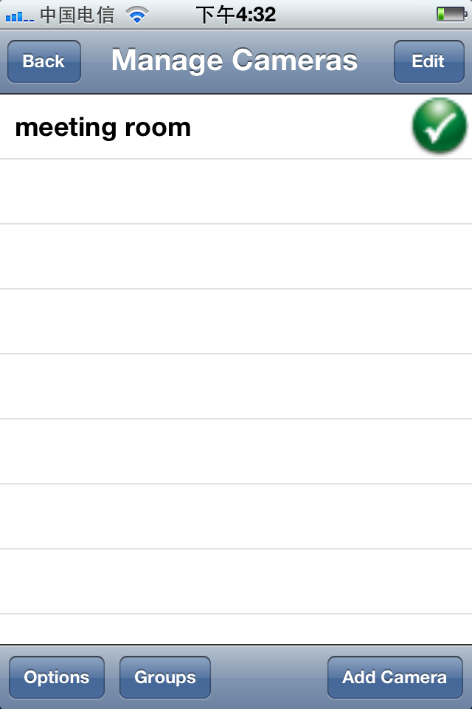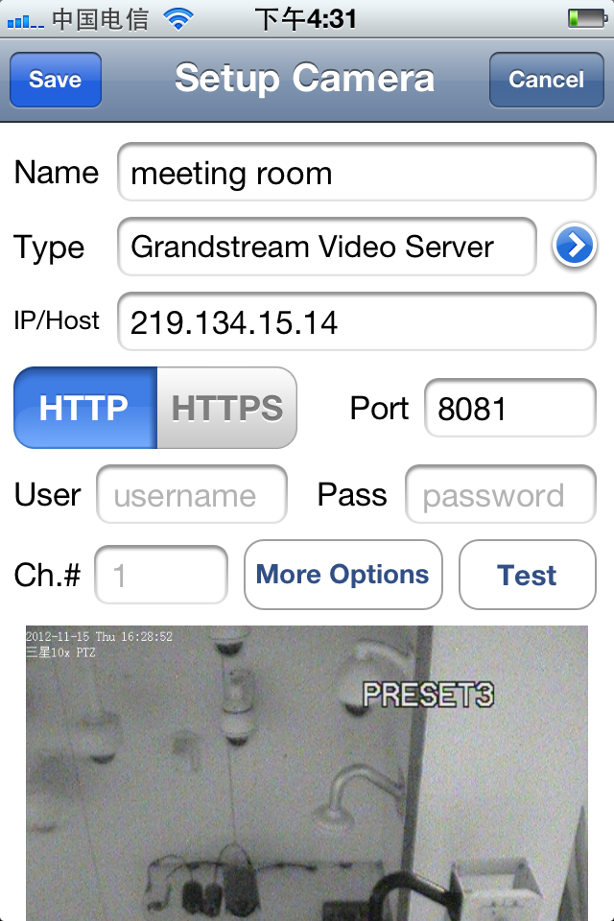

Name the camera
Type: choose Gram Stream
Host: write down the ip address or host name
Port: the port you already set up in the router
Username: the name you set up
Password: the one you set up

Now go the internet and set up the video stream to make it work in iphone.

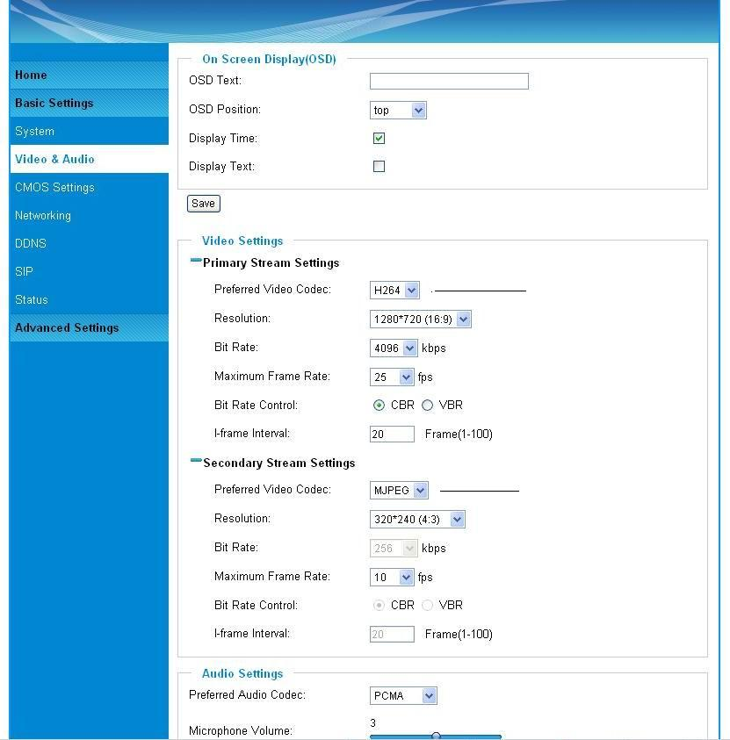

Now the camera should work well.

