Network Video Centralized
Management Software
Manual

Catalogue

Chapter 1 Software Instruction 3
1.1 Summary 3
1.2 Features 3
Chapter 2 Installation instruction 5
2.1 Environment request of running 5
Chapter 3 Introduction of basic functions 8
3.1The main interface operated by CMS 8
Chapter 4 Image Preview 10
4.1 Preview Function 10
4.2 Right-click Menu 11
4.3 PTZ Control 11
4.4 Image Settings 12
Chapter 5 System Settings 13
5.1 Monitoring point settings 13
5.2 Client Configuration 15
5.3 Device Configuration 17
5.4 User Management 26
5.5 The Client Log 27
Chapter 6 Video Recording 28
6.1 Video Playback 28
6.2 Video Plan 30
Chapter 7 Advanced 32
7.1 Decoder 32
7.2 Electronic Map 36
Appendix A Abbreviations 39
Appendix B Main parameters 40

Chapter 1 Software Instruction

Summary
This is a Central Control Software with powerful functions and Distributed Architecture. It combines with multi-window, multi-user, multi-language, voice intercom, video conferencing, alarm center, grading electronic map and is also compatible with other extended products. Stand-alone can directly connected devices surveillance system as one. Together with electronic map function and friendly interface, this software is simple to operate and convenient for permission settings.
This software is only for connecting different devices (DVR, DVS etc...), the manual only descript the software operation, for specific equipment features, pls refer to related product manuals.

Features

User and Authority management
Support N-level organization management, user management and authority setup.

Data interface technology adopted
All data exchanges adopt data interface technology, so it can flexibly support every database sizes, such as SQL, MYSQL, and XML data, etc.

Support EXCEL table editing for adding device
The platform enables users to adopt Excel spreadsheet software to add and edit devices, convenience for users to maintain quantities of devices, and improve system's usability and greatly reduce the workload for maintenance

Intelligent Video Transport Protocol
Intelligent Video Transport Protocol can maximize the use of network bandwidth. Especially on the condition of Front-end network bandwidth limited, it can ensure the normal operation in very low network bandwidth on the basis of the system to keep the quality of the image.

Scalable distributed network architecture
Support multiple servers running coordinately, intelligent load balancing, flexibility to add server and enhance the system capacity effectively on the condition of integrity assurance.

Perfect video monitoring
While real time monitoring, system support alarm recording, automatic monitoring recording, video playback, etc; can exactly control each channel recording status.

Dynamic regulation decoding buffer
When real time monitoring, it can be adjusted flexibly on video image of the fluency, which emphasis on real-time
Flexibility in adjusting the real-time priority or fluency on video image when real time monitoring, can meet different users need.

Adopting shelf technology and modular development
System adopts shelf technology, stratification and modular development, with rich service in pieces, can be flexibly assembled a variety of applications.

Central management
Centralized management of data throughout the system and data forwarding provide the perfect multi-user real-time monitoring program. Remote users can real time monitor or record playback through the network.

1.2.10 Easy operation
In access control, users can easily control and set each monitor point through the system, it also integrates E-map.

1.2.11 High integration level
The system integrates other related information, like Alarm and Voice, etc.

1.2.12 High reliability
The system designs a special Fault tolerance measures to assure data integrity and system running dependability.

1.2.13 Good scalability
The system designs for service, has good scalability and adaptability to maximally protect user investment.

1.2.14 Support Network management and load balancing

1.2.15 Support multi devices upgrade volume via network

1.2.16 Support User DIY interface and multi languages

1.2.17 Support 4 channels real time playback

1.2.18 Support connecting multi devices and view multi-device video (real time monitoring and playback)

1.2.19 XML data storage

Chapter 2 Installation instruction

2.1 Environment request of running

2.1.1 Hardware
CPU P4/2.0G
Graphics must support hardware scaling (such as ATI, TNT2 and PRO, but suggest ATI9800 or above, dual channels), Memory over 128M/128bit.
Note: If many screens need to be decompressed, it needs good configuration for memory, graphics and CPU.
Netcard: 100/1000M

2.1.2 Software
This CMS can run under Vista, WinXP, Win2000, Win2003 and Win2007, it's not suggested for windows 98. Pls close all Antivirus Software and firewall before installing the software so that it can write running program correctly and completely in the control center, or it will not search any devices.

2.2 Installation step
1) Find in the CD and double-click
“CMS_V3.0.9.18.T.exe” file, pop-up dialog box as shown below:
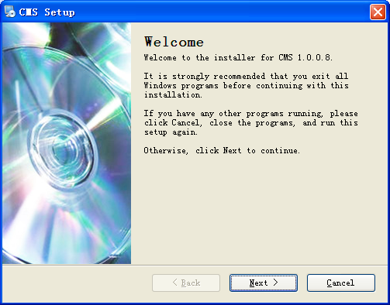
2) Click “Next ", popup dialog box as shown below:
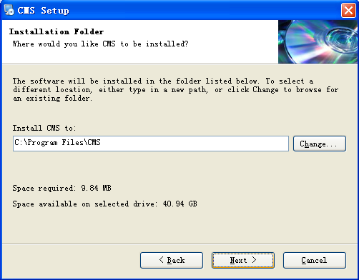
3) Click “Change” button, select the installation path, the system default folder is “C:/Program Files”, click “Next” button, select the Start Menu folder, as shown follow:
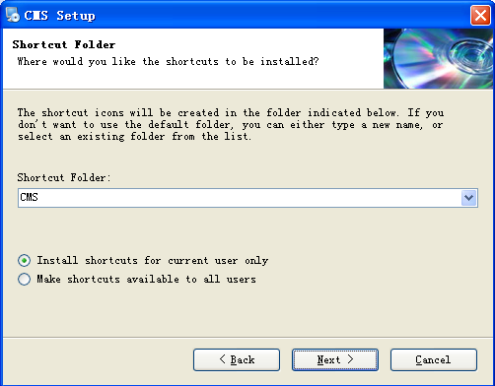
4) Click “Next” button to install CMS, after installed, popup dialog box as shown below:
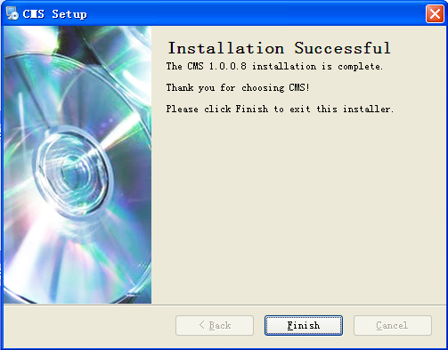
5) Click “Finish” button to finish the installation. At this point, the desktop icon will appear as follows:

After installed, in accordance with the introduction in Chapter 3, 4, 5 to use this control software.

Chapter 3 Introduction of basic functions

3.1The main interface operated by CMS
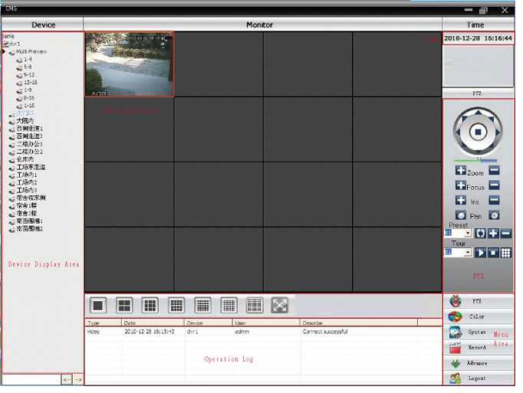

3.1.1 Device Channel Display area
“Device channel display area” is used to display the current channel that can be previewed. Users can preview the live pictures through the device, or preview the current pictures in groups through the channel that set by the super management. Users can click “Device List” or “Channel grouping” to change channel.

3.1.2Operating area
During the image preview, users can preview the current pictures in “operating area”. During the system configuration and video retrieval, users can set parameters in the “operating area”.

3.1.3Time display area
It will display the current time.

3.1.4 PTZ control area
It runs corresponding control and operation to PTZ.

3.1.5 Screen mode selection area
As needed, select the number of channels that need to be monitored.

3.1.6 Operating log information area
Under the associated configuration and operation, the control center can automatically report and detect the operating information.

Menu area
Users can select a single menu items and their sub-menu @The specific functions of each menu@ that need to be set in “menu area”. In the Control Center, users can operate the menu to control the video surveillance system.
Table 3-1 Menu structure
No. |  | First Menu |  | Second Menu |  | Third Menu | Function & Instruction |  | Operating right
1 |  | Preview |  |  |  |  | Click preview button "Monitor" to choose a preview of the screen,touring & switching among all channels and snapshot pictures of the screen. Shup down/open preview menu |  | Admin/User
2 |  | PTZ |  |  |  |  | Controling the speed cameras to go up,down,left,right and stop by operating panel,adjusting speed,zoom,focus,iris and auto pan, preseting and touring. |  | Admin/User
3 | Color |  |  |  |  |  |  | Set brightness,contrast,saturation and hue for video screen | Admin/User
4 | System |  | Device manager |  | Add zone |  |  | Add zone for all devices | Admin/User
4 |  |  |  |  | Add device |  |  | Add video surveillance devices | Admin/User
5 |  |  |  |  | Modify |  |  | Modify device name,ip address,user name and password | Admin/User
6 |  |  |  |  | Delete |  |  | Delete video surveillance devices | Admin/User
7 |  |  | Local Config |  | Base config |  |  | Select disk,disk list and logs maintenance | Admin/User
8 |  |  |  |  | Alarm setting |  |  | Enable audio activated by alarm | Admin/User
9 |  |  | Account |  | Group |  |  | Add and delete users' operating rights | Admin
10 |  |  |  |  | User |  |  | Add,delete and manage users: Set user name,password and operating rights of menu | Admin
11 |  |  | Local Log |  |  |  |  | Search alarm log and operation log in set time area. | Admin/User
12 | Record |  |  |  | Playback |  |  | Search record file and playback | Admin/User
13 |  |  |  |  | Record Plan |  |  | Set record time for every day | Admin/User
14 | Advance |  | Decoder |  |  |  |  | Set DVR and decoder | Admin/User
15 |  |  | Map |  |  |  |  | Using this map,it can visually show every cameras location and find current monitoring page directly | Admin/User

Chapter 4 Image Preview
In the menu area, users click “Image Preview”, the operating area will appear live preview. The main features of image preview are: preview function, PTZ configuration and video parameter settings.
The Chapter will introduce each sub-image preview function and its parameter setting in details.

4.1 Preview Function
In the operating area, users can select the way independently to preview the live pictures; can screenshot a single picture of each channel; can close the live preview screen. The instruction of each function button in operating area is shown as 0.
Table 4-1 Instruction of Preview Image’s function button
NO. | Button | Meaning
1 |  | “Large Screen Preview” button.  Click this button to use large screen to preview each channel.
2 |  | “4 screen preview” button.  Click this button to use 4 screens to preview each channel.
3 |  | “9 screen preview” button.  Click this button to use 9 screens to preview each channel.
4 | 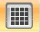 | “16 screen preview” button.  Click this button to use 16 screens to preview each channel.
5 | 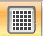 | “25 screen preview” button.  Click this button to use 25 screens to preview each channel.
6 | 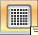 | “36 screen preview” button.  Click this button to use 36 screens to preview each channel.
7 | 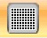 | “64 screen preview” button.  Click this button to use 64 screens to preview each channel.
7 | 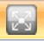 | “Full Screen” button  Click this button to enter full-screen preview interface.

4.2 Right-click Menu
In the live screen of the operating are, users can click right-click to run the following operation:
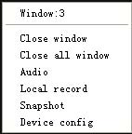
Close Window: Close the current channel’s live coverage.
Close all Windows: Close the current live pictures on all channels.
Audio: Select this option, can hear the sound of the preview screen.
Client Video: The current client-video saves in computer’s corresponding disk.
Capture: Capture the current time, the current channel picture, saves in computer’s corresponding disk.
Device Configuration: access device configuration interface.

4.3 PTZ Control
When the network video monitoring server connected to the speed dome, users can control the speed dome at the control center to move up, down, left, right or stop rotation; can adjust the speed dome’s rotating speed, aperture, zoom and focusing; can also set the path of preset points and cruising. When started cruising function, the speed dome can follow the path set by the user to cruise.
In the PTZ operation panel, user can control the rotation way and the speed. Instructions of each function button in the control panel are shown as Table 4-2:
NO. | Button | Meaning
1 |  | Useto control the direction of the speed dome; indicates stop.
2 |  | Drag the slider to adjust the rotation rate of the speed dome.
3 |  | “Zoom” button.  Click the button, can enlarge this channel’s site screen；click button，can reduce or restore the site screen.
4 |  | “Focus” button.  Clickbutton，can elongate the focus length；clickbutton，can shorter the focus length.
5 |  | “Aperture” button.  Clickbutton，can increase the amount of light into the speed dome；clickbutton，can reduce the amount of light into the speed dome.
6

7 | 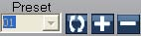 | “Preset point” is used to preset video monitoring points as well as add or delete set preset point by the user for monitoring a particular location.
8 | 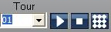 | Cruise path is used for the user to set the path of the speed dome after configuring the preset point. When cruising, the speed dome will display each preset point in set order. It can also add, delete and display cruise of each point.

4.4 Image Settings
NO. | Button | Meaning
1 |  | Brilliance Control
2 |  | Contrast Control
3 |  | Saturation Control
4 |  | Hue Control
Table 4-2 Image Settings
Note: Click “Restore Defaults” button, all settings will revert to the initial value.

Chapter 5 System Settings

5.1 Monitoring point settings

5.1.1 Click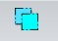to add the area, the interface is as follows:
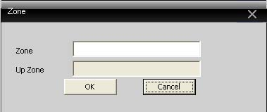
Here can add the wanted monitoring area. It’s convenient to manage all the monitoring points in different areas. Input “windows” will appear below interface:
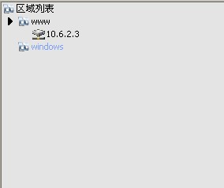

5.1.2 Click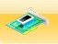button to add device, interface is shown as followed:
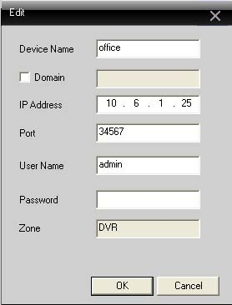
Device name: Name of the device. It’s convenience to search.
Domain: Domain names for visiting Public network domain, such as hzjufeng.3322.org
IP Address: The device’s IP address to access.
Port Number: TCP port number of the device.
User Name: Login device’s username.
Password: The user’s password.
After parameters configured, click “OK”, the added device will increase in the devices list, shown as followed. Double click the device name to access the device. Expand the channel; double click the needed open channel to real-time monitor the channel.
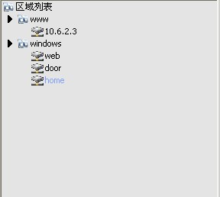
Note: Pass the Domain or IP is ok.

5.1.3 Modify the device
Select the device name you want to modify in the device list, click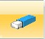button to enter the editing interface. Shown as followed:
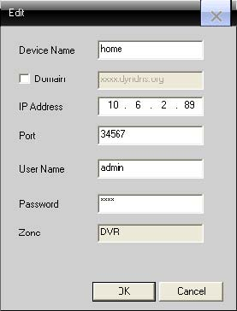
Set and modify the parameters, click “OK” to complete.

5.1.4 Remove Device
Select the device name you need to remote, clickbutton to remote this device.
Note: When modifying and deleting the devices, ensure that the equipment is out of disconnected.

5.2 Client Configuration

5.2.1 Basic configuration
Basic configuration interface as below:
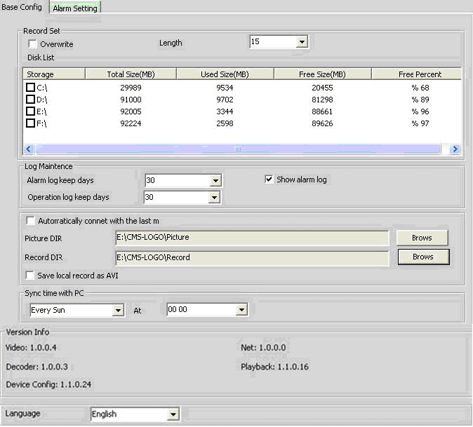
Cycle Cover: If select it, the oldest video will be overwrote when the disk is full.
Length: The length of the video file.
Memory: Select the disk to store.
Log maintenance: Log’s number of days to retain.
Picture directory: The storage location of the capture. Select the storage location through Browse.
Video Category: The storage location of the Client Video. Select the storage location through Browse.
PC synchronization with time: Adjust the time of the equipment to synchronize with your own computer.
Version Information: Display the version information of CMS.
Language Selection: Select the language of CMS.

5.2.2 Alarm Settings
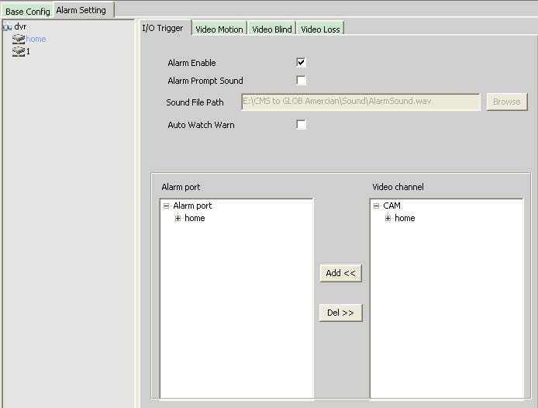
Equipment list: Choose a device name of a device to set the alarm linkage.
Alarm Enable: To implement the alarm configuration, you need to select the Enable.
Beep enabled: Select the tone enable.
Sound path: Through Browse to select a tone.
Linkage surveillance enable: Select the linkage surveillance enable, add the linkage channels when alarming at the following.
Note: Need to select the alarm type in.

5.3 Device Configuration
Through the client-site, you can control the device and configurate the related parameters of it. Select a particular device in the device list to configurate the selected device. Shown as followed:
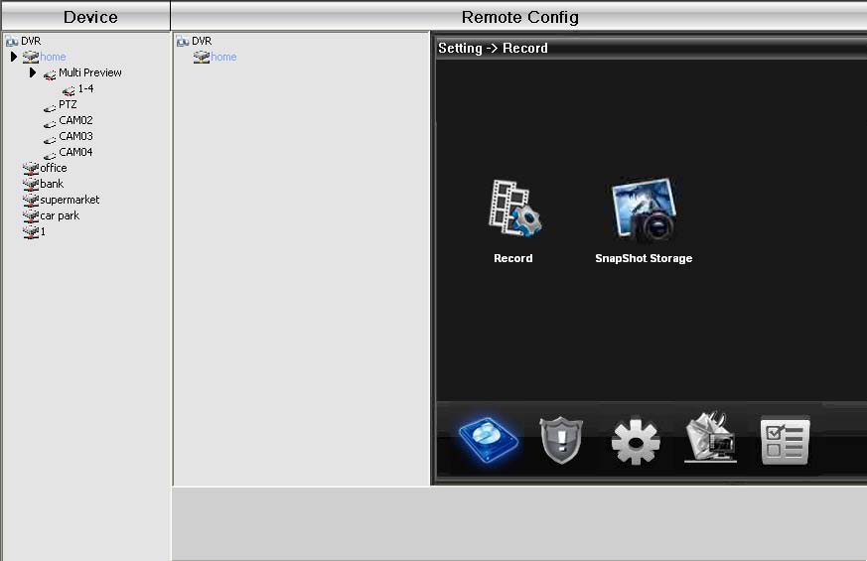

5.3.1 Recoding Function
Click thebutton to enter the recoding function interface. As below:
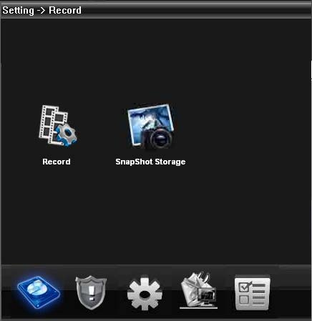
Configurate the parameters on the length, time and recoding type of the video files. As follows:
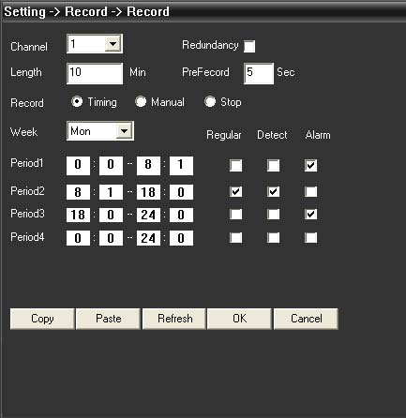

5.3.2 Alarm Function
Clickto enter alarm function. As below:
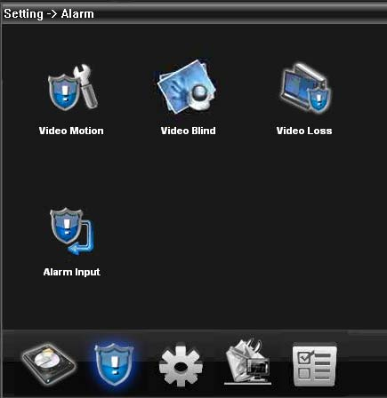
Trigger the corresponding alarm (motion detection, video block, video loss, alarm inputs) for setting a series of linkage, as follows:
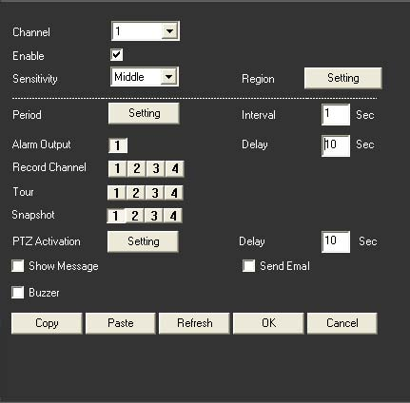

5.3.3 System Settings
Clickbutton to enter the system settings interface. As below:
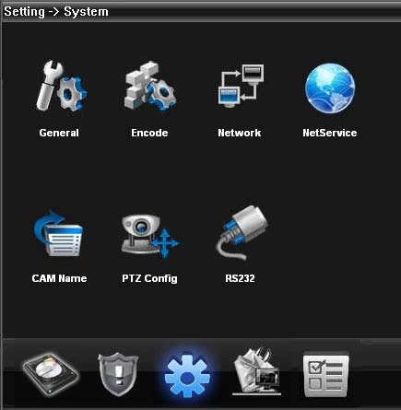
According to the user’s need, set the corresponding function.
- General settings. Basic information on setting configuration parameters is shown as below:
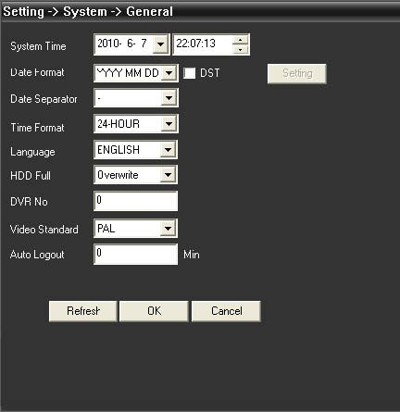
- Encoding settings. Parameter selection on the resolution ratio, code stream and picture quality. The specific configuration is as below:
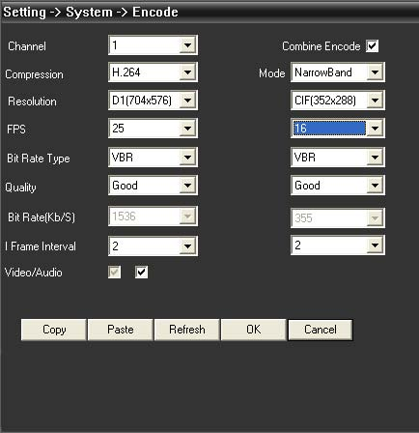
- Network Settings. Set the device’s LAN IP, poet number, DNS, etc, to achieve client monitoring. The specific configuration interface is as follows:
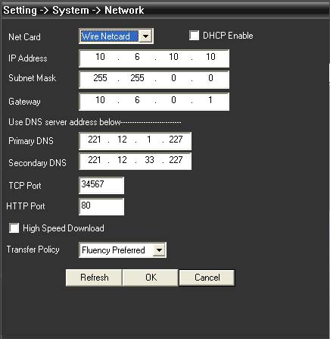
- Network Services. Through configuration to achieve Public Network access to device, mailing, etc. The specific function is as follows:
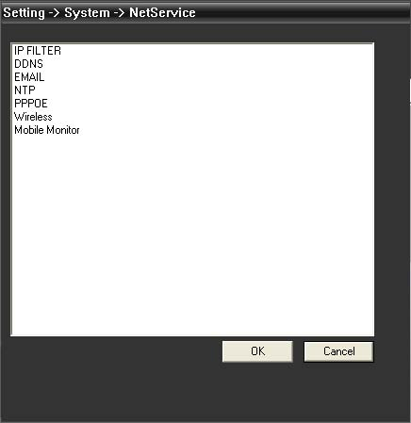
- Channel Name. Modify the name of the corresponding channel according to your need. Shown as below:
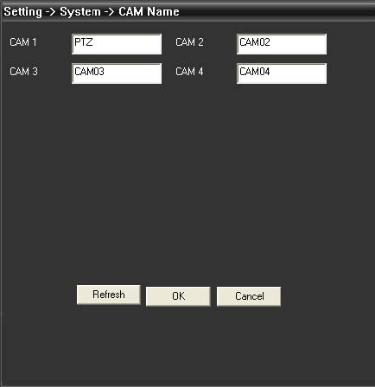
- PTZ Settings. Configure the parameters of the PTZ; make the parameters consistent with the ball machine, so as to achieve the aim of control. Shown as below:
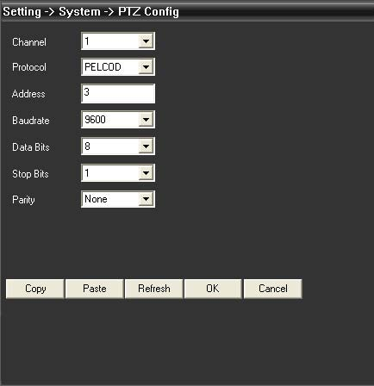
- Serial port settings. To set the serial port. Shown as below:
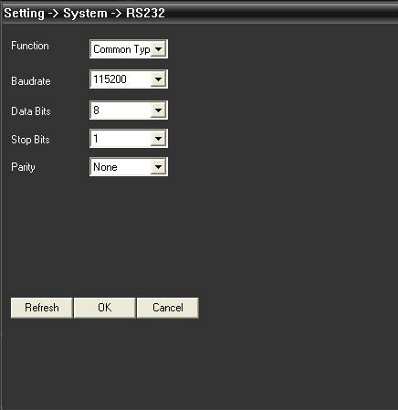

5.3.4 Administrative Tools
Clickbutton to enter the administrative tools interface. Shown as follows:
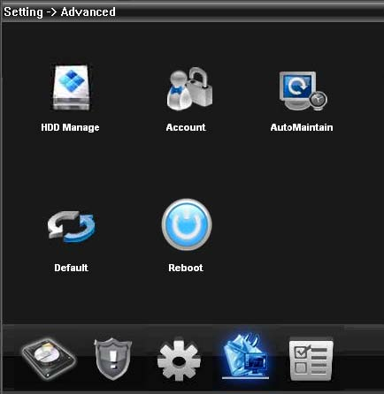
- User Management. To add, modify, delete, and restrict the permissions of the user. The specific function page is as follows:
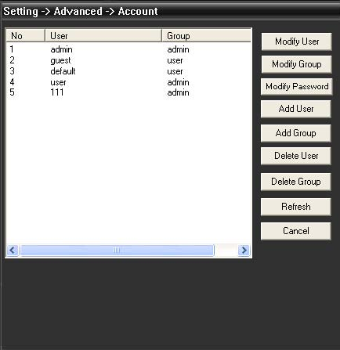
- Automatically Maintenance. Set the device’s automatically restart time and file management. Shown as follows:
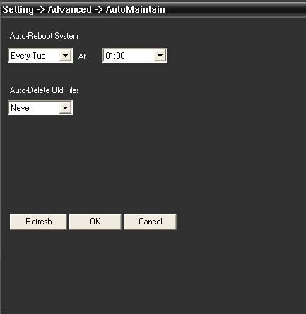
- Restore Default. It is the relevant parameters restore to the delivery configuration. Shown as follows:
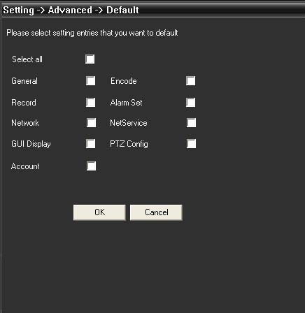

5.3.5 System Information
Clickbutton to enter the system information interface, as follows:
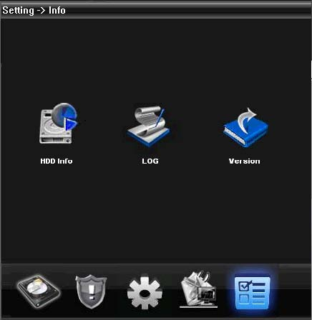
System information includes the hard disk information, log information, version information.

5.4 User Management
Use to increase and manage the client’s users.

5.4.1 Group Management
When increasing group, set permissions for the group on the right side; when deleting group, just need to select the group, and then click “Remove”.
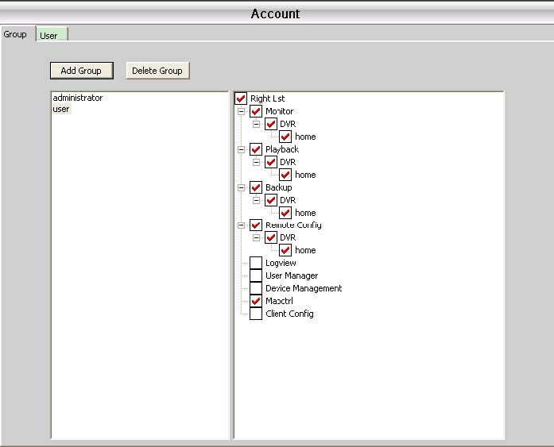

5.4.2 User Management
When increasing user, select the group that belongs to the user, then set the user’s name and password; when deleting user, just need to select Delete User and Modify User, and then select the user to change the password.
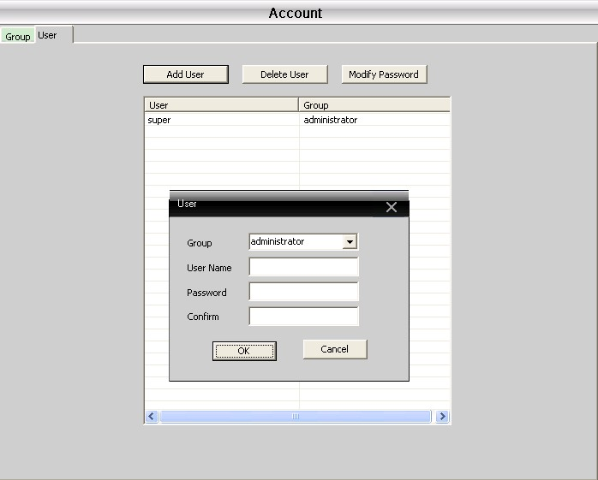

5.5 The Client Log
Users can check the menu operation log and the alarm logs, and other system operation logs. After setting the time slot that needed query, click for details. Interface as follows:
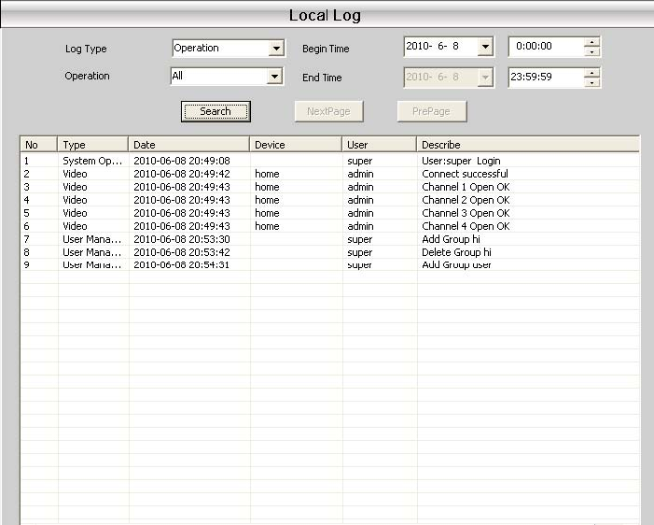

Chapter 6 Video Recording
In the menu area, users click “video record” menu, the operating area will appear “video recording” interface.

6.1 Video Playback

6.1.1 Video Playback
Recording features include Remote Playback and Local Playback. Remote playback playbacks the video files found in the device side; while local playback means playback client-side’s video files. Users can playback the video files in the control center of the particular channel in the particular time. Users can choose at most four channels to playback the video.
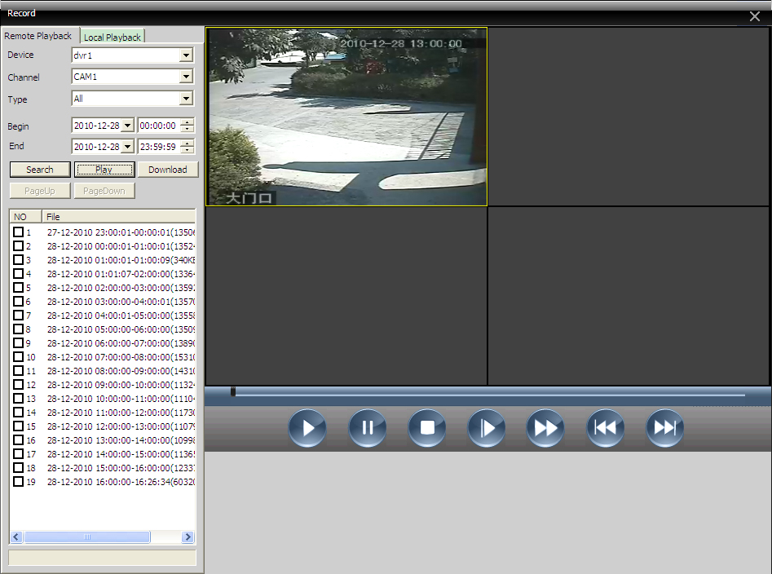

Table 6-1 Introduction of video playback’s function button
NO. | Button | Meaning
1 |  | “Play” button  Search the video file, click the button to play.
 |  | “Pause” button  Click the button to pause playback the video file.
 |  | “Stop” button  When play or pause playback, click this button to stop playing video file.
 |  | “Slow” button  Click this button to select 1, 2, 3, 4, four gears.
 |  | “Quick” button  Click this button to select 1, 2, 3, 4, four gears.
 |  | “Previous Frame” button
 |  | “Next Frame” button

6.1.2 Download/backup
Users can playback the set time video file of a channel in the control center. Select the wanted download/backup file, click the download/backup button, and according to your own needs to choose the appropriate save location for download/backup. Shown as follows:
Note: Remote Playback is: Download; Local Playback is: Backup
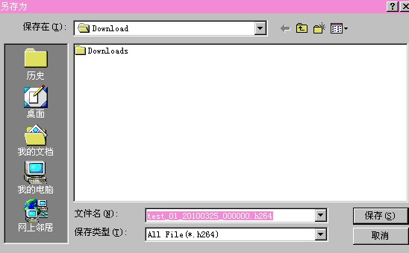

6.2 Video Plan
This feature is mainly use to achieve the client-side video recording and the time settings. Interface as follows:
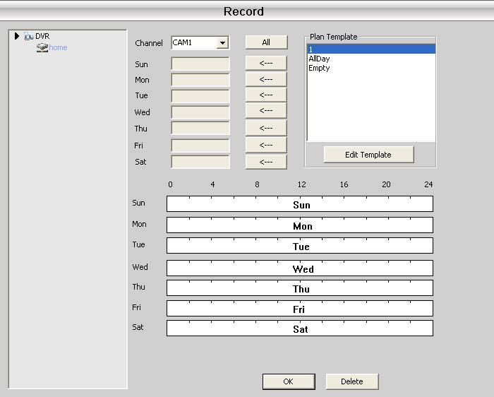
According to your own needs, users can click the Edit Plan template. Shown as follows:
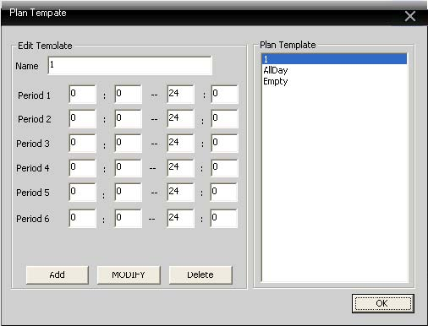
Set the name, time period, click Add; add a new template; click OK. Back to the template selection interface:
Select the appropriate device name from the left, and then select the channel number for setting. It’s able to select the template selection that record from Monday to Sunday as a recording time period. If selected, it will have the visual display of the display time below. Click OK.
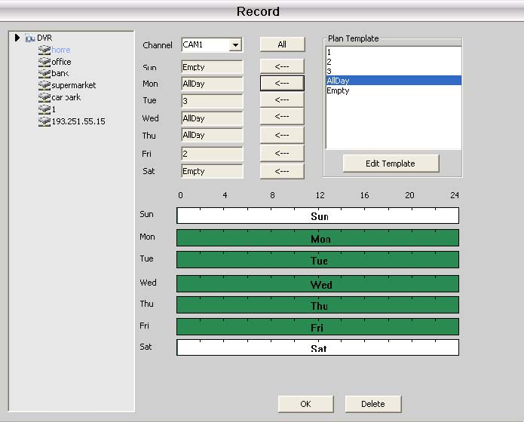
Note: If recording, after setting the plan template, you must ensure the following three points:
- When configuring the client-side, select the video disk for storing.
- Ensure this equipment is connected on.
- The client computer is booting.

Chapter 7 Advanced
It includes Encoding Settings and Electronic Map.

7.1 Decoder
Enable achieve the unified management and configuration on remote decoder. Interface as follows:
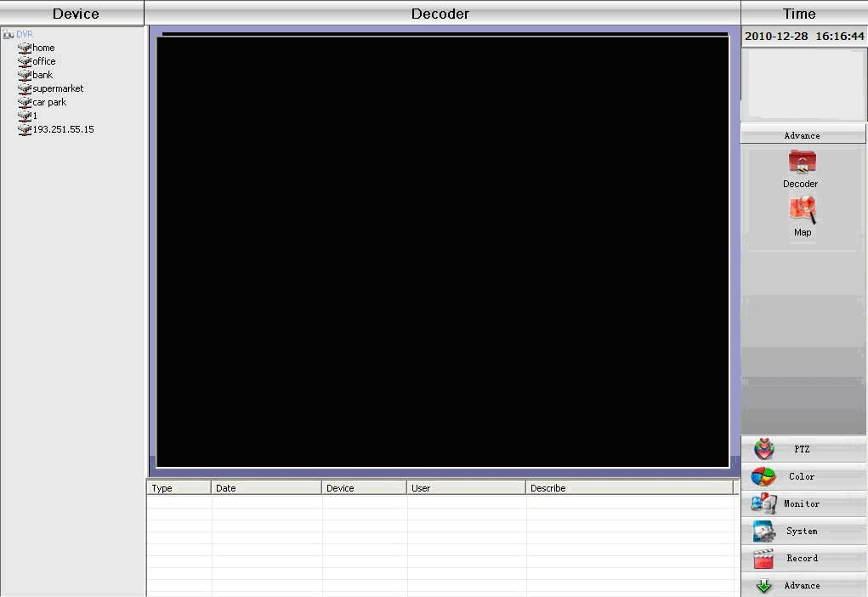
- Add Decoder
Click the right button “Add Decoder” on the interface, shown as below:
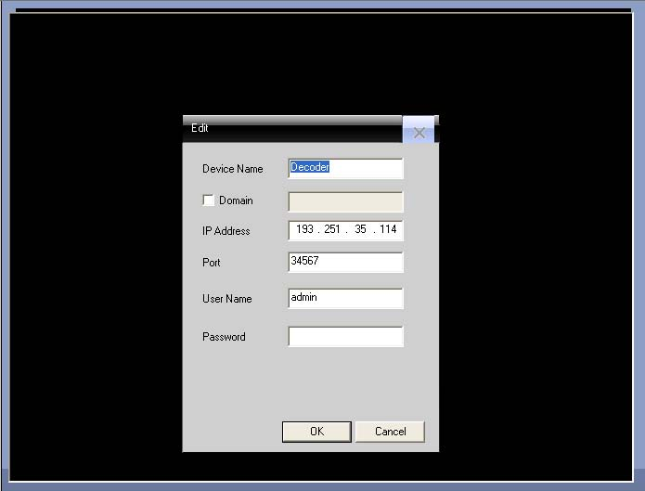
Device Name: The name of the decoder. You can set yourself.
Domain: The decoder’s domain. If the decoder can access the domain, tick before the domain, and input decoder’s domain.
IP Address: The IP address of the decoder.
Port Number: TCP port number of the decoder. The Default is 34567.
User Name: The user’s name to login the decoder. The Default is admin.
Password: Decoder’s login password. The Default is Empty.
Note: Support access via IP address and domain decoder. Choose one between IP address and Domain access.
After successfully added, you will see the decoder on the interface. Right-click the decoder icon, you can
edit, delete, set properties on the decoder
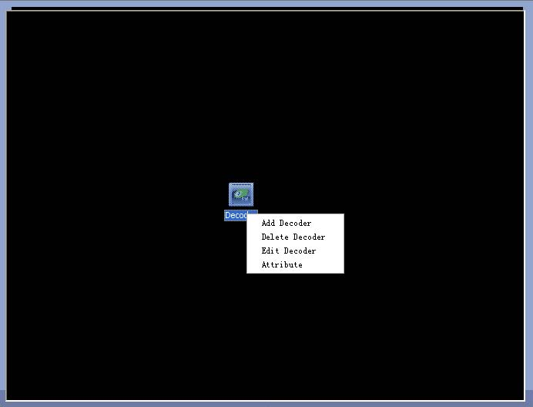
- Edit Decoder
Right-click the Decoder icon, select “Edit Decoder”, you can modify the decoder’s information.
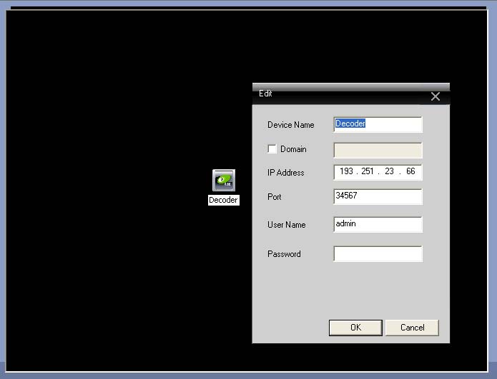
- Set Decoder Property
Right-click the Decoder icon, select “Property”, you can set the properties of the decoder.
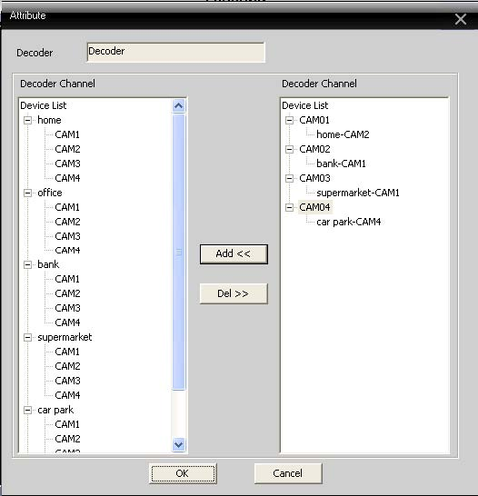
Select the decoding channel in the device list on the left; add to the corresponding decoding channel. Take the above as example:
Decoder’s first channel decoded output the first channel of Device 10.6.10.3.
Decoder’s second channel decoded output the first channel of Device 10.6.10.5.
Decoder’s third channel decoded output the third channel of Device 10.6.10.3.
Decoder’s forth channel decoded output the forth channel of Device 10.6.10.5.
- Remove Decoder
Right-click the Decoder icon, select “Delete Decoder”, you can remove the selected decoder.

7.2 Electronic Map
Electronic map is the plan that simulates the on-site screen. In the electronic map, users can add or remove the camera, and set the alarm on the corresponding location. Electronic map’s interface is as follows:
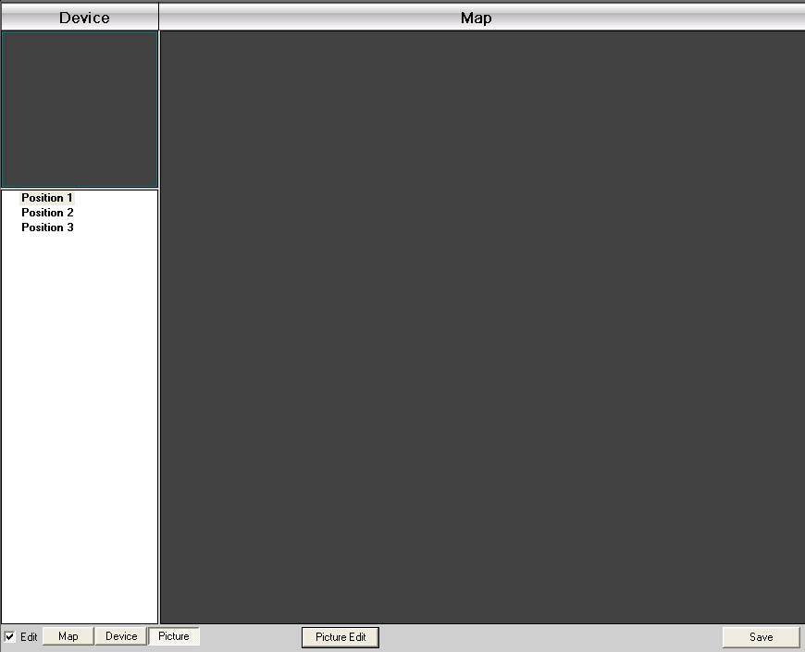
- Select “Image Management”, enter the following interface:
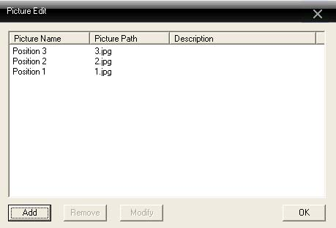
- Select “Add”, enter Picture Selection interface:
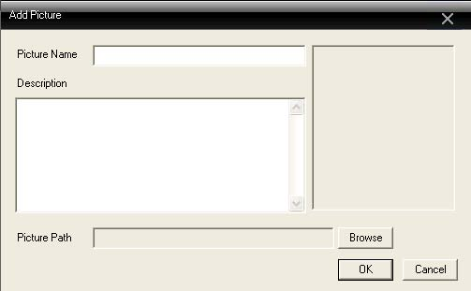
- Find the picture you need to set, input the image name, description, click “OK”; return to the main interface of the electronic map. Click “picture”, The Mouse select left side’s picture, drag to right side’s Image Display Area. Shown as follows:
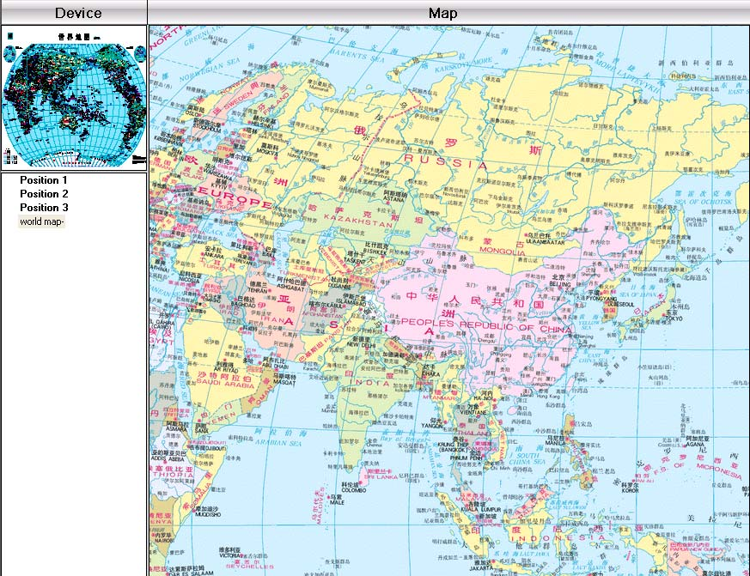
- Click “Equipment”, move the device channel onto the appropriate location on the map, the upper left corner will display the corresponding location on the map that marked with red. Double-click the channel name on the map, you can name and describe it. Setting completed is shown as below:

- Cancel editing; enter the electronic map’s control interface.
In the display area of electronic map, double-click the area that you want to monitor, it will skip to the preview interface:

Appendix A Abbreviations

Appendix B Main parameters
Abbreviation | Full Name | Chinese Meaning
CMS | center manager system | 网络视频控制中心
DVS | Digital Video System | 数字视频监控系统
PTZ | Pan/Tilt/Zoom | 云台设备
TCP/IP | Transmission Control Protocol / Internet Protocol | 传输控制协议/互联网协议
Video Compression |  |  | H.264 main profile
Audio Compression |  |  | G711A
Video Resolution |  |  | D1/CIF
Display resolution | Resolution | NTSC | 704 x 480
Display resolution | Resolution | PAL | 704×576
Display resolution | Rate | NTSC | 30FPS
Display resolution | Rate | PAL | 25FPS
Frame rate |  |  | 30/25(NTSC/PAL) F/S
Video input |  |  | BNC input
Audio input |  |  | RCA input
Type of compressed code |  |  | Combine code
Rate of compressed code |  |  | 32kbps ~ 2048kbps(adjustable)
Network Protocol |  |  | TCP/IP, static IP , DHCP , PPPoE
Net Interface |  |  | 10/100M RJ45
PTZ protocol |  |  | Pelco-P/ Pelco-D/ Minking/ Linlin/ Neon/ Star/ Vido etc...
Remote Monitor |  |  | IE browse, CMS and Mobile
Connected client quantity |  |  | Maximum 10 at one time
Power |  |  | DC12V/5A

