IE Operation User Guide
2014-5-29

Table Contents
1. Login 3
2.1 IE UI Introduction 4
2.2 Tool Bar 6
2.2.1 Playback 6
3. Record Setup 3.1 Recording & Snapshot saving path Setup 7
3.2 Manually record 7
3.3 Schedule Record 8
4. Snapshot Setup 10
5. Playback Setup 11
6. Alarm Setup 13
6.1 Video motion 13
6.1.2 Motion Region setup 14
6.1.3 Motion Period 15
6.1.4 Motion Detection trigger alarm output: 16
6.1.5 Motion Alarm Email Alert Setup 16
6.1.6 Motion Alarm Email Alert attached alarm snapshot 19
6.2 Video Loss 22
6.3 Alarm Input 23
6.4 Alarm Output 24
6.5 Abnormal 24
7. Network Setup 27
8. Video parameters Setup 28
9. Image Quality Setup 30
9.1 Digital WDR Setup 32
9.2 Image Mirror & Image Flip 34
10. OSD Setup 34
11. Privacy Setup 38
12. User Rights Setup 42
12.1 Add one user in different user rights 43
13. Maintenance Setup 44
13.1 Auto maintain 45
13.2 Default Setup 46
13.3 Configuration Import & Export 47
13.4 Reboot & Upgrade 47

1. Login
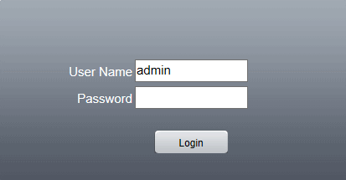
Input IP Address in Internet Explore browser
Default IP address：192.168.1.10
subnet mask：255.255.255.0
gateway：192.168.1.1
User name: admin Password: null

After Login, you will get the below image:
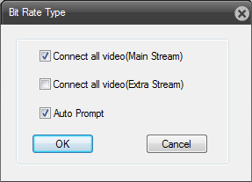
NOTE: you can select “Connect all video (Extra Stream)”

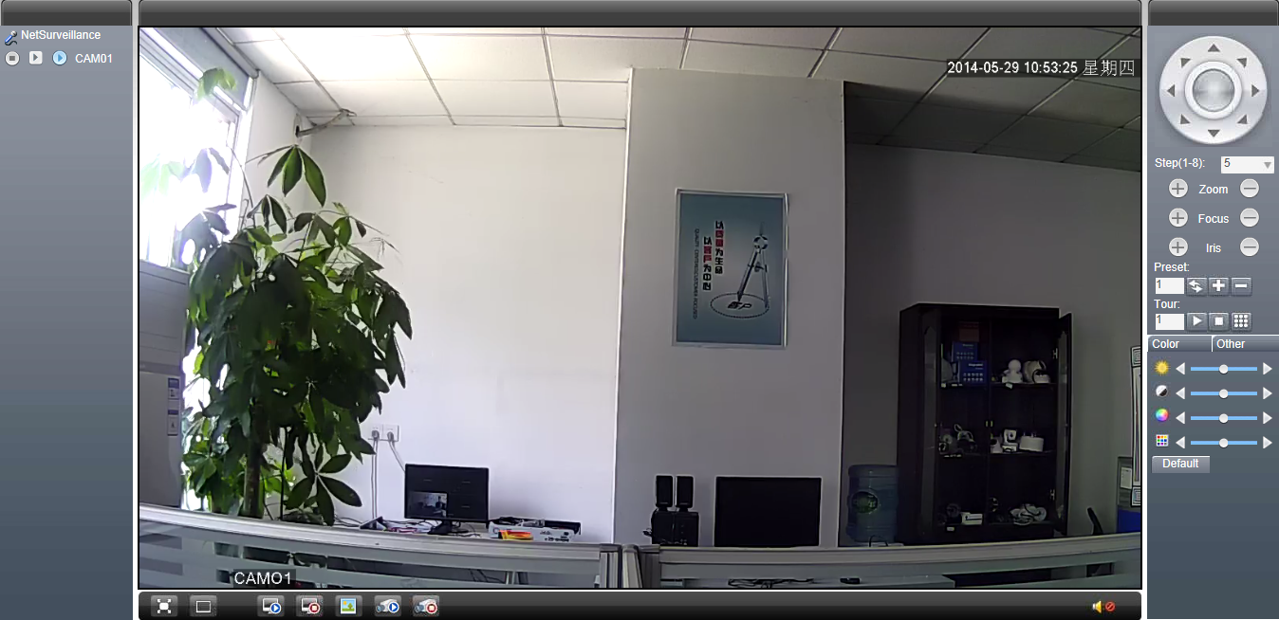

2.1 IE UI Introduction
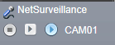
Record Button
Main Stream Button
Extra Stream Button
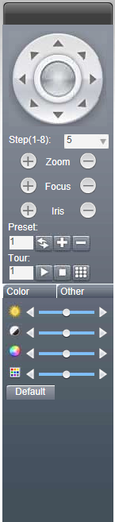
Pan tilt zoom control panel
8 Directions
ZOOM + -
Focus + -
Iris + -
Preset Setting Area
Image Setting Area
Full View
1 View
Connect All Video
Disconnect all Video
Snapshot

All channel record
Close all record

2.2 Tool Bar

2.2.1 Playback
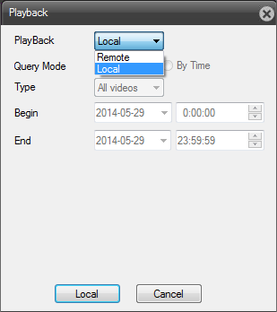

Record Setup
3.1 Recording & Snapshot saving path Setup
Click in the top tool bar, and select option, as shown below:
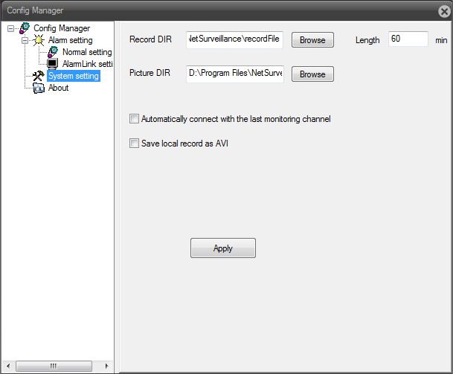
After you setup the Record & Snapshot saving path, click

3.2 Manually record
In the IE UI, you can click to let all the channel IP camera to do recording.
Click to stop recording

3.3 Schedule Record

Click , and select  option, as shown below:
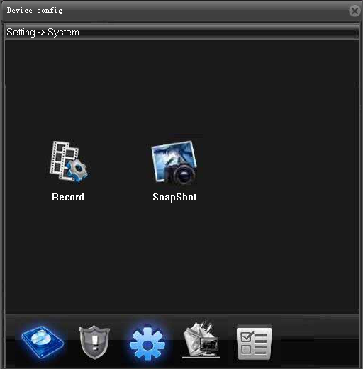
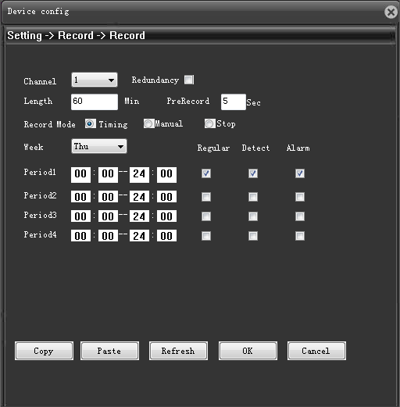

You can setup the schedule recording as below:
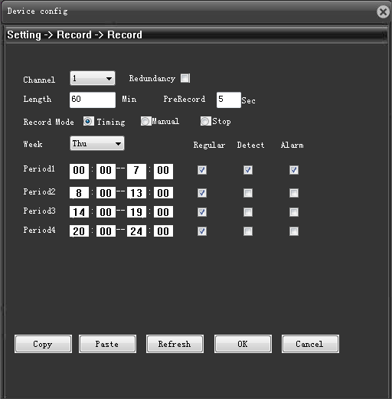
And click
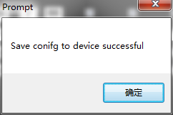

Snapshot Setup
Manually Snapshot Setup

Playback Setup
Click in the top tool bar:
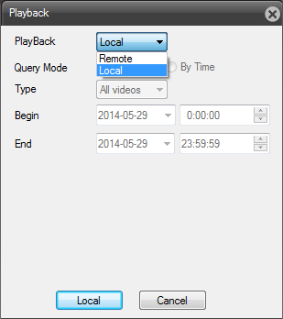
Select “Local” option, and click button, as shown below:
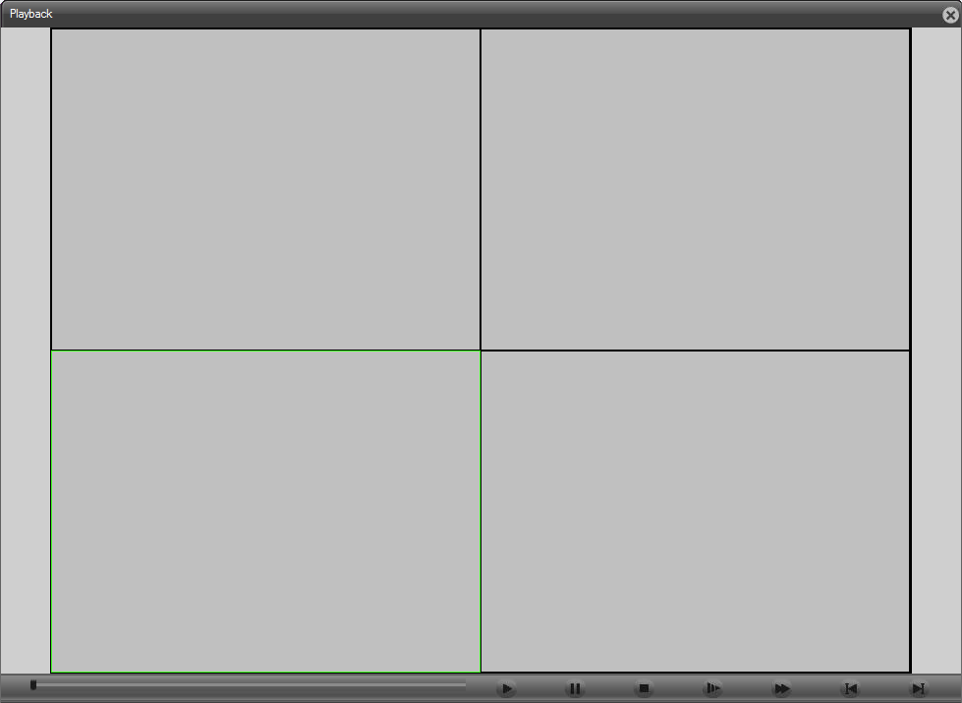
Click , and select the recorded video file as the saving path.
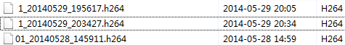
Double click the selected option, then you can play the recorded video files as shown below:

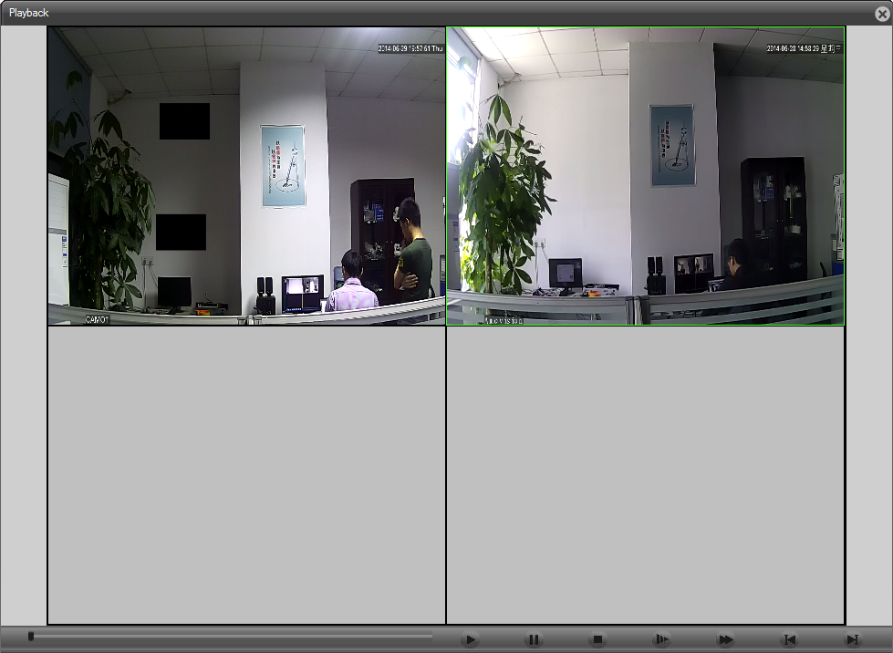
With below playback tool bar, you can do well the video playback setup:
Button | Function | Button | Function
 | Play |  | Pause
 | Slow-play |  | Fast-play
 | Previous fram e |  | Next f rame
 | Stop

Alarm Setup
Click in the top tool bar, and select  option, as shown below:
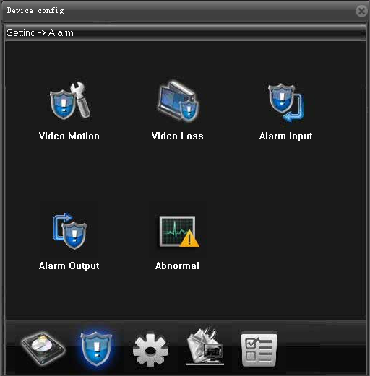

6.1 Video motion
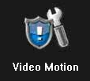

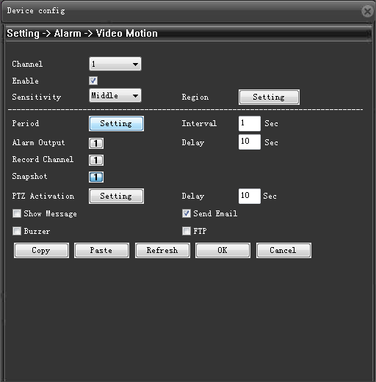

6.1.1 Motion Sensitivity：
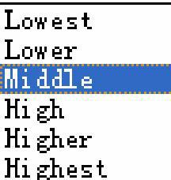

6.1.2 Motion Region setup
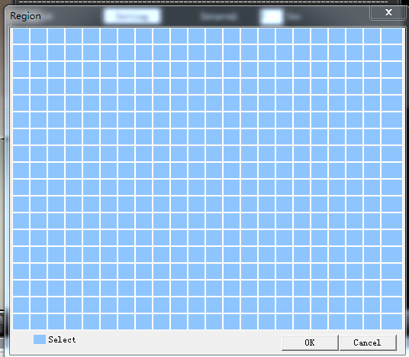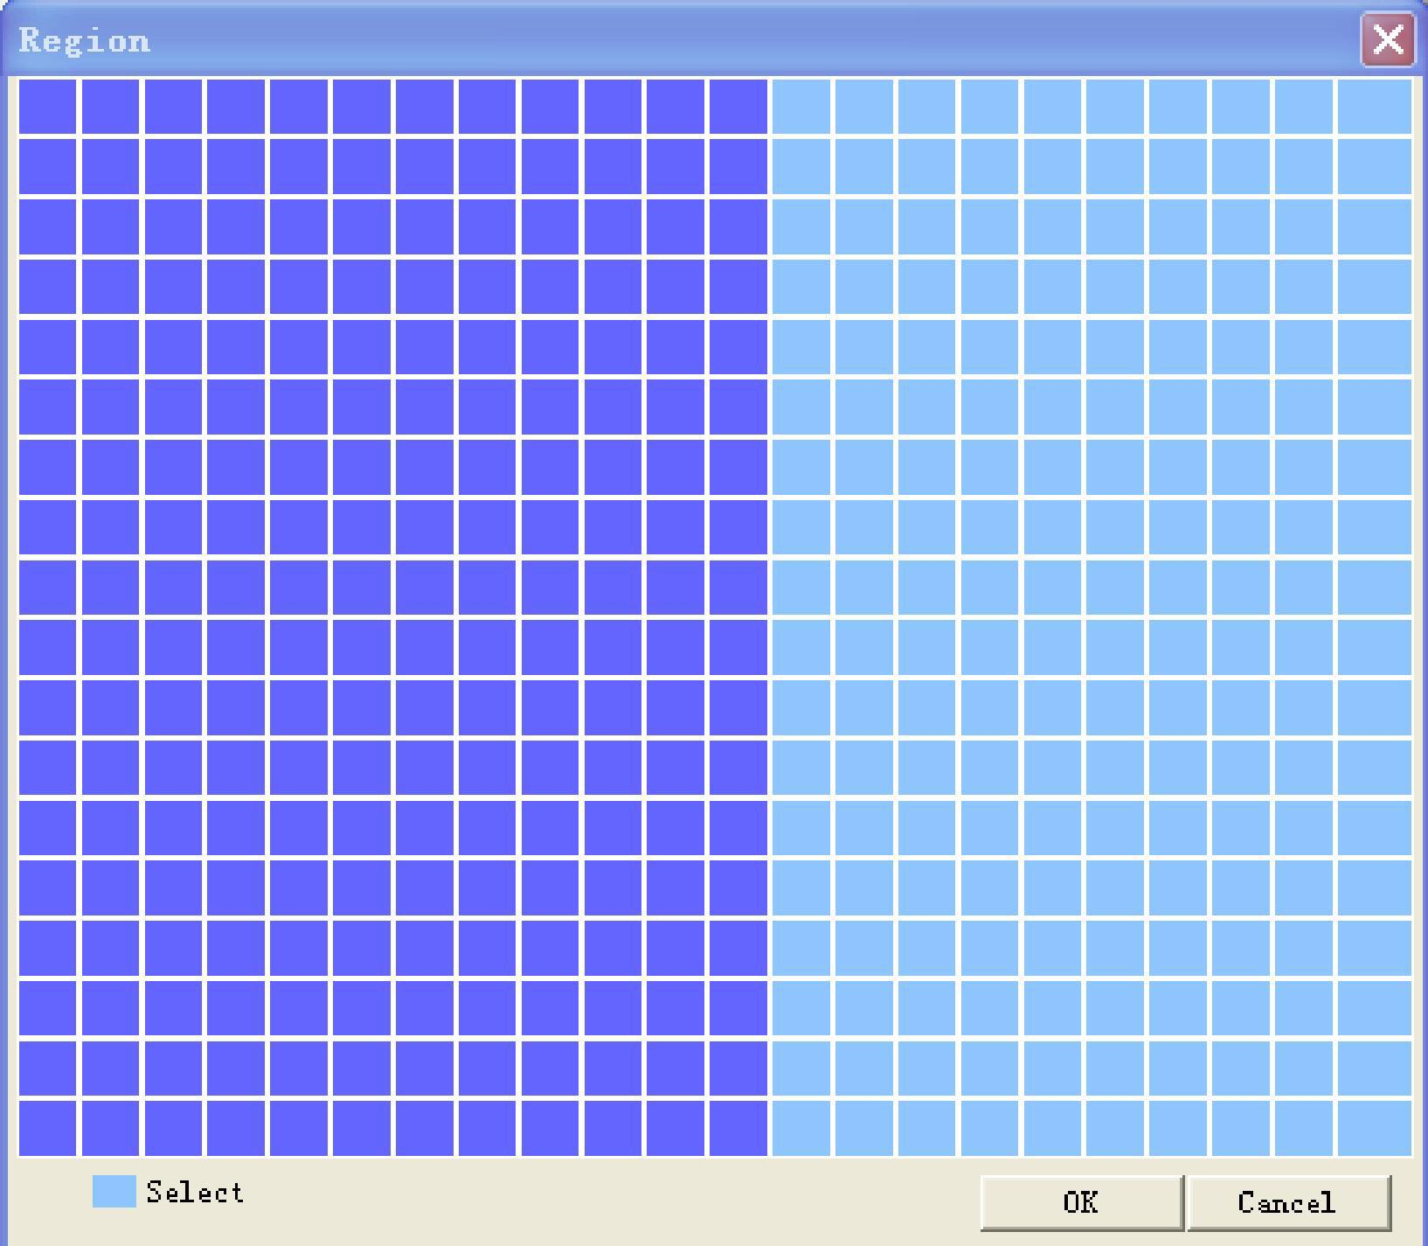

6.1.3 Motion Period
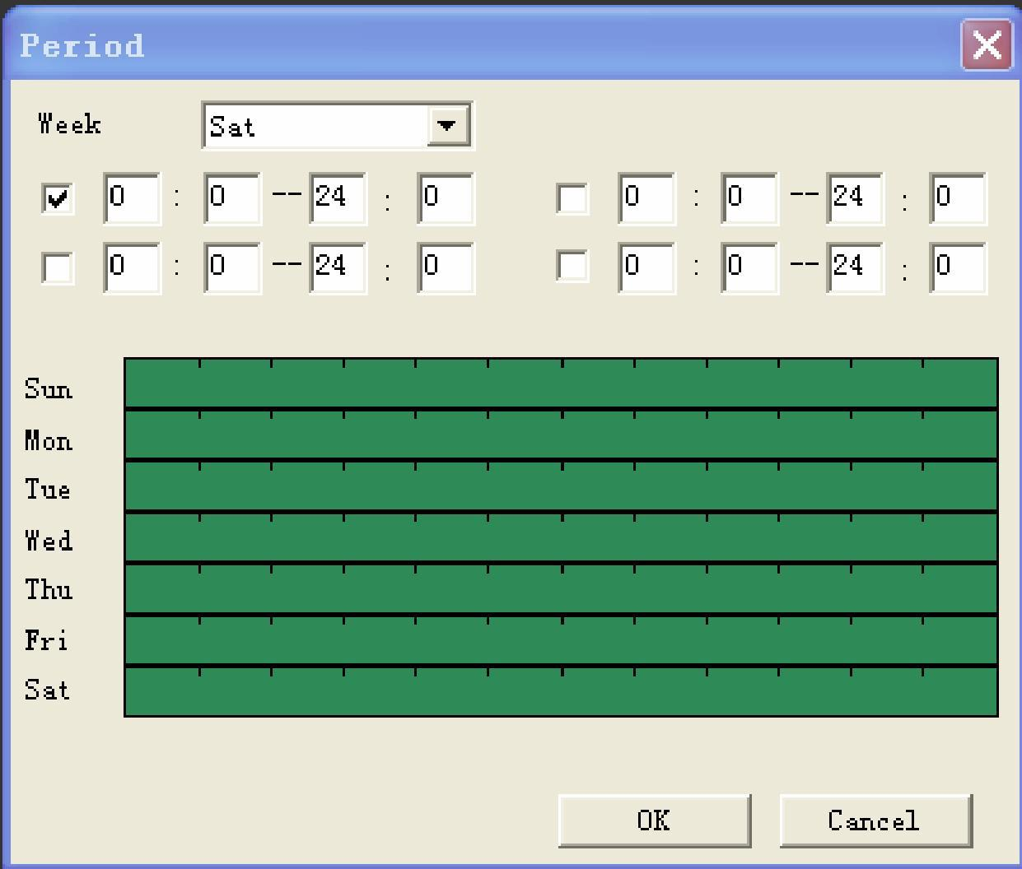

6.1.4 Motion Detection trigger alarm output:
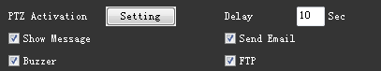

6.1.4.1 PTZ Action:
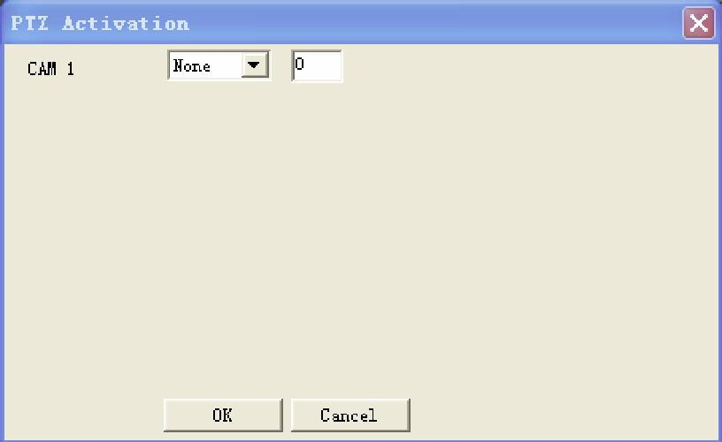
6.1.4.2 Show Message
When enables Motion detection trigger “Show Message”, it will pop up the below alarm window:
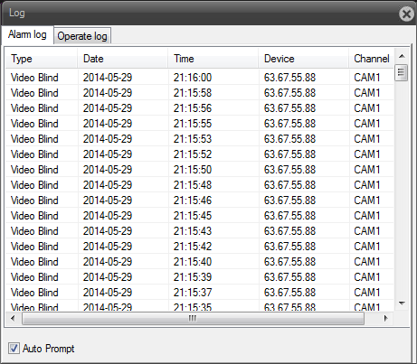

6.1.5 Motion Alarm Email Alert Setup
6.1.5.1 Fisrt do Email Sender setup
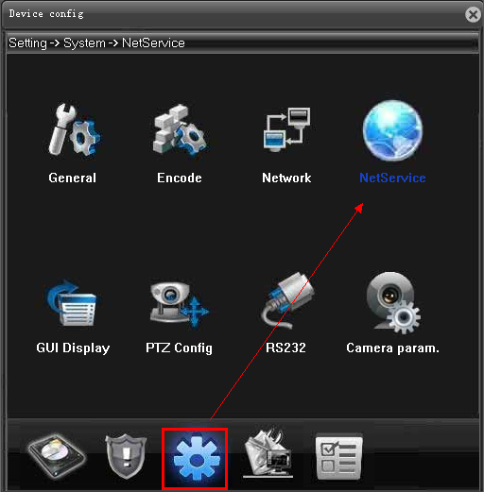
Select  and double click “Email” option
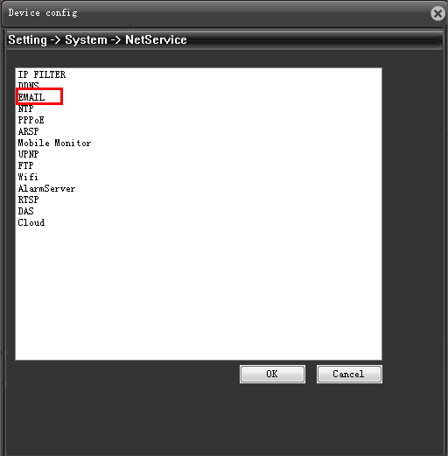
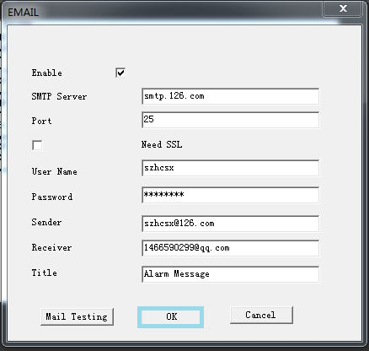
Motion Alarm Email Alert, as shown below:
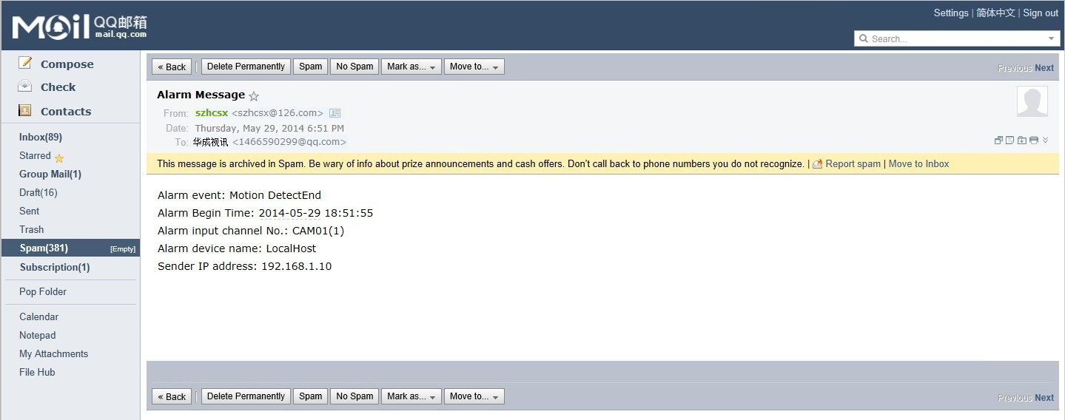

6.1.6 Motion Alarm Email Alert attached alarm snapshot
First you should setup alarm snapshot as below:
6.1.6.1 Select 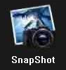 option:
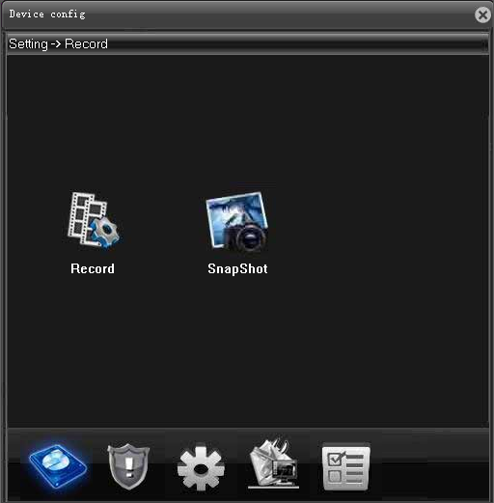
6.1.6.2 Setup Snapshot Alarm as below shown:
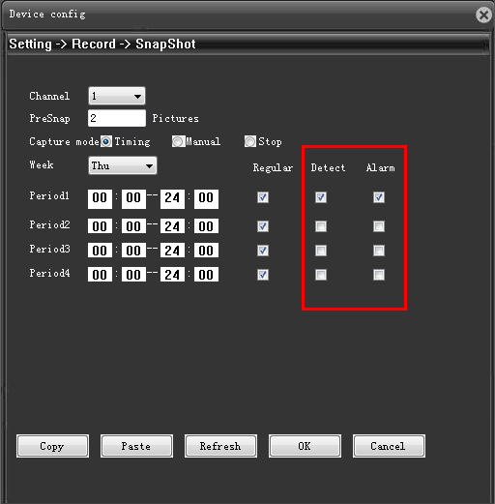
6.1.6.2 When motion detection happened, you will can the below Email alert attached alarm snapshot image.
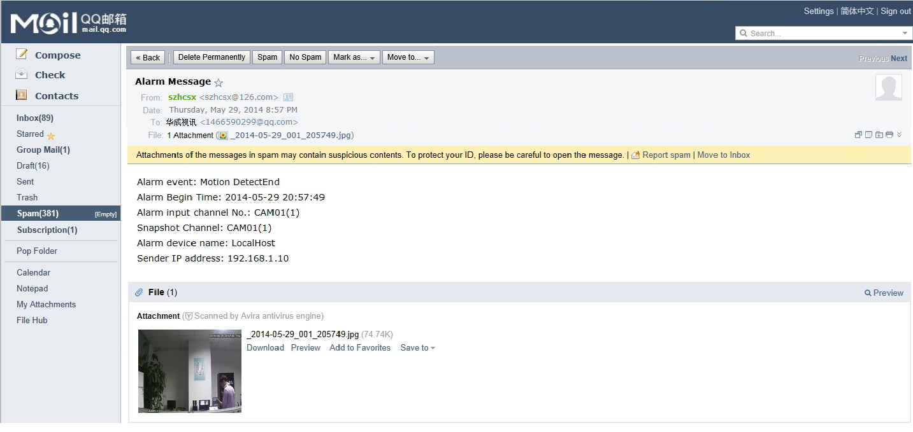

6.2 Video Loss


Video Loss trigger alarm is the same way as motion detection
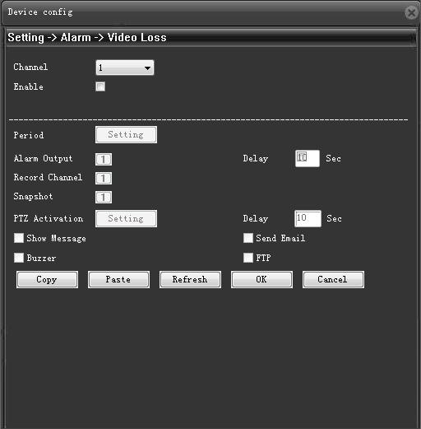
*NOTE:
Hisilicon 3518E Not Support Video Loss Alarm
Hisilicon 3516C Support Video Loss Alarm

6.3 Alarm Input
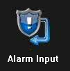
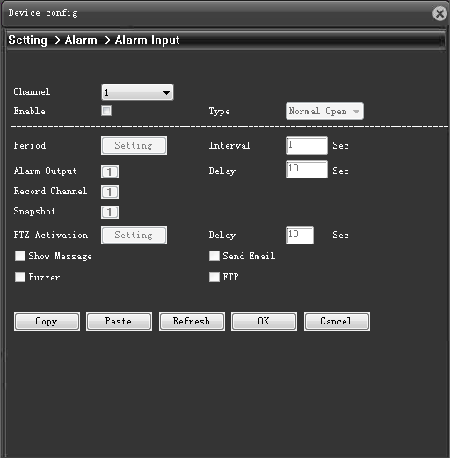
*NOTE:
Hisilicon 3518E Not Support Video Loss Alarm
Hisilicon 3516C Support Video Loss Alarm

6.4 Alarm Output
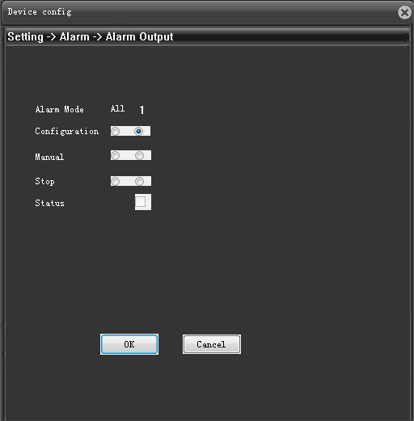
*NOTE:
Hisilicon 3518E Not Support Video Loss Alarm
Hisilicon 3516C Support Video Loss Alarm

6.5 Abnormal
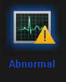
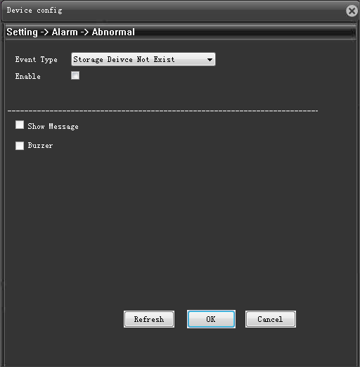
*NOTE:
Hisilicon 3518E Not Support Video Loss Alarm
Hisilicon 3516C Support Video Loss Alarm

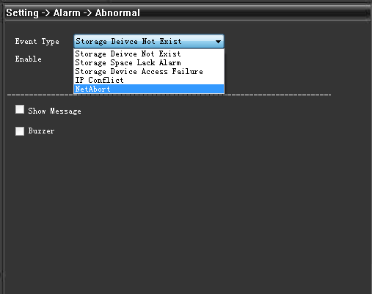

Network Setup
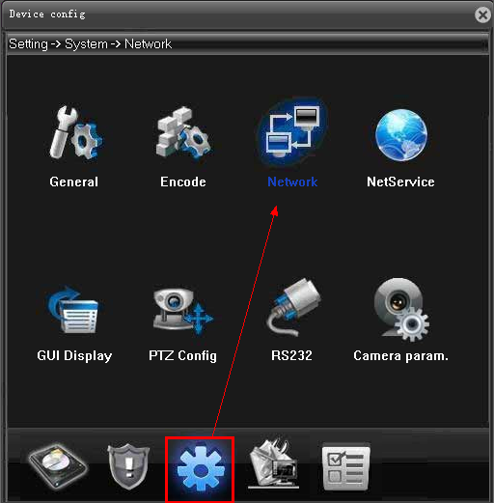

You can do network setup as below:
IP address
Subnet Mask
Gateway
DDNS Server
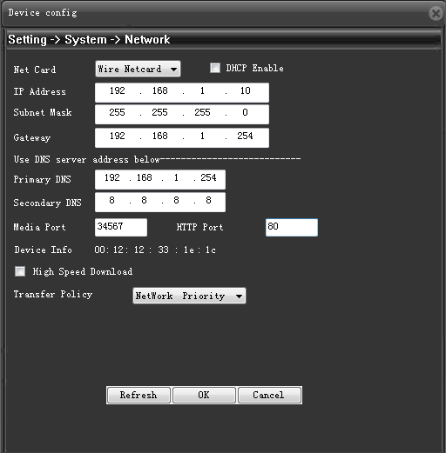

Video parameters Setup
Select 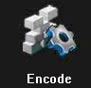option, as shown below:
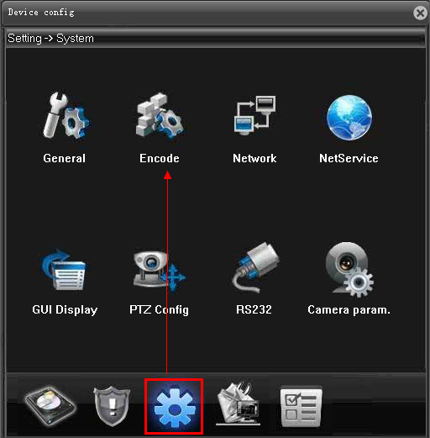

You can setup video parameters as shown below:

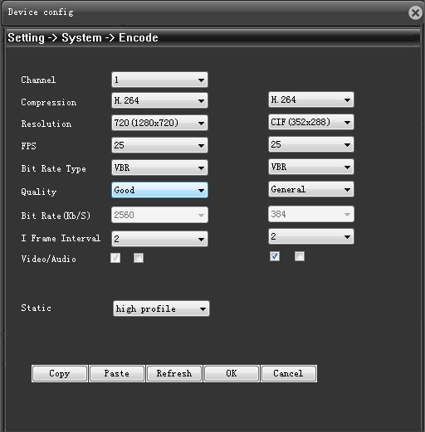

Image Quality Setup
Select 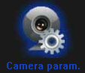
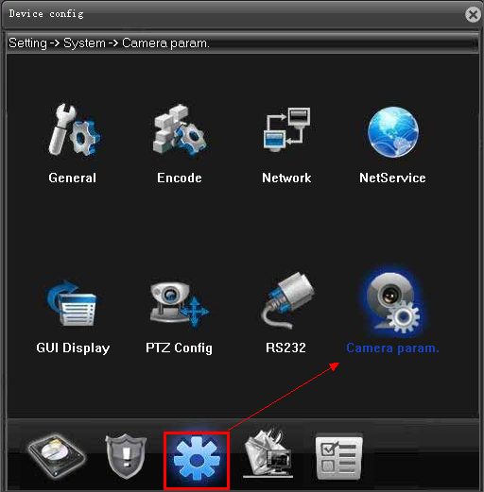
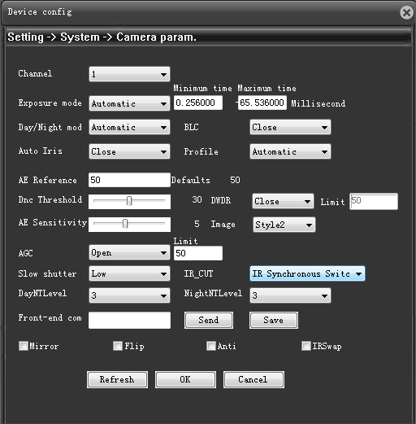

9.1 Digital WDR Setup
Open DWDR as shown below
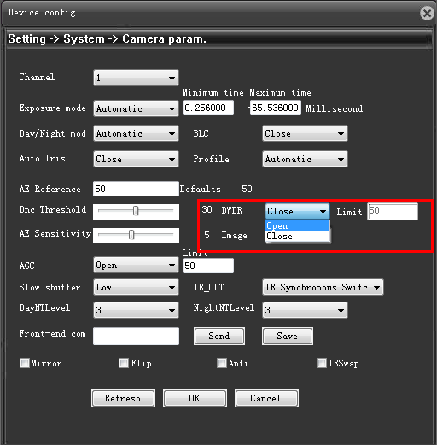

9.2 Image Mirror & Image Flip
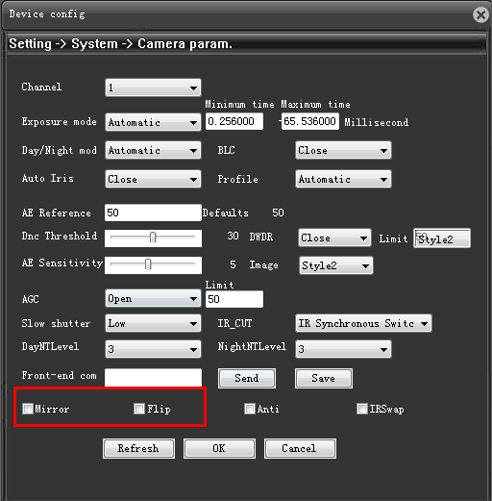

OSD Setup
Select 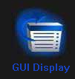 option:
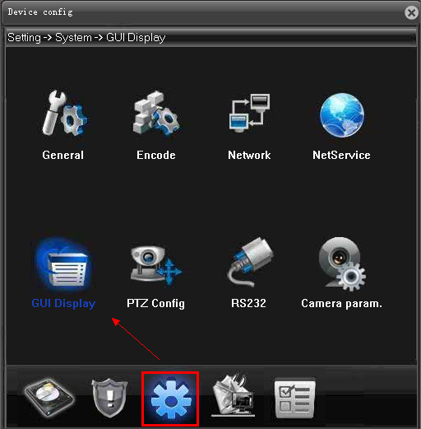
You can edit Camera name as shown below:
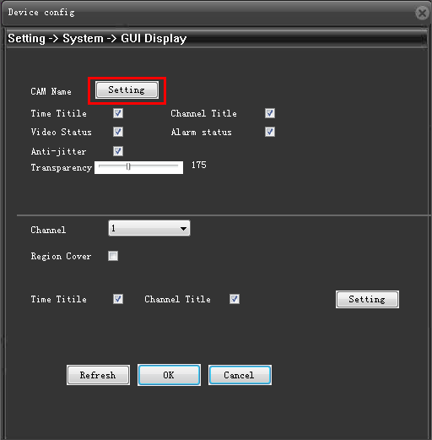
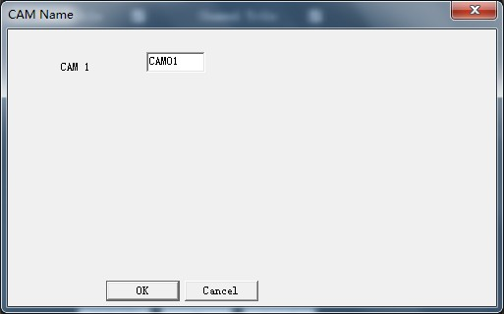

You can edit “”Time Tile” & “Channel Title” position as shown below:
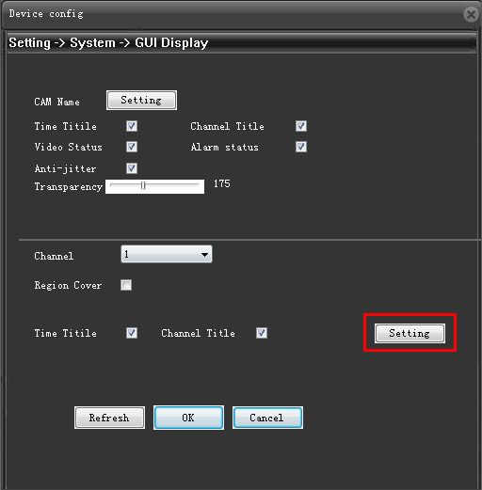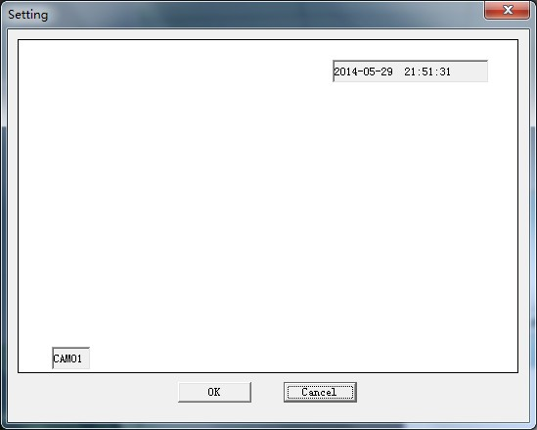

11. Privacy Setup
Select option:
Setup Privacy mask Area shown below:
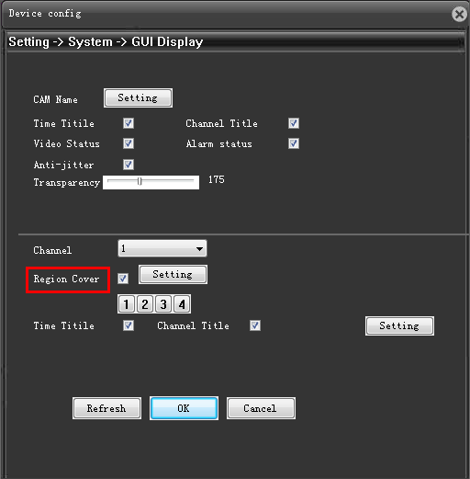
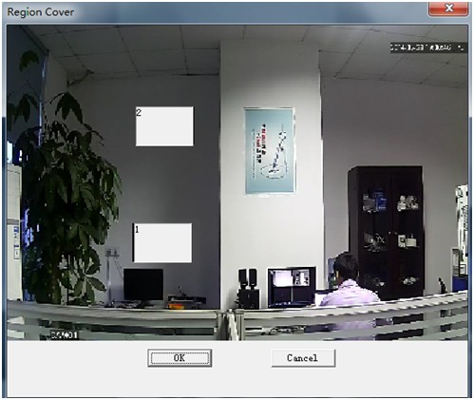
Then you view the camera image as shown below:
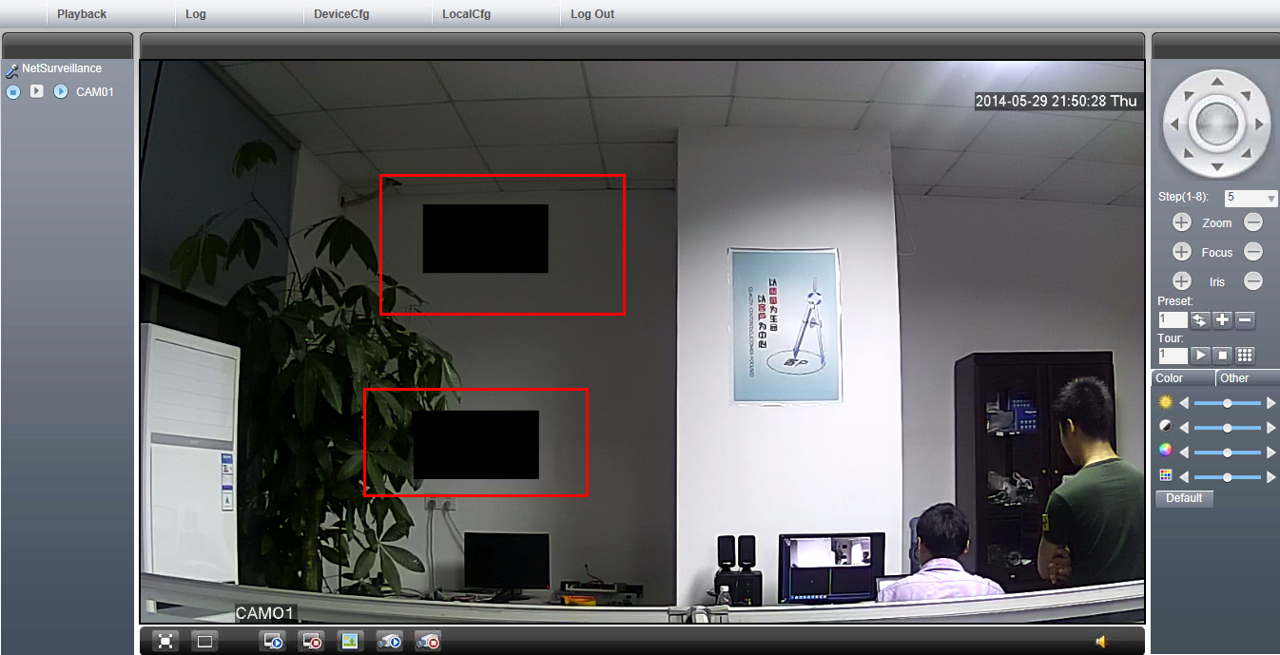

User Rights Setup
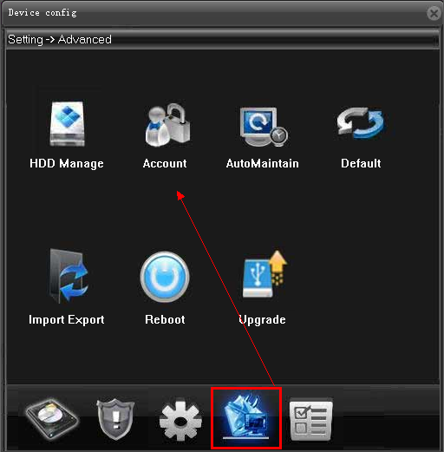
Select 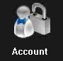 option, you can setup the below settings:
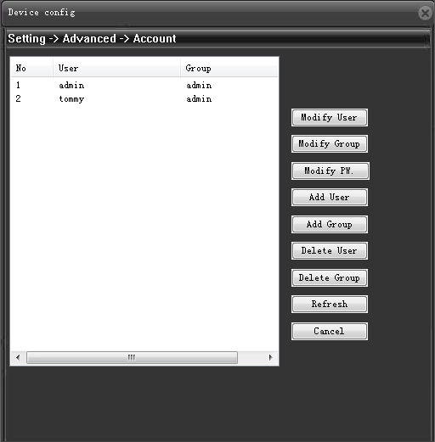
- Modify User
- Modify Group
- Modify PW
- Add User
- Add Group
- Delete User
- Delete Group

12.1 Add one user in different user rights

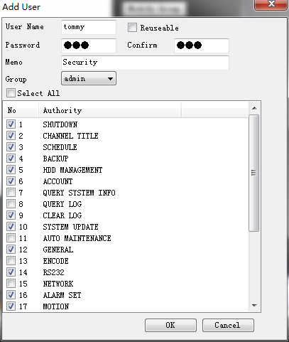
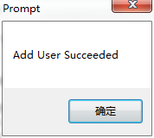

13. Maintenance Setup

13.1 Auto maintain
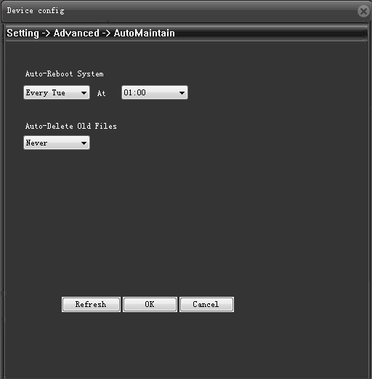

13.2 Default Setup
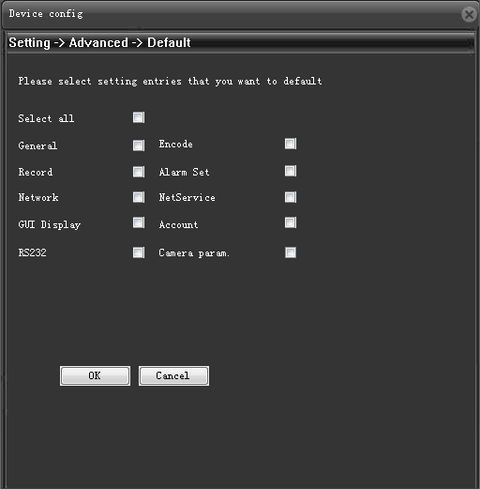

13.3 Configuration Import & Export
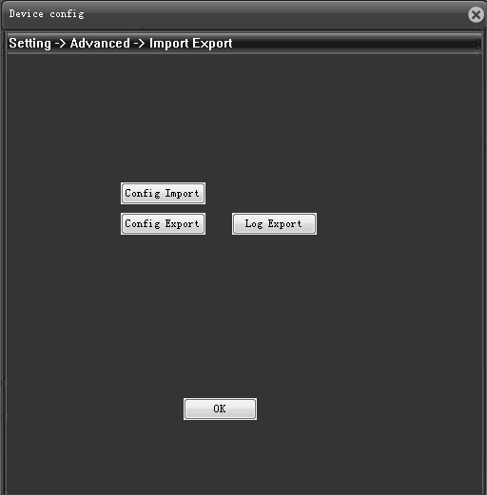

13.4 Reboot & Upgrade
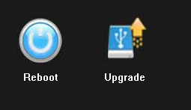
Upgrade
