IP Search Tool User Guide
1. Open the CD and install
2. Double click  to open the IP Search tool “Device manager”
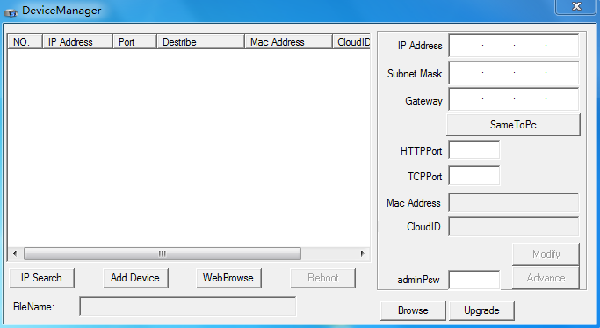
3. Click to search the IP camera, as shown below:
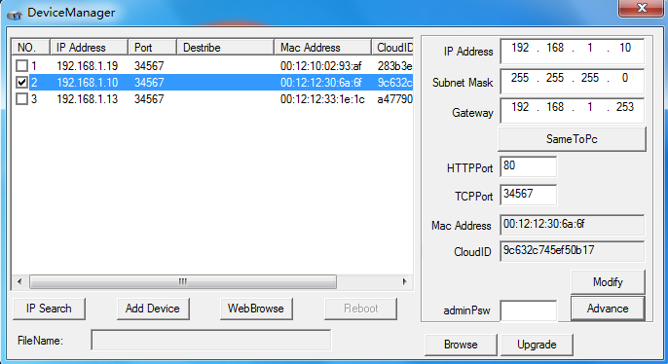4. Select one IP camera, click “Web Browse”, then you can preview te IP camera in web browser
5. Select one IP camera, click , you can modify the IP camera information.

