Smart Phone APP User Guide

iPhone/Android Smart Phone APP Name: vMEyeCloud Lite
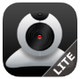

1. Download P2P APP from Apple or Google Play APP Store
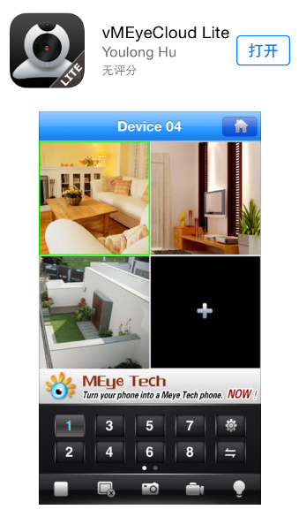

2. Open “vMEyeCloud Lite” APP on your mobile
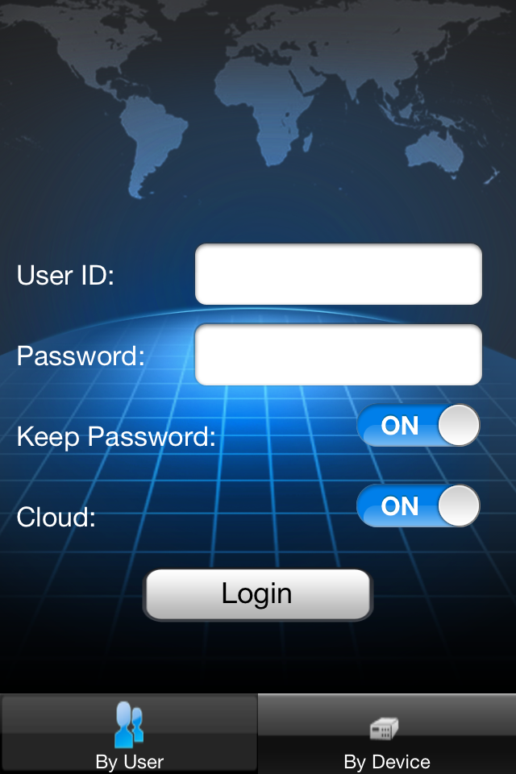

3 Login

3.1 Login in By User
Input the below info:
- User ID
- Password

User name：the same as the one when register in cloud website:http://xmeye.net/
Password：the same as the one when register in cloud website:http://xmeye.net/
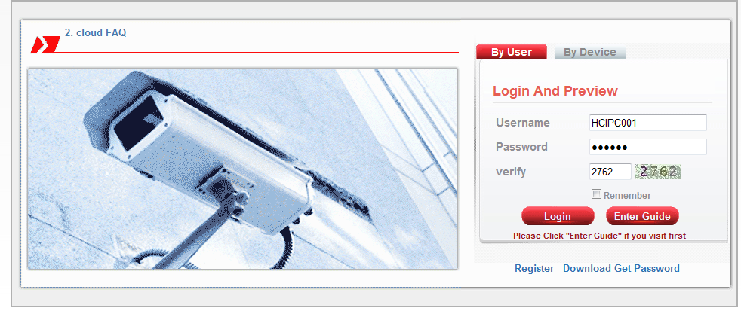
Take one Example as shown below:

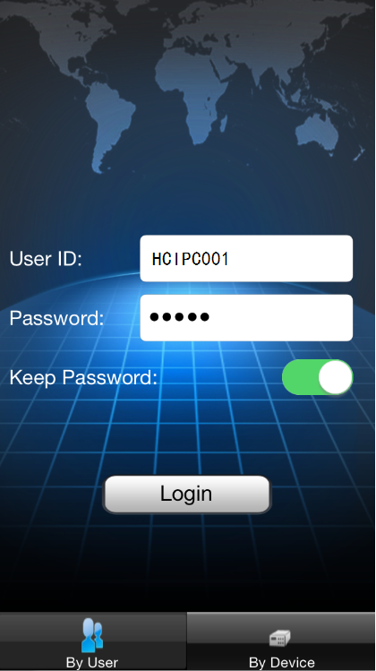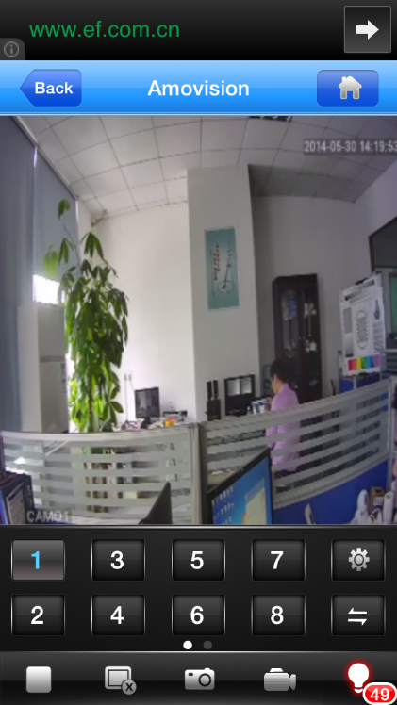

3.3 Menu Introduction:

Advanced Setup, as shown below:
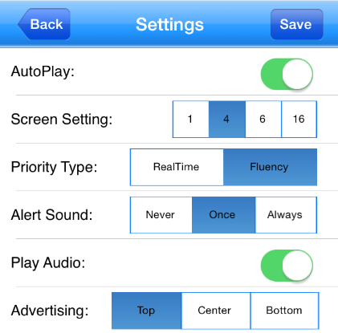
start/stop current preview
snapshot pictures from current preview
take video tapes of the current preview
check alarm information of the current preview

3.3 Login in By User
3.3.1 Select by “By Device” Input the P2P UID code by below two ways:
3.3.1.1 Manually input the P2P UID
3.3.1.2 QR Code Scan
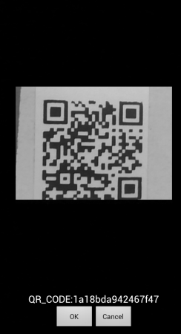
3.3.2 Input the User ID and password, and click “save”, then you will get below image:

