Android (MSurveillance) Instructions
一. System Requirements, install and uninstall
1.System Requirements
Smartphone for all android operating system
2.Software Installation
  - First, download the installer to the phone. Several ways you can download the installer to your phone.While there are two installations，One for Andoid 1.5 and 1.6 versions(MSurveillanceForAndroid1.6_1.0.0_.apk)，another for Android 2.0 or above (MSurveillanceForAndroid2.0_1.0.0_.apk)
- You can use mobile data cable to connect computer and cell phone,it will appear removable disks in "my computer"(Some machines need to install the driver)then, copy the installation files MSurveillanceForAndroid2.0_1.0.0_.apk to memory card root directory.
- You can use a card reader, first, put the memory card into the card reader and then connect computer,it will appear removable disk in"my computer",copy the installation files (MSurveillance_S60_5_1.0.0_.sisx) to memory card root directory.Last,put the memory card back into the phone.
- Use Pea pod or 91 assistants and other tools to copy the installation files to the memory card root directory.
- Use "electronic market" application in Android moble and search"MSurveillance" , then download it to your mobile through Wifi or GPRS.
  - Find the the program you've download to your phone, click to run the Setup program
and click "Install"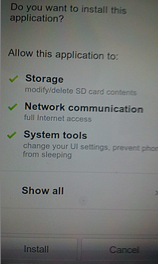
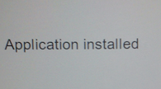
Then click"Done", the installation is completed.

- Uninstall software
Click "Settings" in the mobile interface,
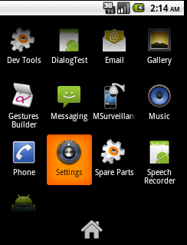
Select "applications"
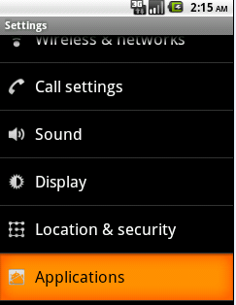
Select "Manage Applications"
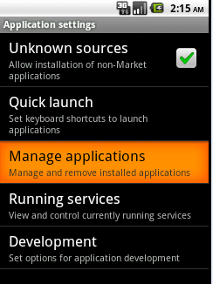
Select“MSurveillance”
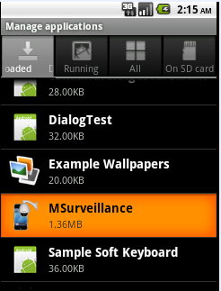
Click "Uninstall"
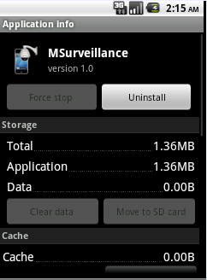
If you decide to uninstall,then click"OK".
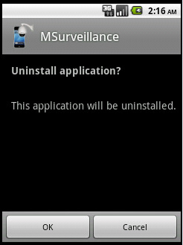
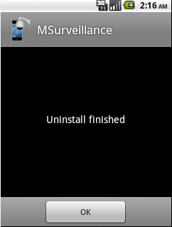

- Log in and exit
- The first time log in
Click the shortcut software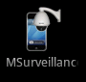，If the first time login, the login window will pop up as follows:
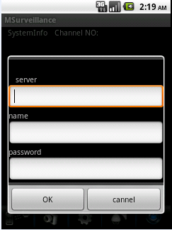
Server：enter the server name e.g.“201000098.isur”
Name and Password：Server user name and password
Fill out the server , name and password, Click"OK", start to connect the server side,
if the connection is successful,it will enter the software interface and the emergence of channel screen.
If not successful, a connection failure of the prompt, and enter the software interface.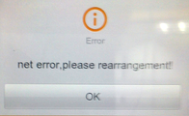

- Non-first time login
Click the shortcut softwareon the mobile desktop，it can enter into the software interface.

- Exit
Click "exit"on the surveillance interface or click Back button on the mobile， then exit the software.

- Basic functions
- Description of monitoring main interface
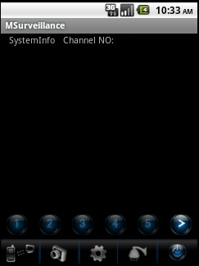

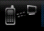 Connect and disconnect

Capture
Settings
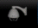 PTZ direction control
Exit
Channel number
Turn the channel number
★Note: If you want to return to the previous interface when in the process of operation.Please click Back button on the mobile. It does not support the Menu key and the Home key during operation.

- Basic functions
A. Connecting the server side connected before

Click"connect"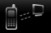on the interface ，it will connect server-side.
B.The new server-side connection

Click"setting" on the interface,it will pop up the dialog box as follows.
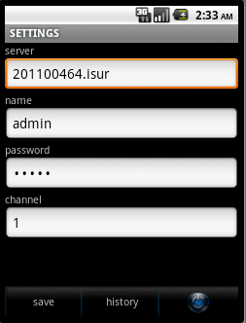
Fill in the server , name and password, click"Save",then click"History".
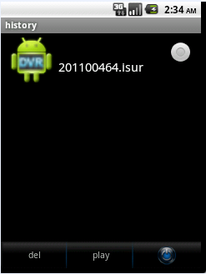
Select the server you want to connect, then click "play"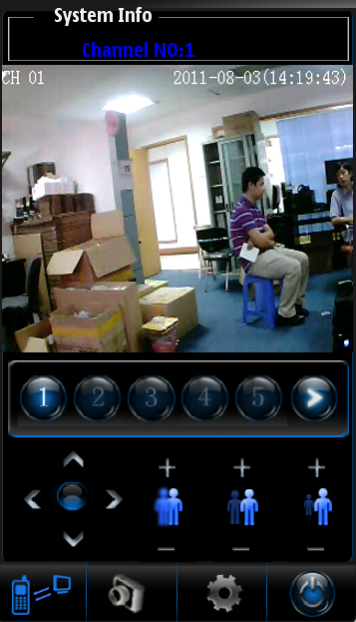

  - Connection fails
If the connection fails,it may be the following three cases:
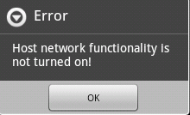 It means host network functionality is not turned on.

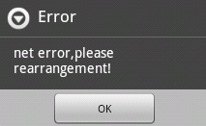 I t means mobile can't connect server-side because of slow network or no network.

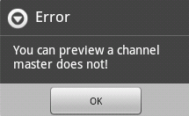 It means any channel on the server didn't start " allow remote preview for selected channel".

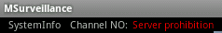 In the case of normal preview, no image and sudden emergence of this prompt, because the server prohibition" allow remote
preview for selected channel".

- Capture
Click"capture "directly on the main interface，the cut-off picture shows the current channel screen. Image storage address：SD card/Msurdata files

4. PTZ（first you need to start PTZ on the server side）
Click PTZ on the interface,thencontrol buttons will appear in the channel. 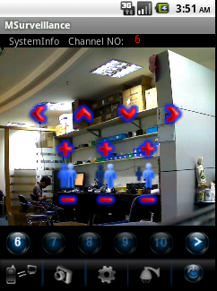

Focus adjustment
Aperture adjustment
Zoom in/out
Left
Up
Down
Right
Note: If you want to exit PTZ, then click the Back button on the phone.

