Symbian (MSurveillance) Instructions
一．System Requirements, install and uninstall
1.System Requirements
Symbian System S60 the fifth edition support the Mobile Model as follows
brand | Model
Nokia | 5230, 5232, 5233, 5235, 5238, 5288, 5250, 5530XM
Nokia | 5800, 5800i, 5800w, 5802XM
Nokia | C5-03, C6
Nokia | N97, N97i, N97 mini
Nokia | X6
Samsung | i8910 HD
SonyEricsson | U1i, U5i, U8i

A.Install
First, download the installer to the phone memory card, several ways you can choose :

a. You can use mobile data cable to connect computer and cell phone,it will appear removable disks in "my computer",then copy the installation files(MSurveillance_S60_5_1.0.0_.sisx) to memory card.
b. You may use a card reader, first, put the memory card into the card reader and then connect computer,it will appear removable disk in"my computer",copy the installation files (MSurveillance_S60_5_1.0.0_.sisx) to memory card.Last,put the memory card back into the phone.
B.Find the MSurveillance_S60_5_1.0.0_.sisx saved in memory card and click this file to begin installation, the installation process as follows:
- Click"OK"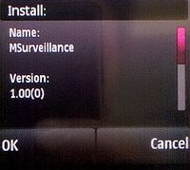
- Select"Continue"，to continue the installation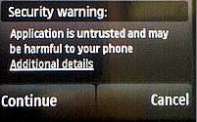
- Select“OK”，continue the installation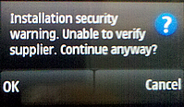
- Then select the target storage place to be installed, it is recommended to select the memory card, because the phone comes with storage space is limited.Click"select"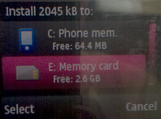
- Select"Yes" 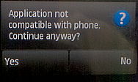
- A full time such as the progress bar means installation is completed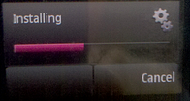

C、Uninstall

a、
Click the "applications" in the mobile interface,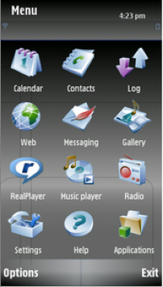

b、Select "Installed apps."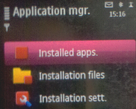

c、 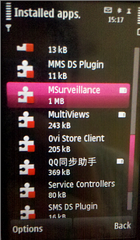

d、Then click "options"; pop-up dialog box as below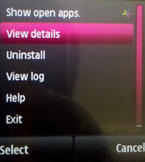
e、Click "unistall"
f、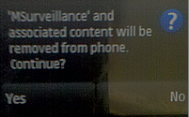
g、Then click"Yes", the software is successfully deleted as follows 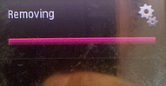

- Log in and exit
1.Log in
A. The first time log in
Click the shortcut software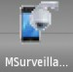on the mobile desktop，If the first time login, the login window will pop up as follows：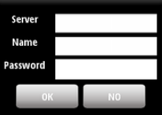
Server：enter the server name e.g.“201000098.isur”
Name and Password：Server user name and password
Fill out the server , name and password, Click"OK", start to connect the server side, if the connection is successful,it will enter the software interface and the emergence of channel screen , if not successful, a connection failure of the prompt, and enter the software interface.

B、Non-first time login
Click the shortcut softwareon the mobile desktop，it can enter into the software interface.

2. Exit

Click the exiton the surveillance interface, then exit the software.

- Basic functions
1.Description of monitoring main interface
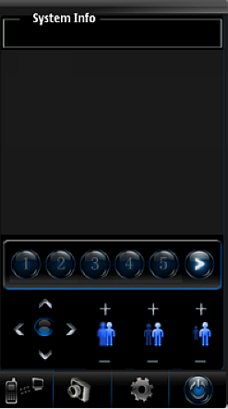
- 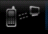 Connect and disconnect
- Capture
- Settings
-  PTZ direction control
- 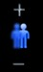 Focus adjustment
- Aperture adjustment
- 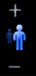 Zoom in/out
- Exit
- Channel number
- Turn the channel number

★Note: If you want to return to the previous interface when in the process of operation.Please click Back button on the mobile. It does not support the Menu key and the Home key during operation.

2. Basic functions
A.Server-side connection
      - Connecting the server side connected before
Click"connect"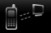on the interface ，it will connect server-side.
      - The new server-side connection
Click"setting"on the interface,it will pop up the dialog box as follows.
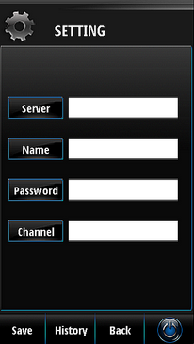
Fill in the server , name and password, click"Save",then click"History"
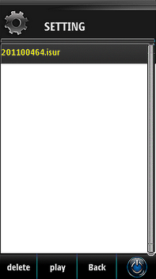
Select the server you want to connect, then click "play", 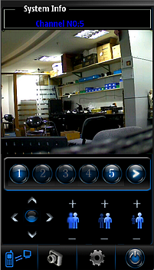

B.Connection fails
If the connection fails,it may be the following three cases:
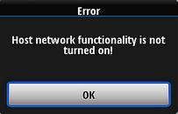It means host network functionality is not turned on.
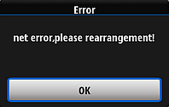It means mobile can't connect server-side because of slow network or no network.
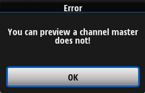 It means any channel on the server didn't start " allow remote preview for selected channel".
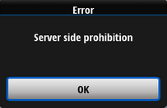In the case of normal preview, no image and sudden emergence of this prompt, because the server closed" allow remote preview for selected channel".

3.Capture
Click"capture "directly on the main interface.The cut-off picture shows the current channel screen. Image storage address：data/images/pictures files
  - PTZ（first you need to start PTZ on the server side）
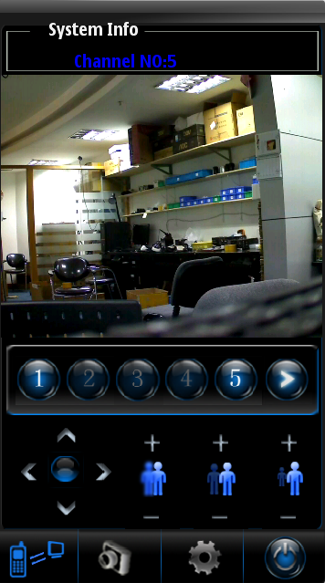
Instructions：
Control PTZ up, down, left and right.
Focus adjustment.
Aperture adjustment.
zoom in/out.

